
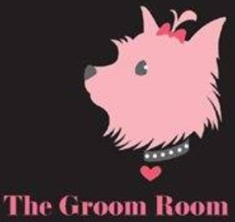

THE GROOM ROOM

PRICE LIST

SIZE SERVICE DESCRIPTION PRICE
Small Wash & Tidy Short, Smooth Coat $35
Medium Wash & Tidy Short, Smooth Coat $40
Large Wash & Tidy Short, Smooth Coat $45
Extra Large Wash & Tidy Short, Smooth Coat $55

Small Wash & Tidy Long, Fluffy, Curly Coat $45
Medium Wash & Tidy Long, Fluffy, Curly Coat $50
Large Wash & Tidy Long, Fluffy, Curly Coat $60
Extra Large Wash & Tidy Long, Fluffy, Curly Coat $70
Wash & Tidy includes: wash, blow dry, ear clean, feet tidy, pads trimmed, nails clipped, bottom tidy, cologne and bow.

Small Full Groom Short, Smooth Coat $55
Medium Full Groom Short, Smooth Coat $65
Large Full Groom Short, Smooth Coat $75
Extra Large Full Groom Short, Smooth Coat $85

Small Full Groom Long, Fluffy, Curly Coat $65
Medium Full Groom Long, Fluffy, Curly Coat $75
Large Full Groom Long, Fluffy, Curly Coat $90
Extra Large Full Groom Long, Fluffy, Curly Coat $100
Full Groom includes: Full body clip, face scissor and clip, wash, blow dry, ear clean, feet tidy, pads trimmed, nails clipped, bottom tidy, cologne and bow.
EXTRA SERVICES WITHOUT GROOMING
Nail clip $10 Ear clean $5 Nail sanding (smooth nails, no sharp tips) $10

