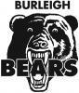
Sun-Gard with your help is raising funds for the Burleigh bears!!
They will be embarking on a Football trip to the UK in October and the boys need all the help we can give them!
Sun-Gard Gold coast will donate $15 dollars to the bears for EVERY car tint done!! All you have to do, is Quote the Burleigh Bears and Leo Bugden from Sun-Gard will donate 15 dollars! But that’s not all, for every 2 cars tinted on the same booking, Leo will donate $40!
Show your support and book your car in today!!
BURLEIGH BEARS FUNDRAISER!

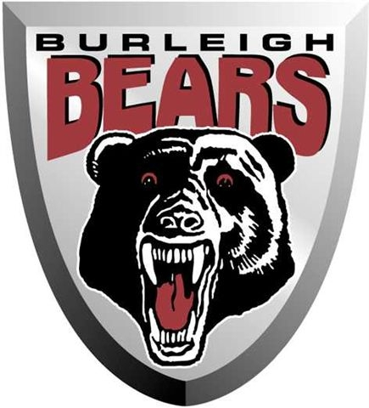

-Enhance vehicle appearance!
-Knockout annoying heat and glare!
-Block 99% of destructive UV Rays!
-Backed by a Manufacturer’s Lifetime Warranty!!
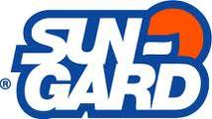
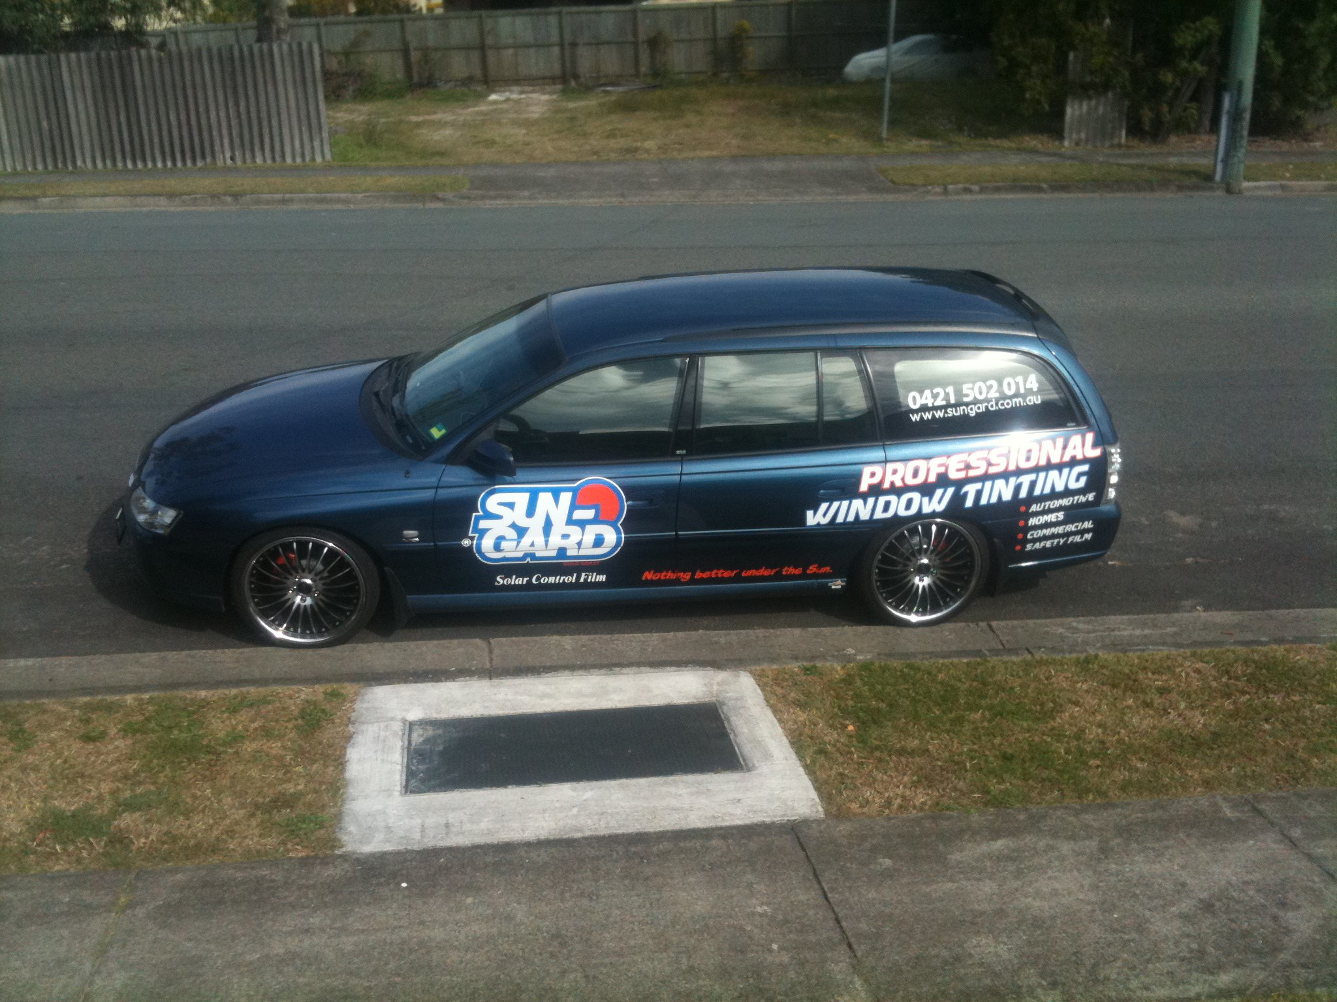

LEO BUGDEN
0421502014
e. sungardgoldcoast@gmail.com
w. www.sun-gard.com



