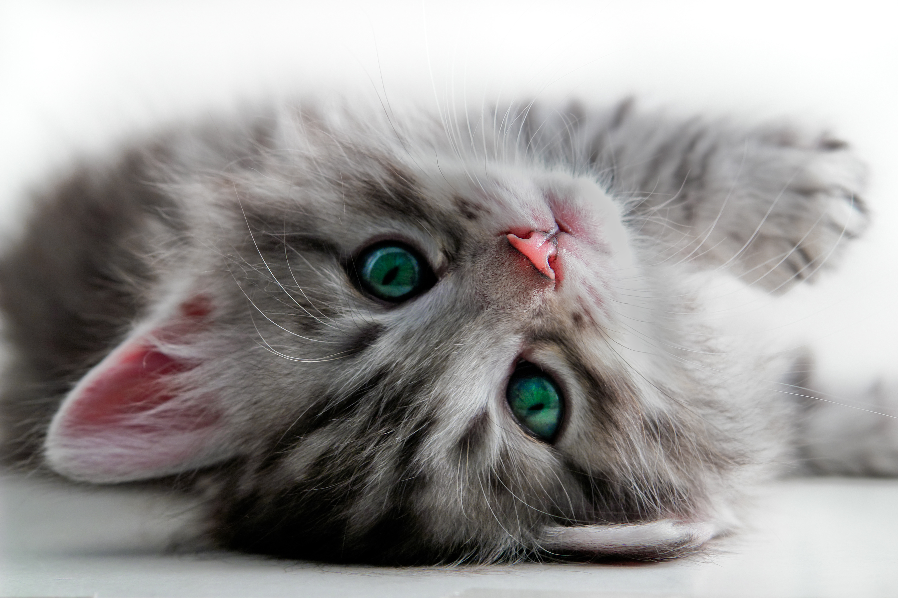
cat BOARDING
Call us for a quote
Discounts are available
PROFESSIONAL CARE BECAUSE WE KNOW YOUR CAT IS ONE OF THE FAMILY

Our clean and cozy Cat Motel is conveniently located within the Thirlmere Veterinary Clinic.

Cats stay in a separate indoor climate controlled facility – ‘Our Cat Motel’ – away from dogs or hospital patients so comfort is maximized and stress level is minimized.

Special needs can be catered including medication and prescription diet however there is a surcharge for diabetics.

Long stays are welcomed and all cats receive love and attention every day from our caring team of vet nurses.
www.caringcountryvets.com/cat-boarding
25 Oaks St Thirlmere NSW 2572 Tel 02 4681 8470
OUR RATES
STANDARD DAILY RATE
$16 per day

WEEKLY RATE (7+ days)
15% discount | $95 per week

LONG STAY RATE (14+ days)
$12.15 per day | $85 per week

SENIORS | PENSIONERS
15% discount | $13.60 per day

2 OR MORE CATS SHARING
Additional 10% discount applies

