
- Are you an owner operator?
- Are you looking for a simple accounting solution?
- Do you want to improve your business decision making?
- Do you want to take control?
- Can you enter numbers on a spreadsheet?
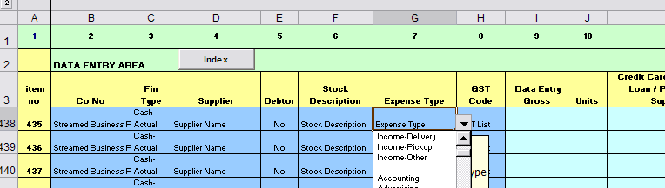
If you have answered “Yes” to the questions above then Pivotal Accounts is the answer for you

Pivotal Accounts is a flexible no fuss accounting solution
for your business – no need to be an accountant just enter
and click to refresh to be provided instantly with key business reports
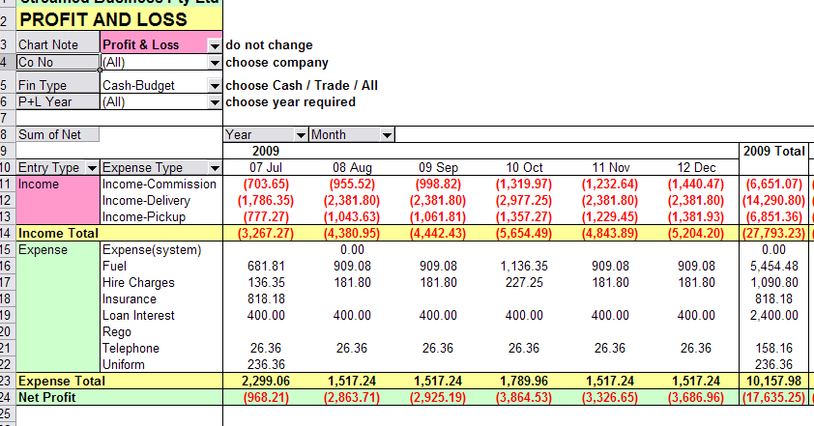
Set up a Budget
Profit and Loss
Bank Account Balance
Charts
Credit Card reconciliation
Supplier money outstanding
Instant GST liability
Customer debts
and much more

Pivotal Accounts is supplied with a selection of accounting charts to suit your business and an easy to read manual with optional support.

Just $49.00and a support option of only $9.95 a year – Pivotal Accounts is the way forward.
Interested? Check out our website for more details

www.streamedbiusiness.com.au
Email: info@streamed.com.au or phone Lyn 0414 771587

