MELBOURNE MACHINERY CO.
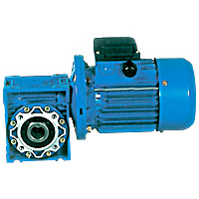
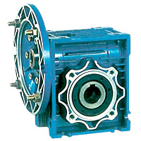
RIGHT ANGLE GEARED MOTORS

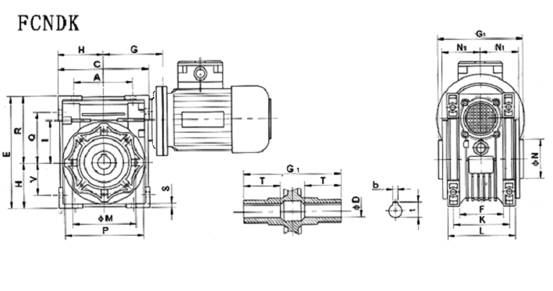

Size | A | B | C | D(H7) | D₁(J6) | E | F | G | G₁ | G₂ | H | I | L | M | N h8 | N1 | O | P | Q | R
30 | 54 | 20 | 80 | 14 | 9 | 97 | 32 | 55 | 63 | 51 | 40 | 30 | 56 | 65 | 55 | 29 | 6.5 | 75 | 44 | 57
40 | 70 | 23 | 100 | 18 | 11 | 121 | 43 | 70 | 78 | 60 | 50 | 40 | 71 | 75 | 60 | 36. | 6.5 | 87 | 55 | 71.
50 | 80 | 30 | 120 | 25 | 14 | 144 | 49 | 80 | 92 | 74 | 60 | 50 | 85 | 85 | 70 | 43. | 8.5 | 100 | 64 | 84
63 | 100 | 40 | 144 | 25 | 19 | 174 | 67 | 95 | 112 | 90 | 72 | 63 | 103 | 95 | 80 | 53 | 8.5 | 110 | 80 | 102
75 | 120 | 50 | 172 | 28 | 24 | 205 | 72 | 112 | 120 | 105 | 86 | 75 | 112 | 115 | 95 | 57 | 11 | 140 | 93 | 119
90 | 140 | 50 | 208 | 35 | 24 | 238 | 74 | 129 | 140 | 125 | 103 | 90 | 130 | 130 | 110 | 67 | 13 | 160 | 102 | 135
110 | 170 | 60 | 252 | 42 | 28 | 295 | - | 160 | 155 | 142 | 127 | 110 | 144 | 165 | 130 | 74 | 14 | 200 | 125 | 167
130 | 200 | 80 | 292 | 45 | 30 | 335 | - | 180 | 170 | 162 | 147 | 130 | 155 | 215 | 180 | 81 | 16 | 250 | 140 | 187

Size | S | T | V | K | KA |  |  | KB |  |  | KC |  |  | KE | ¦Á | ¦Á₁ | KM |  |  | KN(H8)
 |  |  |  |  | F | FB | FL | F | FB | FL | F | FB | FL | KE | ¦Á | ¦Á₁ | F | FB | FL | F | FB | FL
30 | 5.5 | 21 | 27 | 44 | 54.5 | - | - | 6 | - | - | 4 | - | - | M6X11(n,4) | 0⁰ | 45⁰ | 68 | - | - | 50 | - | -
40 | 6.5 | 26 | 35 | 60 | 67 | 76.5 | 97 | 7 | 9 | 7 | 4 | 5 | 4 | M6X8(n,4) | 45⁰ | 45⁰ | 87 | 115 | 87 | 60 | 95 | 60
50 | 7 | 30 | 40 | 70 | 90 | 87.5 | 120 | 9 | 10 | 9 | 5 | 5 | 5 | M8X10(n,4) | 45⁰ | 45⁰ | 90 | 130 | 90 | 70 | 110 | 70
63 | 8 | 36 | 50 | 85 | 82 | 99 | 112 | 10 | 11 | 10 | 6 | 5 | 6 | M8X14(n,8) | 45⁰ | 45⁰ | 150 | 165 | 150 | 115 | 130 | 115
75 | 10 | 40 | 60 | 90 | 111 | - | - | 13 | - | - | 6 | - | - | M8X14(n,8) | 45⁰ | 45⁰ | 165 | - | - | 130 | - | -
90 | 11 | 45 | 70 | 100 | 111 | - | - | 13 | - | - | 6 | - | - | M10X18(n,8) | 45⁰ | 45⁰ | 175 | - | - | 152 | - | -
110 | 14 | 50 | 85 | 115 | 131 | - | - | 15 | - | - | 6 | - | - | M10X18(n,8) | 45⁰ | 45⁰ | 230 | - | - | 170 | - | -
130 | 15 | 60 | 100 | 120 | 140 | - | - | 15 | - | - | 6 | - | - | M12X21(n,8) | 45⁰ | 22.5⁰ | 256 | - | - | 180 | - | -

