Creed of a Locksmith

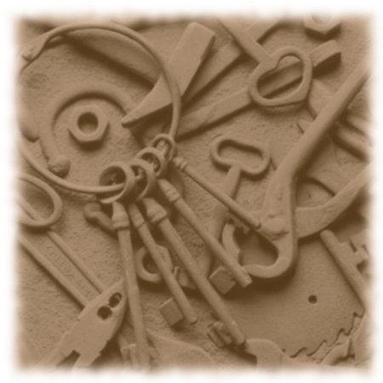
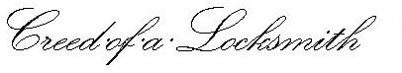
A Locksmith always remembers his public trust. With him rest the security of property and fortune.
As a public guardian, he shuns the dishonest, the wicked and the avaricious. For thousands of years he and his predecessors have placed trust and honor above temptation.
Hishonesty is incorruptible. His allies are the custodians of law and order. He is an artist at his trade, and the symbol of skill and integrity to the world.
— M. Leonard Singer

