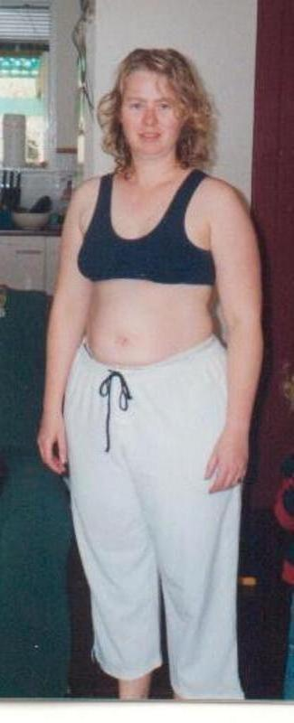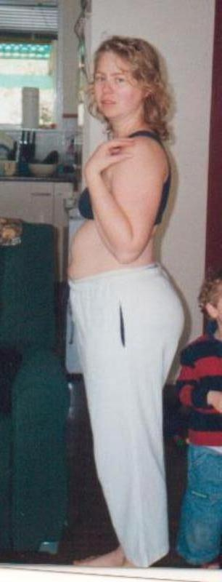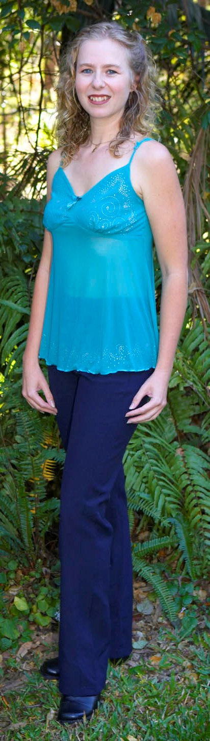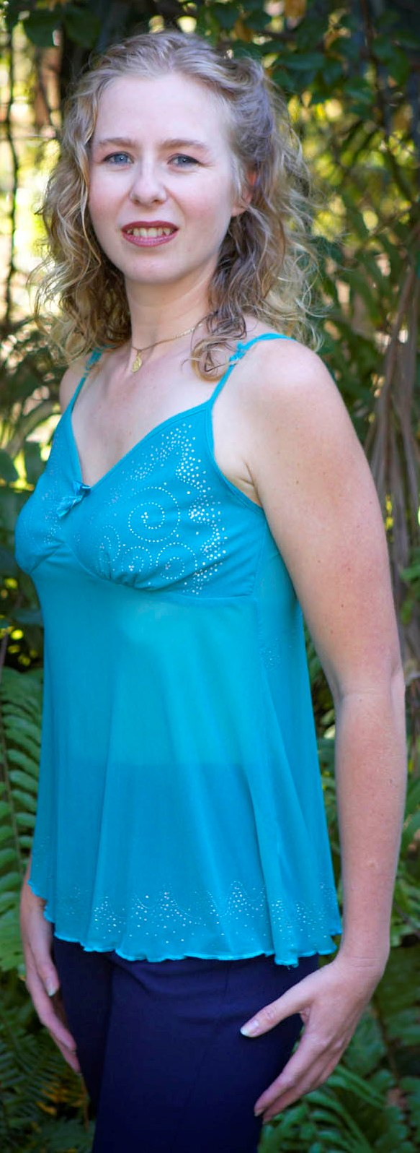
BEFORE: 72 KGS Size: 16 AFTER: 50 KGS Size: 8

All of my life I had been constantly sick with allergies, asthma, eye problems, migraines, anxiety/panic attacks, night blindness, fatigue, joint & muscle pain, which meant I would need to sleep most of the time.

Six months after my first son was born in August ‘2000’ four years ago I started to go numb from the chest down. I went to my GP, was sent to a Neurologist who discovered and diagnosed me with having Multiple Sclerosis. I was admitted to hospital for treatment which helped my condition but aggravated my arthritis so I was given medication for that as well as tablets for my severe migraines and the side-effects was more than I could handle which led me to getting post-natal depression and prescribed anti-depressants.

My second son was born 25 months ago and my health and depression was even worse. I went into a deeper depressed state and had thoughts of getting rid of everything and everyone around me so of course I starting using an increase dose of anti-depressants to help me cope.

In August 2004 my husband saw an ad in the paper about working from home, I responded, looked at the information discovered it was Herbalife and got started straight away. I thought it would be good to do something around my children and have a separate focus than just being Mum!

I started on the Ultimate Program, added Protein Powder, Herbalifeline, Tang Kuei, X-Tra Cal, Rose Ox and Formula 4.

I lost 10kg’s in my first 6 weeks and have gone on to lose a total of 22kg’s and 100cm’s in 6 months and have maintain it. I no longer need to take any of my medication! I don’t suffer from fatigue and have heaps of ENERGY to walk everywhere. No more eye problems, migraines, anxiety/panic attacks, asthma, muscle joint aches & pain, food cravings and my depression has lifted. I’m able to play, pickup and enjoy my 2 boys. I’m healthier now than I have ever been in my life my family and friends can see what a major difference it has made. The best part is my Neurologist has said and confirmed that my M.S. is STABLE!

I praise and thank God everyday for Herbalife finding me. HERBALIFE YOU ARE MY MIRACLE!

Belinda Wylie
Strathpine QLD

