
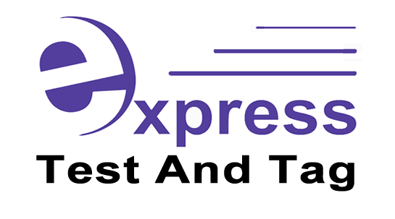
DON’T LET THIS HAPPEN TO YOU…
BE SAFE NOT SORRY!

GET COMPLIANT TODAY
Your first service only
$3.95 per item (plus GST)
Plus FREE Microwave testing
For prompt reliable service direct from the business owner contact
Merrick on 0432 782 960
Some of the items that require testing include:
- Computers & Monitors
- Printers, Fax Machines & Copiers
- Extension Leads & Power Boards
- Electric Power Tools
- Residual Current Devices (RCD’s)
- Kitchen Appliances
- And many more

Express Test and Tag Joondalup and Wangara

