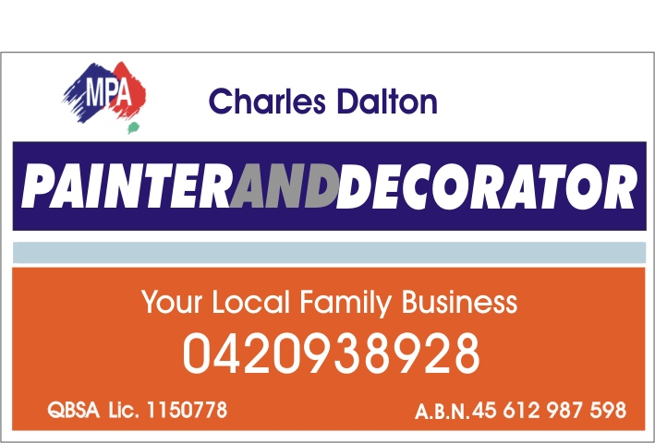

My name is Charles Dalton. My family is the proud owner of a local business –
Charles Dalton Painting and Decorating.

We specialise in all facets of Painting and Decorating including the following domestic and commercial services:

- Interior painting
- Exterior painting
- Maintenance work and repaints
- Feature walls
- Textured finishes
- Garage floors

We are QBSA licenced, Insured and members of Master Painters Australia.

We are committed to quality workmanship, ensuring we deliver quality, friendly service and excellent value for money on both large and small painting and decorating projects. Our painting projects aim to satisfy both the aesthetics and the practical aspects of painting and decorating. This is achieved by combining only the highest quality products, experience and expertise in the painting and decorating industry.

Please don’t hesitate to give me a call on 0420 938 928 at anytime to request further information in regards to your painting and decorating requirements. We do free quotations and are more than happy to speak with you in regards to any questions you may have.

Thank you
Kind Regards
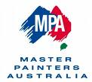
Charles Dalton

