BURGERS  Hamburger  Hamburger works  Steak Burger  Steak burger works  Bacon & Egg  Fish burger  Chicken burger  Bacon burger  Deluxe burger  Caesar burger  Jumbo burger  Tower sandwich  Club sandwich  EXTRAS  Egg  Beetroot  Pineapple  Cheese  Bacon  FISH  Cod  Snapper  Sea Perch  Flake  Barramundi  Mullet  Whiting  HOTDOGS  Hotdog - Plain  Hotdog - the lot  COFFEE AND HOT BEVERAGES  We like to use real Italian Lamducci coffee  Small: $3.00 Large: $3.50  Cappuccino Flat White  Long Black Café Latte  Hot Chocolate  Milkshakes $2.90 malt 40c extra  DESSERTS  Homemade Rice pudding  Homemade triffle  Apple Crumble  Homemade Greek sweets including Baklava, Nut rolls, Shortbread biscuits,  Honey biscuits, Greek Vanilla Slice  Chocolate Cake, Carrot cake, Fruit cake, Cheesecake lattice biscuits  Variety of other cakes, slices, muffins and cookies that vary each week just to  keep your sweet tooth happy  CATERING  Yes we can cater for your function  Cut sandwiches  Assorted cake/muffin/slice platter  Fruit platter  Hot nibbles platter  Cold meat platter  Or just come and see us and tell us what you have in mind.  You’ll be surprised what we can do! | SANDWICHES  $4.80  $4.50  $4.00  $5.00  $4.50  $5.00  $3.80  $4.80  $2.50  $2.50  $2.00  $2.00  $2.30  $3.30  $3.30  $2.80  $ .20  $19.00  $24.40  $32.00  $41.00  $8.00  Ham, cheese and tomato  Ham & cheese  Ham & tomato  Ham & salad  Chicken & lettuce  Chicken & salad  Egg & lettuce  Ham & pickle  Toasting an extra 20c  We also have silverside, roast beef and other cold meats at  Various times.  RISSOLES  Chicken rissoles  Meat rissoles  Chicken herb garlic rissoles  Beef & Gravy  Veal & cheese  PIES  Plain meat pies  Roast beef pies  Sausage rolls  Sauce extra  PACKS  Family Pack  Mega Seafood Pack 3  Mega Seafood Pack 4  Mega Seafood Pack 5  Seafood basket for 1  THE HENDRA FISH & CHIPS STORY  Originally the building which is now Hendra Fish & Chips, was built in 1915 and was a general store owned by a Mr Jno Aspinall. Following a small fire, the store was re-opened as Hendra Fish & Chips in 1930.  In 1976, Mr John and Vicky Galakatos bought the building and business and moved their family, Emmanuel, Michael and Katina, to live in the house behind the shop. Here the family lived for a few years before moving but they continued to run the business.  In 1994, Emmanuel Galakatos took over the business and has been the owner ever since. Since then, Emmanuel married Vicky and now have two children, Yianni and Karla who are already learning the tricks of the trade!  Hendra Fish & Chips had a major overhaul in 2006 with renovations transforming the shop into its modern form. Most recently we have introduced many new menu items including our hearty hot breakfasts, fresh salads and ready to go homemade meals.  Not to forget the introduction of freshly brewed Italian Landucci coffee. And what better way to enjoy your coffee than with one of our delicious desserts seated in our new lounge area with club chairs, leather lounge and plasma TV for your enjoyment.  With over 30 years experience in takeaway business, you can be sure that you will receive fantastic food at Hendra Fish & Chips cooked and prepared the old fashioned way. Our fish is crumbed on site, we make our own potato scallops (yes with real potato), our meat rissoles are made with lean mince and real herbs and spices and our burgers are the talk of the town.  So why don’t you come and enjoy the Hendra Fish & Chips family experience. Our prices would suit even the tightest of budgets so there is something for everyone here to enjoy whether you are single, a couple or a family. Come and see us,  We would love to see you! | SNACKS  $1.30  $ .50  $1.00  $1.10  $1.80  $0.50  $1.60  $1.10  $1.10  $2.00  $2.50  $2.50  $2.50  $2.90  $2.60  $2.60  $1.10  $1.10  $2.60  $ 1.00  $1.50  $3.00  Sea scollops  Calamari  Potato Scollops  Fish pieces  Prawn cutlets  Seafood bites  Seafood sticks  Mini spring rolls  Mini Dim Sims  Large mini dim sims  Savs  Pork sausages  Crumb sausages  Kabana  Chiko rolls  Spring rolls  Chicken & garlic balls  Beef croquets  Minimum chips  Pineapple fritters  Fish cakes  Souvlaki  *NEW* HOT BREAKFAST *NEW*  Small Brekky: bacon, pork sausage, fried egg, piece of toast, grilled tomatoes  $6.50  Large Brekky: bacon, fried eggs, hash brown, pork sausage, grilled tomatoes and toast $8.00  Awesome Brekky : 1 rib fillet steak, bacon, fried eggs, hash brown, grilled tomatoes & 2 toast $9.50  READY TO GO HOMEMADE SALADS AND MEALS  Fresh ready to go, homemade meals varied daily. Come in and check out what’s available today.  WE CATER FOR THE HUNGRY!  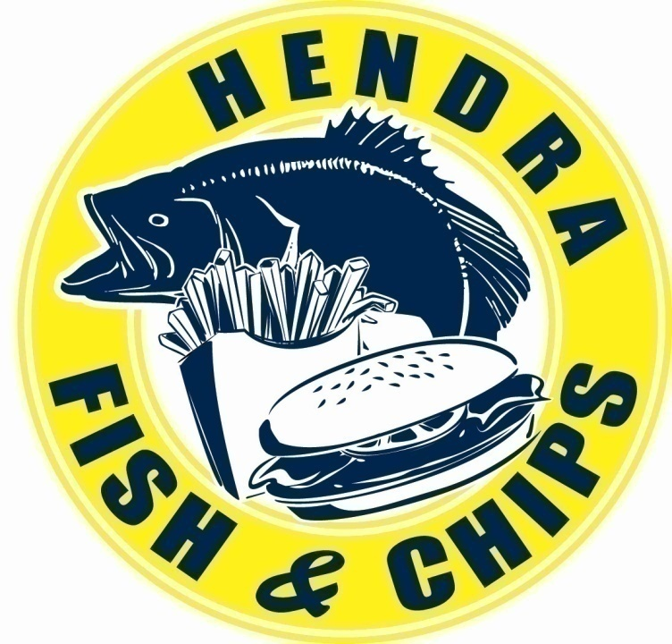  270 Nudgee Road, Hendra Ph/Fax: 07 3268 3346  RING US FOR YOUR ORDER AND WE WILL HAVE IT READY FOR YOU TO PICK UP!  For a great selection of tasty food cooked the old fashioned way at fantastic prices for the whole family, then come and see us.  OPEN 7 DAYS A WEEK  Mon – Sat 6am – 8pm  Sun 8.30am – 8pm  EFTPOS AND XPOS AVAILABLE
  $4.50
  $6.70
  $5.50
  $7.70
  $5.50
  $4.50
  $4.50
  $4.30
  $8.20
  $6.20
  $6.70
  $5.90
  $6.50
  0.70
  0.50
  0.50
  0.60
  1.00
  $4.60
  $5.00
  $6.30
  $4.30
  $5.10
  N/A
  $2.00
  $3.20
  $5.00
  NEED CATERING?????
  ndwiches or rolls or why not just call Emmanuel to discuss your catering needs.

