
Cultural Cooking Exchange
with your Bessemer cookware
Cooking Classes from around the world
Fiona Lawrence
0425 804 394
fionaandtrevor@bigpond.com
TAIWANESE CUISINE
Li-Liu

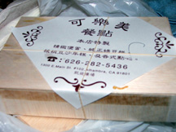

Taiwanese food is a combination of Chinese and Japanese influences. Taste and presentation heavily influence this Taiwans’ cuisine.
Li-Lieus’ fun personality and tradition make this exchange a true delight. Learn how to create the wonderful complete meal of Combination sticky rice in bamboo leaf fantastic for its portability and funky presentation. As well Li-Lieu will cook for us a traditional Taiwanese soup to tantalise the tastebuds. These dishes are simple and easy to replicate at home for all to enjoy
Cost: $40.00 per person for ingredients and presenter
Placement confirmed once payment is made
Please contact for alternative payment arrangements
Date: Thursday25th September (school holidays)
Time: 1.30 – 3.30 pm
Where: Fiona Lawrence
34 Second St
Parkdale 3195
R.S.V.P promptly to ensure position

