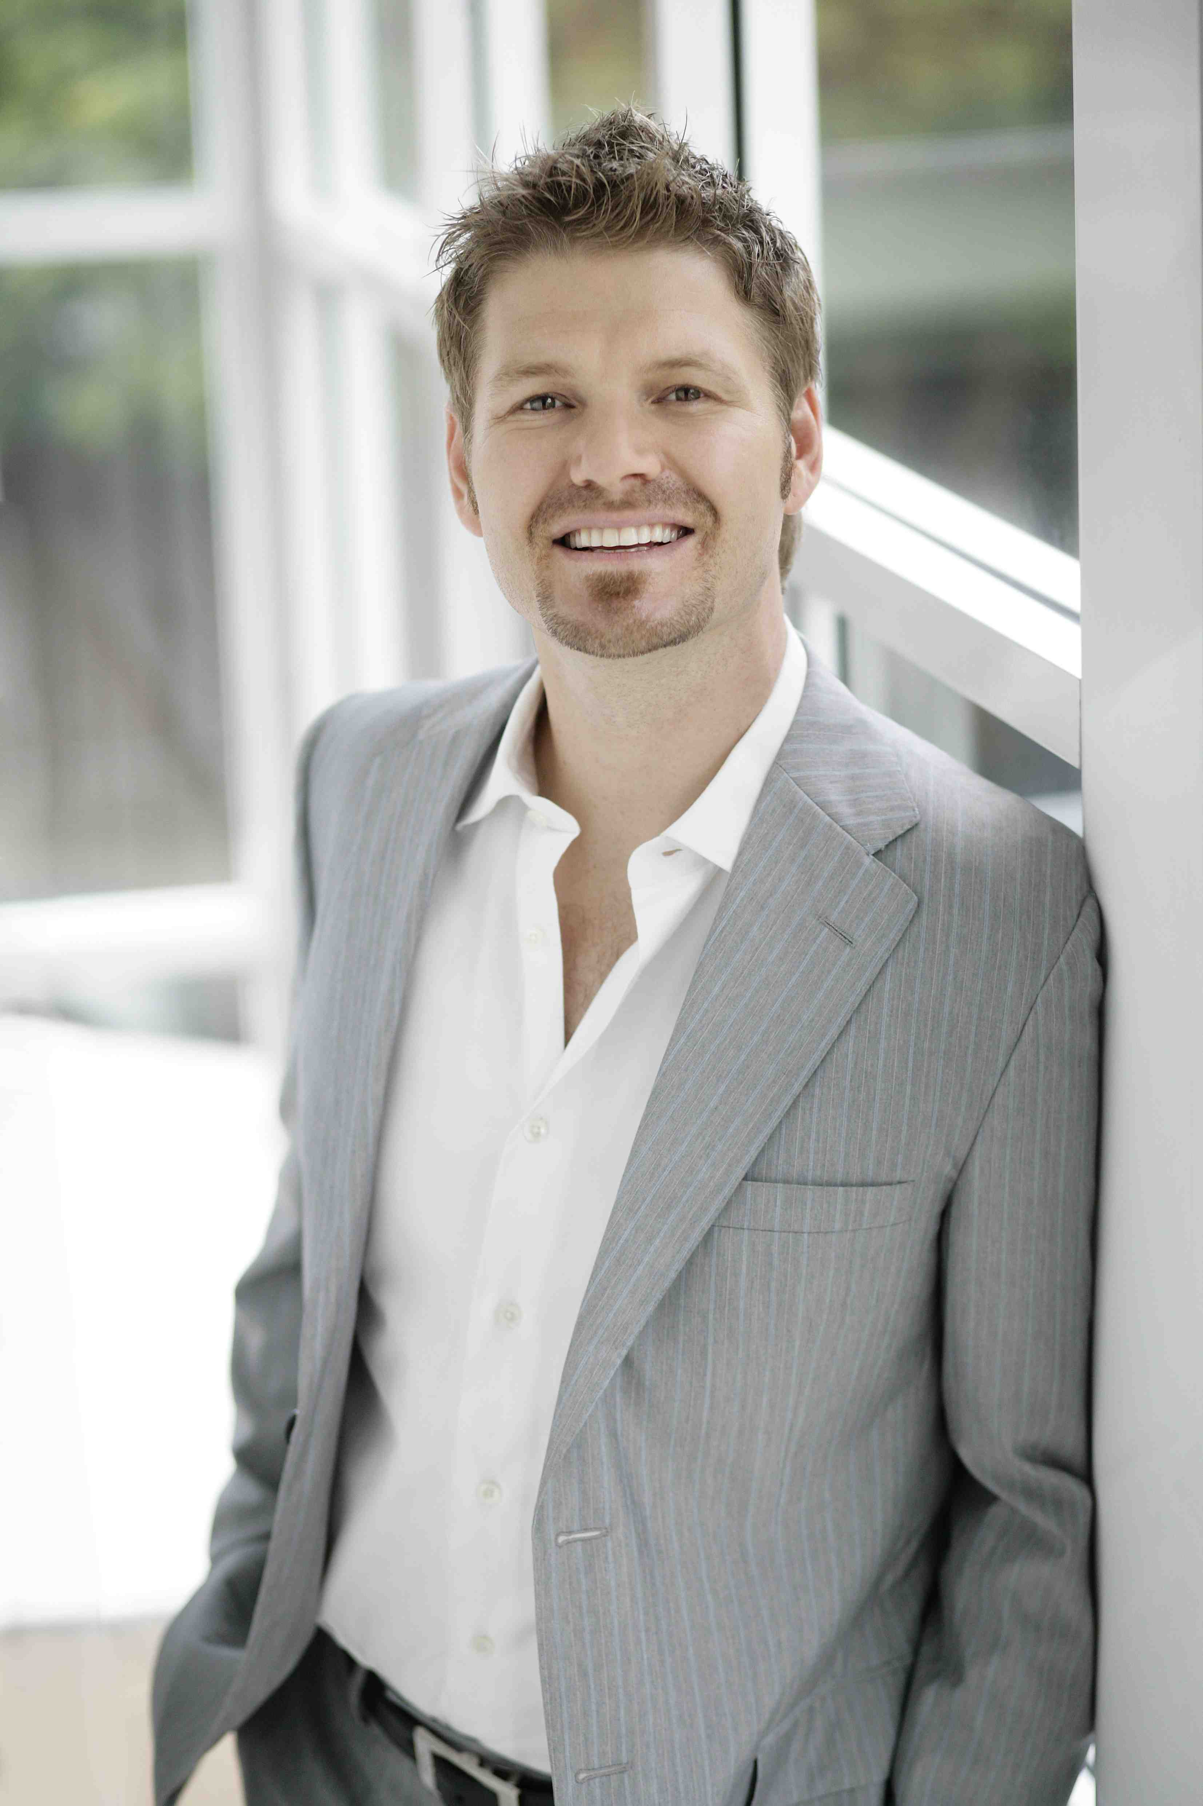
The 7 Most Important Things You Should Know About Your ActionCOACH

Blair Harding

“Blair is currently ranked In The Top 20 Business Coaches Globally, out of over 1500 Coaches.”

- Blair has had 14 years Business Development Experience in a variety of Industries including Hospitality, Retail, Travel and Tourism, Building and Construction and Sales and Marketing.

- Blair is currently a Director of two Property Development Companies, a Retreat on the Gold Coast, (Wings Hinterland Retreat) and just sold a Day Spa company (The Thai Foot Spa) after tripling the turnover taking it right through to the franchising stage.

- Blair has lived and worked on three continents and travelled to over 106 Countries. Currently coaching Business Owners between $500,000 and $50 million turnover. Being a Business owner himself, fully understands that a “Business” is a Profitable Commercial Enterprise “that works without YOU”.

- Blair’s passion and enthusiasm for property and growing businesses led to him becoming a Self Made Millionaire by 26 years of age. He is continually learning and growing his skills and transferring these across to the clients he coaches to get some very impressive results.

- Blair has studied under leading Australian Entrepreneur Brad Sugars bradsugars.com and the world-renowned ActionCOACH business improvement program and advocates its countless successful strategies. He is also mentored by 'Rich Dad' Keith Cunningham, and completed Keith’s MBA program. keystothevault.com. Blair has literally spent hundreds of thousands on the right type of education from people who have led truly inspirational lives. Jim Rohn, Zig Ziglar, Tony Robbins, Deepak Chopra, Dr John DeMartini, Robert Kyosaki to name a few.

- Blair’s family are of extreme importance to him and he very much enjoys spending quality family time with his partner Bethany and little legend of a son, 2 year old Jake.

- Blair enjoys reading, a good red wine & socialising with friends. He has always had a strong desire in helping people and has spent much of his life giving back. He has a keen interest for travel and culture. He is currently training to complete his second Marathon and has a strong belief in whole, raw & nutritious foods having an impact on our energy and wellbeing.
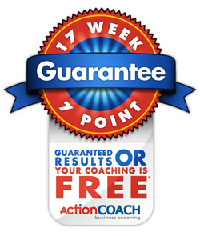
Blair is looking forward to helping you achieve your business and personal goals!

Blair Harding, Licensed ActionCOACH Business Coach

Unique Asset Acquisitions Pty Ltd – Representing ActionCOACH Pty Ltd
Brisbane Office Level 18, 333 Ann Street, Brisbane Qld 4000
Gold Coast Office: 14 Fiona Street, Biggera Waters Qld 4216
Phone: + 61 7 3232 1195 Mobile: 0417 992 791 Fax: +61 7 3011 1072

E-mail: blairharding@actioncoach.com Website: www.actioncoach.com/blairharding

