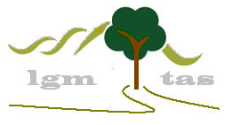

Lifestyle Garden Maintenance

Quality Manual


Contents
Page

Section 1 Overview 3
Executive Summary 3

General 4
Job Description 4
Quality Management System 5
Chemical Control 6
Emergency Response 7
Environmental Management 8
Health and Safety management including OH&S 9
Incident Management 13

Section 2 Policies 14
Alcohol and Drug Policy 15
Client Policy 16
Dangerous Goods and Hazardous Materials Policy 17
Environmental Awareness and Protection Policy 18
Occupational Health and Safety Policy 19
Personal Protection Equipment Policy 20
Quality Policy 21
Risk Assessment Policy 22
Smoking Policy 23

Section 3 Reporting Forms 24
Accident Report 25
Daily diary 26
Incident reporting 27
Risk assessment and action plan 28

Section 4 Employee/Subcontractor Requirements 29
Licenses 30
Insurances 30
Equipment 30

Section 5 Job Safety Analysis 31

Section 1

Overview
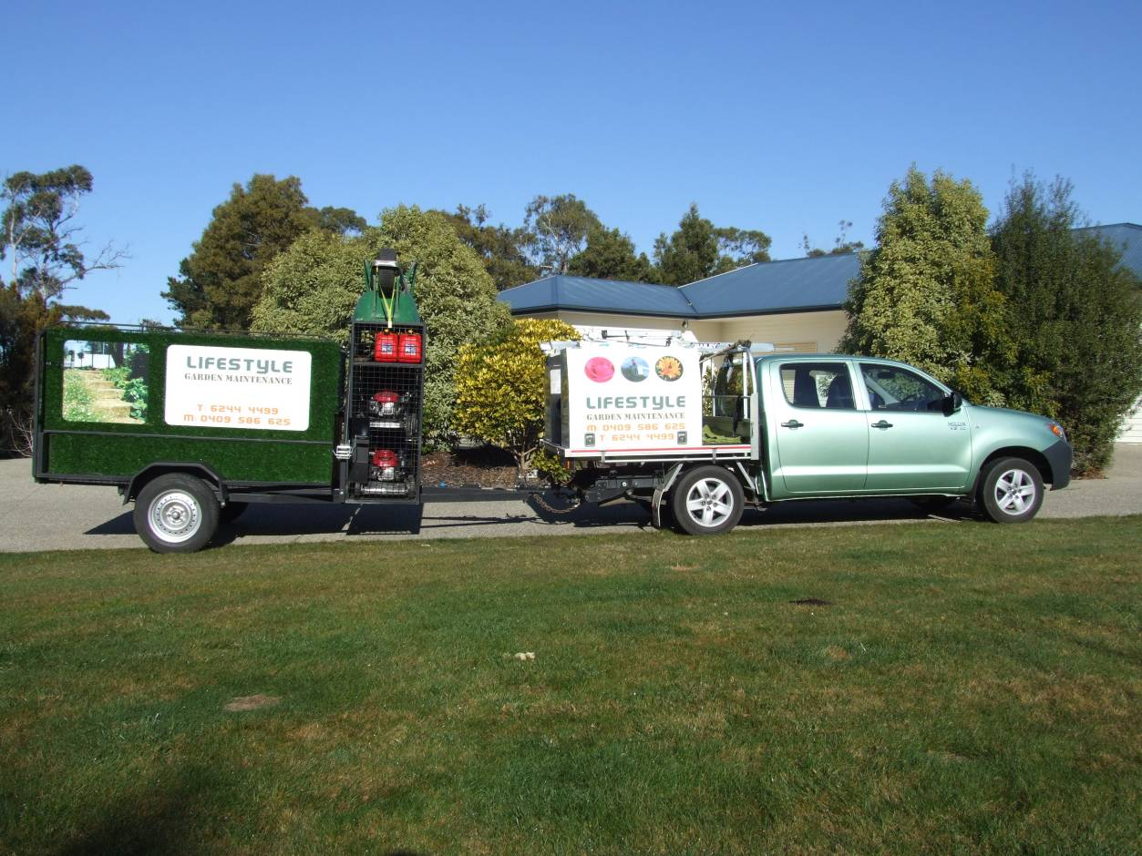

Executive Summary

Lifestyle Garden Maintenance has been an established business since 1998.
Lifestyle Garden Maintenance currently manages over 15 contracts and agreements across Tasmania and is well placed to deliver grounds maintenance. Settings vary from households, businesses spanning, education and corporate management. Already contracts are in place from a wide variety of industries including:
- public private sector
- body corporate management
- state government branches; and
- general public.

Over this time our expertise in all aspects of property maintenance and garden care has been finely honed to ensure a complete service will be provided to you to meet all your needs and desires whilst staying within budget.

Our qualified staff have 14 years experience between them and their ethical approach to garden care will ensure your garden is kept looking healthy and beautiful with minimal fuss
With many operational and management skills spanning years of experience this business offers
confidence and security in delivering high quality ground and garden maintenance .
Whilst the business is technical and operational it is orchestrated within a people centred working
environment. Business values held include integrity, fairness and a strong work ethic.

One of the greatest strengths of this business lies with our personal care delivering ground maintenance and cleaning services. These sub contractors have a long
association with the managing director and commitment to operations. Another attribute of the
business is the negotiation capacity to deal with timelines, agreed deliverables and if required
contract variation.

The current number of contracts differ in size yet are all managed similarly. All contracts are
implemented with the prime purpose of delivering a high quality service irrespective of
contract size. A continuous quality management system is in place with people, quality,
safety and risk management being business cornerstones. A quality manual contains
relevant legislation, policies and procedures guiding operational activity.

Cleaning Job Description

Step 1 Ensure all equipment is available with work schedule in place
Step 2 Confirm entry, sign in
Step 3 Undertake Risk Assessment
Step 4 Develop plan of control if required
Step 5 Complete tasks
Step 6 Complete documentation
Step 7 Communicate issues to supervisor if any

Tasks
- Dust entry foyers and landings  - Wipe wall, signs and switches  - Wipe doors  - Remove cobwebs  - Sweep, or vacuum all areas  - Mop floors | - Clean hand basins  - Clean office, toilets and storerooms  - Wipe all benches, tables and windowsills  - Rubbish removal

Equipment
- PPE  - Disinfectant in spray bottle  - Electrostatic dust mop  - Dustpan and broom  - Cobweb brush  - Broom  - Vacuum cleaner – to be electrically approved and tagged  - Hand towels  - Toilet soap  - Toilet rolls | - Mop and bucket  - Floor cleaner  - Scrub pad  - Surface spray  - Bin liners  - Rubbish bags

Quality Management System

- General  requirements | Legislative requirements  - Workplace Health Safety Act 1995  - Dangerous Goods Act 1976 & Regulations  - Environmental Protection Act 1973  - Pesticides Act 1968  - Industrial Safety, Health and Welfare Act 1997 |  | Operational Plans  - Safe Work Management  - Scope of Works
- Documentation | Policy and Procedures  - Alcohol and Drug  - Client Focus  - Dangerous goods and hazardous materials  - Dispute resolution  - Environmental awareness and protection  - Occupational Health and Safety Management  - PPE  - Quality  - Rehabilitation  - Risk Management  - Smoking  - Training
- Management  responsibility | Commitment  Client focus  - Requirements  - Review  - Communication | Policy and Procedures |  | Responsibility Authority Communication Review
- Resource  Management | General  - Job descriptions and equipment checklist  Work Environment | Human Resources  - Competence  - Awareness  - Training  - Licenses/permits |  | Infrastructure  - Equipment:  - Maintenance, registration, inventory
- Continuous  quality  improvement | Monitoring  - Client satisfaction  - Audits  - Inspections  - Control Systems | Analysis  - Client satisfaction  - Conformity  - Productivity |  | Improvement  - System review  - Action

Chemical Control & Management System

Lifestyle Garden Maintenance is committed to Chemical Control & Management through the following process.

Approval of Chemicals and Herbicides for usage
- Employees/sub contractors will only use approved chemicals
- Only licensed operators to apply chemicals.

Transport and Storage
- Chemicals must remain in original containers
- Check lids are secure, containers do not leak and container lids are replaced immediately.
- Store containers safely for transportation
- Maintain MSD Sheets in vehicles used for transporting chemicals.
- Chemicals will never be stored with foodstuffs, seeds or fertilizers.
- Chemicals must be used prior to expiry date.
- Herbicides will not be stored on sites.

Containers and Labelling
- Original label must always be on the container.
- Chemicals must be used according to manufacturing directions and prior to expiry date.
- Read the 3 main sections on the label e.g. product information directions for use and safety and first aid instructions.

Legislative requirements
- Chemical containers must be disposed of according to instructions and local government requirements.

Chemical Registers and MSDS Management

Lifestyle Garden Maintenance maintains a register of chemicals stored and used but keeps this to a minimum.
- Lifestyle Garden Maintenance management will ensure that MSD sheets accompany products stored and are in each vehicle that carries chemicals.
- Ensure MSD sheets accompany new products.

Risk/Hazard Controls (Manual Handling and Environmental)
- Lifestyle Garden Maintenance will ensure that appropriate PPE is worn by all operators.
- Risk/Hazard Controls are managed through ongoing training and certification.

Emergency Response

In the event of any of the following situations an emergency response may be required.

- Electrocution
- Battery Acid Spillage
- Cuts
- Bums
- Broken Limbs
- Heart Attack
- Injury from Manual Handling

Depending on the situation there are a number of options to choose.

- Phone 000 for Fire Police or Ambulance
- Phone Office 62444499
- Phone Contract Supervisor from Operations Booklet in Building
- Phone Operational Manager 0409586625 or 0438651012
- First Aid
- Note exits
- Note position of fire extinguisher
- Estimated Time of Arrival
- Last known time of Contact
- Capacity to drive

In the event that an emergency phone call has to be made please give the following information clearly.

Name
Specific Location of Accident! Incident
What happened?
Number of injured persons
Nature of injury

The next step is to repeat the information and speak clearly so that assistance can be sent quickly and to the exact location. As soon as practicable make safe the environment or person injured.
Environmental Management Process

Lifestyle Garden Maintenances Environmental Management Plan addresses the following environmental aspects and is included in employee and sub contractor training.

Pollution control
All employees are trained to minimise any pollution of the environment both from machine or any other source. Any incidents of pollution will be recorded in daily diary sheets and reported to Lifestyle Garden Maintenance management. Our work practices comply with Environmental Laws.

Land
- Mowing equipment will not be used where soil damage may occur.
- Avoid spillages of chemicals.
- Any evidence of soil erosion is to be reported to the Manager.
- Any damage to be made good as soon as practicable and rehabilitate the site at least to that of the previous condition.

Air
- Minimise smoking exhausts
- Do not burn rubbish
- Report any unusual odours

Water
- Do not allow fuel, chemicals or any other hazardous substance enter drains and waterways.
- Report all spills.

Noise
- Minimise all sources of noise
- Change work practices in order to reduce the problem if necessary.

Waste control
- All wastes will be managed in accordance with the Environmental Management Pollution and Control Act.
- All prescribed wastes will be managed by licensed contractors.
- Aspects and impacts are shown in the attached environmental aspects report.

Flora and Fauna
- Where advised by the contractor of any flora or fauna that needs protecting these areas are to be indicated by markers.
- Minimise the effects on habitat to fauna and assist in protecting species.
- Ensure a proactive approach at all times in protecting flora.

Health and Safety Management

Introduction
Lifestyle Garden Maintenance recognises its legal responsibility to provide a safe and healthy work environment for employees and subcontractors. Industry standards guide the Occupational Health and Safety (OH&S) policy and practices for Lifestyle Garden Maintenance with risk assessment and control measures clearly part of work practices. Lifestyle Garden Maintenances health and safety management process is managed through the implementation of a number of policies and procedures including auditing processes and documentation. This is all framed within a continuous quality improvement process as an ongoing commitment to better practice and accreditation.

Key OH&S workplace areas
- Accident and emergency response
- Incident monitoring
- Workplace safety
- Job description
- Personal Protection
- Environmental awareness and protection
- Dangerous goods and hazardous materials
- Equipment purchase and selection
- Training
- Rehabilitation
- Workers Compensation

Policies
- Alcohol and Drug Policy
- Client Policy
- Dangerous Goods and Hazardous Materials Policy
- Dispute resolution
- Environmental Awareness and Protection Policy
- Occupational Health and Safety Policy
- Personal Protection Equipment Policy
- Quality
- Rehabilitation Policy
- Risk Assessment
- Smoking Policy
- Training Policy

Legislation
Workplace Health and Safety Act 1995 including Workplace Health and Safety Regulations 1998
- Dangerous Goods Act 1976 & Regulations
- Environmental Protection Act 1973
- Pesticides Act 1968
- Industrial Safety, Health and Welfare Act 1977

___________________________
¹ Occupational Health and Safety Policy
² Job descriptions
Occupational Health and Safety

Lifestyle Garden Maintenance manages a safe work environment according to the following workplace areas.

- Accident and emergency response
All accidents are investigated using the accident report form procedure³. It is the responsibility of all staff to report any work injury to their immediate supervisor. Management is responsible for reporting accidents to Workplace Tasmania within 24 hours. A register of accidents⁴ is held in administration. In the case of a critical incident staff follow emergency response checklist⁵. This process is reviewed annually, tested and upgraded as required. A summary of the procedures is placed prominently in operations folder in each vehicle. At orientation staff are informed of the emergency procedure.

- Incident monitoring
There is a broad duty of care by Lifestyle Garden Maintenance employees and clients to communicate any unsafe work practice or condition to Lifestyle Garden Maintenance supervisor or management. Following risk assessment, corrective action may be undertaken immediately by the operator if appropriate and communicate incident to management. Management will carry out an incident investigation and implement remedial action as necessary. The use of an incident investigation report form⁶ documents the incident. As part of the quality management system an incident register is maintained in administration.⁷

- Workplace safety
Workplace safety addresses individual issues, environmental awareness, dangerous goods, and equipment. Lifestyle Garden Maintenance will fulfil its broad duty of care obligations and has systems⁸ in place as far as practicable to protect employees.

3.1 Personal Protection
Protective clothing is made available for employees whilst sub contractors supply their own. Management will ensure that employees and subcontractors are trained in the use of and are required to wear/use appropriate clothing and protection equipment at all times⁹ • Personal protection equipment covers the following:

- Equipment (eye goggles, ear muffs, ear plugs, helmets, first aid kit, sun screen protection, respiratory aids, safety restraints and
- Clothing (boots, special trousers, fire protection, safety vests).

PPE is audited, using a PPE inspection sheet¹⁰, monthly at work inspection sites as part of auditing and the continuous quality improvement process.

There is an alcohol and drug safety policy^{ll} and a smoking policy¹² in place for employees and subcontractor compliance.
___________________________
³ Accident and incident report form procedure
⁴ Accident register
⁵ Emergency procedures
⁶ Incident investigation report form
⁷ Incident Register
⁸ Job descriptions
⁹ PPE and usage
¹⁰ PPE inspection sheet
¹¹ Alcohol and Drug safety Policy
¹² Smoking Policy
3.2 Environmental awareness and protection policy¹³

Lifestyle Garden Maintenance is committed to a sustainable environmental future by maintaining high environmental protection practices that address:

- Pollution -land, air, water and noise;
- Waste control- minimization and reduce, reuse where possible and disposal; and
- Flora and fauna.

3.3 Dangerous goods and hazardous materials policy¹⁴
Lifestyle Garden Maintenance complies with the relevant regulations pertaining to the handling, storage, transport and use of dangerous goods, hazardous materials and substances. Manufacturing recommendations are followed in the use of goods and hazardous materials. Compliance is the responsibility of individuals using the product. Individuals undergo training for competency in the use of these products which includes:

- Chemical management-oil and fuel, and
- Herbicide management.

3.4 Equipment purchase and selection
Lifestyle Garden Maintenance management is responsible for the purchase, selection and supply of goods. These goods conform to relevant statutory requirements, standards and or codes of practice. Lifestyle Garden Maintenance adheres to manufacturing recommendations, Codes of Practice, Australian Standards and Safe Operating procedures in relation to the use of equipment. Lifestyle Garden Maintenance complies with the relevant regulations pertaining to the handling, storage, transport and use of equipment.

4. Training
Lifestyle Garden Maintenance has a training policy¹⁵ and program¹⁶ in place for employees and subcontractors. This includes induction, orientation and continuing education.

5. Rehabilitation
Lifestyle Garden Maintenance endeavours to provide appropriate rehabilitation arrangements to assist employees and subcontractors who have suffered a work related injury in the return to work process. Management will liaise with the medical profession and case manager throughout this process.

- Negotiate rehabilitation program as early as possible
- Mutually agree between employer, employee, subcontractors and medical profession on return date and program
- Provide information and training as required
- Introduction to light duties
- Ensure safety practices are implemented
- Ensure no disadvantage to employee, subcontractors, employer or client

6. Workers Compensation (Employees)
Lifestyle Garden Maintenance complies with statutory requirements of workers compensation through insurance coverage. Lifestyle Garden Maintenance will:

- Ensure currency of workers compensation coverage for all employees
- In the event of a claim, obtain and complete documentation regarding the claim is completed in full.
- Maintain contact with Insurance Company and injured employee ensuring a speedy and safe outcome.
- At the appropriate time, initiate rehabilitation process.

Approval date
Accepted by Lifestyle Garden Maintenance Signature
Accepted by Employee
Signature

Changes required/made
Reviewed by
Position
Signature

___________________________
¹³ Environmental Awareness and Protection Policy
¹⁴ Dangerous Goods and Hazardous Materials Policy
¹⁵ Training Policy
¹⁷ Competency Checklist

Incident Management Process

Incident Reporting/lines of communication
- Upon incident and or accident immediately employee/ subcontractor must contact Lifestyle Garden Maintenance Management by phone within one hour. Should mobile phone reception be out of reach the landline is to be used.
- All incidents and or accidents although that may be minor, must be reported and recorded in the incident and or accident register by administration as soon as practicable
- Lifestyle Garden Maintenance Management will notify client of any incident and or accident
- As soon as practicable the incident and or accident report form is to be completed by operator and sent to management for review and action.
- Management reports employee accident to Workers Compensation within 24 hours on receipt of medical report.

Regulatory Requirements
Lifestyle Garden Maintenance abides by the Workplace Health and Safety Regulations 1998 under the Workplace Health and Safety Act 1995.

Incident Investigations
Lifestyle Garden Maintenance management will
- Identify the severity of the incident and or accident
- Inspect site
- Carry out risk assessment
- Investigate cause
- Develop control plan
- Implement control plan
- Review.

Corrective/preventative actions
- Remove hazard from the workplace
- Substitute the hazard by a lesser hazard
- Isolate hazard from person being put at risk
- Control hazard by engineering means
- Control hazard by administration means including safe working practices
- Use additional PPE.

Injury Management/rehabilitation/re-introduction into workplace
- Lifestyle Garden Maintenance management ensures medical attention is provided
- Ensure follow-up with injured person
- Follow up Worker Compensation Claim when necessary
- Negotiate rehabilitation process with medical practitioner, Workers Compensation case manager and injured party
- Develop rehabilitation plan in consultation with case manager and injured party
- Monitor rehabilitation progress
- Encourage full return to work.

Section 2

Policies

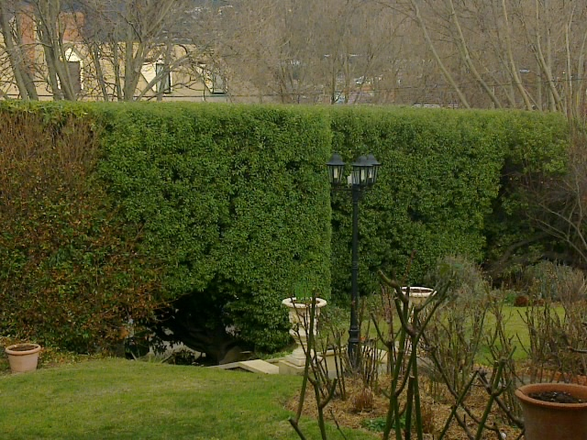
Alcohol and Drug Policy

To be read, understood and signed by employee/subcontractor
The alcohol and drug safety protocol applies to all personnel associated with Lifestyle Garden Maintenance.

Lifestyle Garden Maintenance requires that all employees and sub contractors under no circumstances work whilst under the influence of alcohol or non-prescription drugs.

Employees and sub contractors who are required to take prescription medication will consult with their medical practitioner about the effects of this medication upon their work performance and in particular with the use of machinery.

If such medication is likely to have, in the opinion of the medical practitioner, an adverse effect upon the work performance or safety, an employee or subcontractor will remain away from work.

Therefore

- Alcohol and non-prescription drugs will not be permitted at work operations.
- Any persons affected by alcohol or non-prescription drugs at the workplace will be liable to summary dismissal.

All employees must agree to the conditions within our policy and sign a copy of the policy, which is kept by the Business Manager.

The employee is issued with his or her own copy of this policy.

Approval date
Accepted by Lifestyle Garden Maintenance Signature
Accepted by Employee
Signature

Changes required/made
Reviewed by
Position
Signature

Client Policy

To be read, understood and signed by employee/subcontractor
Lifestyle Garden Maintenance is committed to delivering a high quality service to all clients.

Our aim is to deliver services that match the Client's expectations and requirements for solutions which when put in place are appropriate, of superior presentation and socially responsible.

Lifestyle Garden Maintenance will:
- Communicate regularly with clients;
- Commit to meeting contractual obligations and service delivery;
- Be proactive in relational management;
- Treat clients with respect and dignity and
- Operate within a continuous quality improvement process.

Approval date
Accepted by Lifestyle Garden Maintenance Signature
Accepted by Employee
Signature

Changes required/made
Reviewed by
Position
Signature

Dangerous Goods and Hazardous Materials Policy

To be read, understood and signed by employee/subcontractor
As part of Lifestyle Garden Maintenances commitment to the environment and occupational health and safety we will implement the following dangerous goods and hazardous materials processes.

Dangerous goods

Oil and Fuel:
- Maximum amount carried 20 litres. However, in the event of a spillage it is our policy to wipe it up with a cotton rag immediately.
- Oil or fuel is carried by employees only in approved containers.
- Oil and chemical management is part of our ongoing training and is controlled by spot checks and auditing.

Herbicide
- Licensed employees/subcontractors only, will undertake application of herbicide.
- The only herbicides used on Client's sites shall be those approved by Client.
- All employees/subcontractors are instructed in writing of the approved herbicides.
- All chemicals are stored, transported and applied as per the National Farm Chemical User Training Program.
- When any work is done and or conditions noticed on a Client's site a daily diary sheet is to be completed. This sheet records what work has been done and any chemical used.
- The Contract Manager keeps abreast of any alterations or additions to the range of herbicides available. If necessary he will seek approval from Client's contract supervisor and notify all employees in writing of any changes to approved herbicides.
- MSD Sheets applicable to each herbicide used are to be stored in operations manual held in all vehicles.

Hazardous substances
- With the exception of fuel, oil, and herbicide, no hazardous substances will be taken on to a client's site.
- In the event of an employee/subcontractor identifying a hazardous substance on a Client's site they will immediately notify the Contract Manager who will notify the Client.
- Any incident of this nature will be reported on the daily diary sheet.

Approval date
Accepted by Lifestyle Garden Maintenance Signature
Accepted by Employee
Signature

Changes required/made
Reviewed by
Position
Signature

Environmental Awareness and Protection Policy

To be read, understood and signed by employee/subcontractor
Lifestyle Garden Maintenance is committed to a sustainable environmental future by maintaining high environmental protection practices. All employees/subcontractors are informed at orientation and made aware of environmental issues that may impact as a result of work carried out.

Pollution control
All employees are trained to minimise any pollution of the environment both from machine or any other source. Any incidents of pollution or other source will be recorded in daily diary sheets.

Land
- Mowing equipment will not be used where soil damage may occur.
- Avoid spillages of chemicals.
- Any evidence of soil erosion is to be reported to the Manager.
- Any damage to be made good as soon as practicable and rehabilitate the site at least to that of the previous condition.
Air
- Minimise smoking exhausts
- Do not burn rubbish
- Report any unusual odours

Water
- Do not allow fuel, chemicals or any other hazardous substance enter drains and waterways.
- Report all spills.

Noise
- Minimise all sources of noise
- Change work practices in order to reduce the problem if necessary.

Waste control
- All wastes will be managed in accordance with the Environmental Management Pollution and Control Act.
- All prescribed wastes will be managed by licensed contractors.
- Aspects and impacts are shown in the attached environmental aspects report.

Flora and Fauna
- Where advised by the contractor of any flora or fauna that needs protecting these areas are to be indicated by markers.
- Minimise the effects on habitat to fauna and assist in protecting species.
- Ensure a proactive approach at all times in protecting flora.

Approval date
Accepted by Lifestyle Garden Maintenance Signature
Accepted by Employee
Signature

Changes required/made
Reviewed by
Position
Signature
Occupational Health and Safety Policy

To be read, understood and signed by employee/subcontractor
Lifestyle Garden Maintenance is committed to the principles and practice of a safe working environment for all employees,
subcontractors, clients and the general public. This policy aims to:

- Provide a safe working environment;
- Develop a culture where all employees and subcontractors care for the environment;
- Prevent pollution;
- Respond in a timely manner with accidents and emergencies;
- Provide a rehabilitation program as required, and
- Deliver a comprehensive and suitable training program.

Legislation
Legislative requirements include Workplace Health and Safety Act 1995 including Workplace Health and Safety Regulations 1998.

Responsibility
- Management, Employees/Subcontractors have responsibility for OH&S.
- Businesses outsourcing work to Lifestyle Garden Maintenance often have specific requirements applicable to employees and subcontractors. In such circumstances relevant people are advised verbally and in writing.

Commitment
Workplace safety, as stated by WORKCOVER Tasmania, provides the OH&S framework for Lifestyle Garden Maintenance. Lifestyle Garden Maintenance is committed to:
- Promoting occupational health and safety in the workplace
- Providing work systems that are safe and without risk to health
- Preventing injuries and disease
- Protecting the health and safety of the general public in relation to work activities
- Protecting the environment
- Resource allocation
- Performance analysis and review within a continuous quality improvement process

Approval date
Accepted by Lifestyle Garden Maintenance Signature
Accepted by Employee
Signature

Changes required/made
Reviewed by
Position
Signature
Personal Protective Equipment Policy

To be read, understood and signed by employee/subcontractor
All employees/subcontractors will maintain all machinery and other equipment used in the course of Lifestyle Garden Maintenance's work in a good and safe condition.

All operators will wear clothing appropriate to their tasks and be holders of current licences as required by law pertaining to the use of particular machinery or equipment.

The PPE selection and usage table guides employees/subcontractors in the requirements of this policy.

For example:
- Safety boots must be worn at all times
- Sun hats, sunscreen applied when working outside in hot sunny conditions
- Goggles or other appropriate eye protection, hard hats, respiratory apparatus must be worn when engaged in tasks e.g. brush cutting, herbicide application which may cause debris to be at risk
- Ear muffs/plugs to minimise the impact of any unduly noisy equipment
- Protective trousers when engaged in chainsaw operation.

Monthly inspections will be carried out by Lifestyle Garden Maintenance management as part of auditing and conformance processes.

Approval date
Accepted by Lifestyle Garden Maintenance Signature
Accepted by Employee
Signature

Changes required/made
Reviewed by
Position
Signature

Quality Policy

To be read, understood and signed by employee/subcontractor
Lifestyle Garden Maintenance is committed to delivering a high quality cleaning and ground maintenance service to all clients.

Our aim is to deliver services that match the industry standards with requirements for solutions which when put in place are appropriate, of superior presentation and socially responsible.

Accordingly Lifestyle Garden Maintenance is developing a quality system, which reflects management's attitude of having systems and procedures based on the prevention of defects, waste, rework and other costs of quality.

Lifestyle Garden Maintenance will:
- Carefully manage the quality management system;
- Undertake regular auditing and review findings;
- Encourage employees/subcontractors to be dedicated, innovative, and responsible for their work and
- Operate within a continuous quality improvement process.
- A quality, timely and dedicated service will be paramount to the business.

Approval date
Accepted by Lifestyle Garden Maintenance Signature
Accepted by Employee
Signature

Changes required/made
Reviewed by
Position
Signature

Risk Assessment Policy

To be read, understood and signed by employee/subcontractor

Lifestyle Garden Maintenance is committed to the principles and practice of risk assessment for all employees, subcontractors, clients and the general public. A risk assessment process must be undertaken prior to work commencing on any site. By undertaking routine risk assessments a process is established estimating the overall level of risk associated with all cleaning and ground maintenance operations. In the case of unacceptable risk work must be suspended and immediately consult with management. At no time should the achievement of work deliverables be allowed to compromise safety. Employees/Contractors will be, in consultation with management, responsible for risk assessment and control by:
- Identifying risks
- Assessing risks
- Controlling risks and
- Managing risks.

The management process for implementation is:
- Provide information
- Make suggestions
- Provide warnings including
- type of hazard
- level of risk
- controls to be implemented
- location
- possible impact
- duration of operational activities.

All employees/subcontractors must keep a risk analysis record on the Risk Assessment Form and the controls implemented to reduce identified risks. Once hazards are identified the following risk control strategies must be considered in sequence:
- Risk reduction and or elimination;
- Equipment control;
- Operations control; and
- PPE.

Management review will consist of:
- Risk assessment documentation
- Work plans;
- Work methods;
- Job Safety Analysis
- Relevant permits and certificates.

Approval date
Accepted by Lifestyle Garden Maintenance Signature
Accepted by Employee
Signature

Changes required/made
Reviewed by
Position
Signature
Smoking Policy

To be read, understood and signed by employee/subcontractor
Lifestyle Garden Maintenance has a no smoking policy that is consistent with health and client requirements. Smoking is prohibited whilst any equipment is being operated. This non smoking policy also applies whilst chemicals are being used.

Approval date
Accepted by Lifestyle Garden Maintenance Signature
Accepted by Employee
Signature

Changes required/made
Reviewed by
Position
Signature

Section 3

Reporting Forms


Lifestyle Garden Maintenance Accident Report

Part A Reference no ……………...……………………………………………….
Location of accident ……………………………………………………………………………………………

Service provided (e.g. slashing, mowing, cleaning, gardening, spraying, tree maintenance)

Equipment in use
Extent of injury/Damage
Description of Accident/Damage
………………………………………………………………………………………………………………………
………………………………………………………………………………………………………………………
………………………………………………………………………………………………………………………
Category (Ft – Fatality, Mt – Medical Treatment, D – Damage, N near miss, major, minor)

Action (first aid, admitted to hospital, attended hospital, specialist contractor)
………………………………………………………………………………………………………………………
………………………………………………………………………………………………………………………
………………………………………………………………………………………………………………………
Lost Time (part or whole of day) ……………………………………………………………………………….
Date of event ………………………………………… Time of event ………………………………………..
Should/have Workplace Standards Authority be advised Y/N

Date and time advised ………………………………………………………………………………………….
Name of person completing this form ………………………………………………………………………
Name of person/party affected: ………………………………………………………………………………
Date of Birth only required in case of an accident ………………………………………………………
Address of person only required in case of an accident ………………………………………………..
……………………………………………………………………………………………. Postcode …………..

Part B
Details of immediate action taken after the event ………………………………………………………...
………………………………………………………………………………………………………………………
Investigation details ……………………………………………………………………………………………
………………………………………………………………………………………………………………………
Investigation results and action taken ……………………………………………………………………...
………………………………………………………………………………………………………………………

Estimated Costs Labour Property Insurance Miscellaneous
Employee Personal File Y/N Contract File Y/N

Lifestyle Garden Maintenance Daily Diary & Checklist Summary Record

Client: | Contract: | Operator:

Legend for Checklist P = preliminary B = brush cutting M= mowing Q = quality control L = Leaving Site

Lot of site | Date | Times |  |  | Equipment | Checklist |  |  |  |  | Remarks | Inits
 |  | start | finish | total | type | P | B | M | Q | L

Lifestyle Garden Maintenance Incident Report

Part A Reference no ……………...……………………………………………….
Location of accident ……………………………………………………………………………………………

Service provided (e.g. slashing, mowing, cleaning, gardening, spraying, tree maintenance)

Equipment in use
Extent of injury/Damage
Description of Accident/Damage
………………………………………………………………………………………………………………………
………………………………………………………………………………………………………………………
………………………………………………………………………………………………………………………
Category (Ft – Fatality, Mt – Medical Treatment, D – Damage, N near miss, major, minor)

Action (first aid, admitted to hospital, attended hospital, specialist contractor)
………………………………………………………………………………………………………………………
………………………………………………………………………………………………………………………
………………………………………………………………………………………………………………………
Lost Time (part or whole of day) ……………………………………………………………………………….
Date of event ………………………………………… Time of event ………………………………………..
Should/have Workplace Standards Authority be advised Y/N

Date and time advised ………………………………………………………………………………………….
Name of person completing this form ………………………………………………………………………
Name of person/party affected: ………………………………………………………………………………
Date of Birth only required in case of an accident ………………………………………………………
Address of person only required in case of an accident ………………………………………………..
……………………………………………………………………………………………. Postcode …………..

Part B
Details of immediate action taken after the event ………………………………………………………...
………………………………………………………………………………………………………………………
Investigation details ……………………………………………………………………………………………
………………………………………………………………………………………………………………………
Investigation results and action taken ……………………………………………………………………...
………………………………………………………………………………………………………………………

Estimated Costs Labour Property Insurance Miscellaneous
Employee Personal File Y/N Contract File Y/N
Lifestyle Garden Maintenance Risk Assessment and Action Plan

Qualitative risk analysis matrix – levels of risk
Consequences
Likelihood | Insignificant  1 | Minor  2 | Moderate  3 | Major  4 | Catastrophic  5
A (almost certain) | H | H | E | E | E
B (likely) | M | H | H | E | E
C (moderate) | L | M | H | E | E
D (unlikely) | L | L | M | H | E
E (rare) | L | L | M | H | H

NOTE: The number of categories should reflect the needs of the study.

Legend
E: extreme risk, immediate action required
H: high risk, senior management attention needed
M: moderate risk, management responsibility must be specified
L: low risk, manage by routine procedures

Action Plan
What is the Hazard?
………………………………………………………………………………………………………………………
………………………………………………………………………………………………………………………
………………………………………………………………………………………………………………………

What is the Risk?
………………………………………………………………………………………………………………………
………………………………………………………………………………………………………………………

What is the level of risk E H M L

Remedial Action Plan and Control
………………………………………………………………………………………………………………………
………………………………………………………………………………………………………………………
………………………………………………………………………………………………………………………
………………………………………………………………………………………………………………………

Review control plan
………………………………………………………………………………………………………………………
………………………………………………………………………………………………………………………
………………………………………………………………………………………………………………………
………………………………………………………………………………………………………………………

Signature Employee and subcontractors

Date

Manager

Section 4

Employee/Subcontractor Requirements

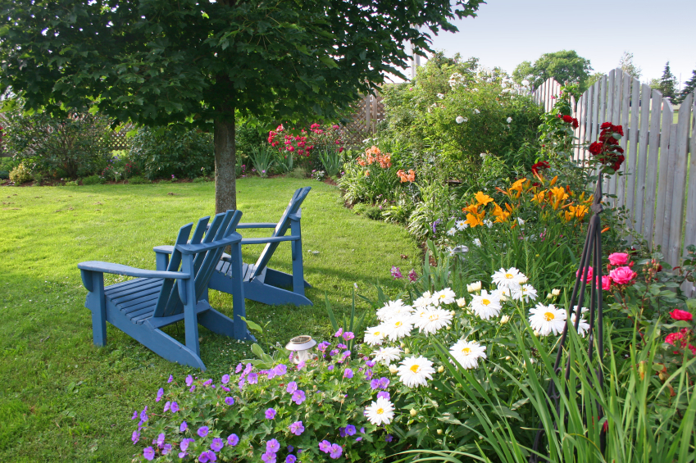

PLEASE NOTE

Confidentiality

Employees/Subcontractors must keep strictly confidential all information of Lifestyle Garden Maintenance and clients which is disclosed, communicated or delivered under the Contract or comes to their knowledge or into their possession in connection with the contract.

Licences
Employees/Subcontractors will hold the following licences
- Drivers licences to appropriate level
- Chemical application certificate
- Chainsaw operator licence (Ground level only)
- Horticultural Certificate (if applicable)
- CPRlFirst Aid.

Insurance
- Employees are covered under Lifestyle Garden Maintenance Policies
- Subcontractors will hold Public Liability Insurance to value $5,000,000.

Equipment
- Employees equipment to carry out contract supplied by Lifestyle Garden Maintenance
- Subcontractors to supply all equipment to carry out contract
- All electrical equipment to be tested and tagged to Australian Standard AS3760.

Section 5

Job Safety Analysis



LIFESTYLE GARDEN MAINTENANCE
Job Safety Analysis |  |  |  | Date: | Issue 1
Grounds Maintenance
Task | Hazards | Initial Risk | Control Measures |  |  | Control Risk
Brush cutting | Fuel/Oil | C3 | Store and transport fuel and oil in approved labelled containers  Wipe up any spills immediately |  |  | E3
 | Trips/slips/falls | C4 | Inspect site for hazards, eliminate or reduce hazard prior to commencing work  Wear non-slip safety boots Keep firm footing and balance at all times |  |  | E4
 | Sharps | B5 | Sharps container to be available  Safety gloves to be worn for sharps pickup  Dispose of container at licensed outlet |  |  | D5
 | Muscle strain | B4 | Warm up before carrying out active work  Use correct manual handling procedures  If necessary seek assistance |  |  | D4
 | Using brush cutter  Rotating blades  Flying debris  Terrain | B4 | Brush cutter must be serviced in accordance with manufacturers specifications  Prior to operating read operators manual  Operator to be trained prior to use  Fully understand safety features  Wear hearing protection

LIFESTYLE GARDEN MAINTENANCE
Job Safety Analysis |  |  |  | Date: | Issue 1
Grounds Maintenance
Task | Hazards | Initial Risk | Control Measures |  |  | Control Risk
Brush cutting (Cont) |  |  | Wear eye protection  Wear shin protection  Wear hat/sunscreen  First aid kit available at all times  Fire extinguisher available at all times  Before operation safety guards must be in place  Cutting attachments are in serviceable condition  Do not operate near unprotected persons  Do not brush cut where stones may be dislodged  When working on embankments safety harness must be worn. |  |  | D4

LIFESTYLE GARDEN MAINTENANCE
Job Safety Analysis |  |  |  | Date: | Issue 1
Grounds Maintenance
Task | Hazards | Initial Risk | Control Measures |  |  | Control Risk
Mowing | Trips/slips/falls | C4 | Inspect site for hazards, eliminate or reduce hazard prior to commencing work  Wear non-slip safety boots  Keep firm footing and balance at all times |  |  | E4
 | Muscle strain | B4 | Warm up before carrying out active work  Use correct manual handling procedures  If necessary seek assistance |  |  | E4
 | Fuel/Oil | C3 | Store and transport fuel and oil in appropriate labelled  containers  Wipe up any spills immediately |  |  | E3
 | Using Mower/ride on  Rotating blades  Flying debris  Terrain | B5 | Mower must be serviced in accordance with manufacturers specifications  Prior to operating mower operator must read operators manual  Operator to be trained prior to its use  Operator to fully understand safety features  Wear hearing protection  Wear eye protection  Wear hat/sunscreen

LIFESTYLE GARDEN MAINTENANCE
Job Safety Analysis |  |  |  | Date: | Issue 1
Grounds Maintenance
Task | Hazards | Initial Risk | Control Measures |  |  | Control Risk
Mowing (Cont) |  |  | First aid kit available at all times  Before operation safety guards must be in place  Cutting attachments are in serviceable condition  Do not operate near unprotected people  Inspect area prior to mowing  Do not operate on wet soggy ground or where soil damage may occur  Do not mow across slopes  Mow up and down  When dismounting ride on blades must be disengaged and hand brake on |  |  | D5

LIFESTYLE GARDEN MAINTENANCE
Job Safety Analysis |  |  |  | Date: | Issue 1
Grounds Maintenance
Task | Hazards | Initial Risk | Control Measures |  |  | Control Risk
Chainsaw Operation | Fuel/Oil | C3 | Store and transport fuel and oil in approved labeled containers  Wipe up any spills immediately |  |  | E3
 | Trips/slips/falls | C4 | Inspect site for hazards, eliminate or reduce hazard prior to commencing work  Wear non-slip safety boots  Keep firm footing and balance at all times |  |  | E4
 | Muscle strain | B4 | Warm up before carrying out active wok  Use correct manual handling procedures  If necessary get assistance |  |  | E4
 | Operating chainsaw  Kick back  Falling objects  Cuts | A5 | Operator must have chainsaw operator license  Chain saw must be serviced in accordance with  manufacturers specification  Prior to operating chainsaw operator must read Operators manual  Operator must be fully trained in its use  Must fully understand safety features  Wear hearing protection  Wear hard hat  Wear eye protection

LIFESTYLE GARDEN MAINTENANCE
Job Safety Analysis |  |  |  | Date: | Issue 1
Grounds Maintenance
Task | Hazards | Initial Risk | Control Measures |  |  | Control Risk
Chainsaw Operation  (Cont) |  |  | Wear protective trousers  Wear sunscreen  First aid kit available at all times  Before operation all safety features must be in place  Chain serviceable, sharp and adjusted correctly  Do not operate near unprotected persons  Do not operate in a manner where kick back may occur. |  |  | C5

