Tuition / Private Lessons
Traditional Guinean percussion classes
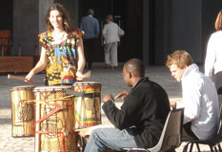 | Mohamed teaches traditional Guinean percussion classes every Tuesday evening at Esoteric Gallery, 557 High Street, Northcote.  The classes are open to people of all ages and abilities, and are both challenging and fun.  Anyone can drum, so come and try it out!
Where and When?
 | Place : | Esoteric Gallery, 557 High Street, Northcote.  (Near cnr. High Street and Darebin Road)
 | Time : | 5:30-6:30pm: Beginner  6:30-8:00pm: Advanced
How much?
Six week course :
 | Beginner | Full: $18, Concession: $16
 | Advanced | Full: $25, Concession: $22  * drum hire: $2 per class
Private Tuition
Mohamed also offers one-on-one and small group classes in Heidelberg,
by private arrangement.

