Social Media Marketing Workshop
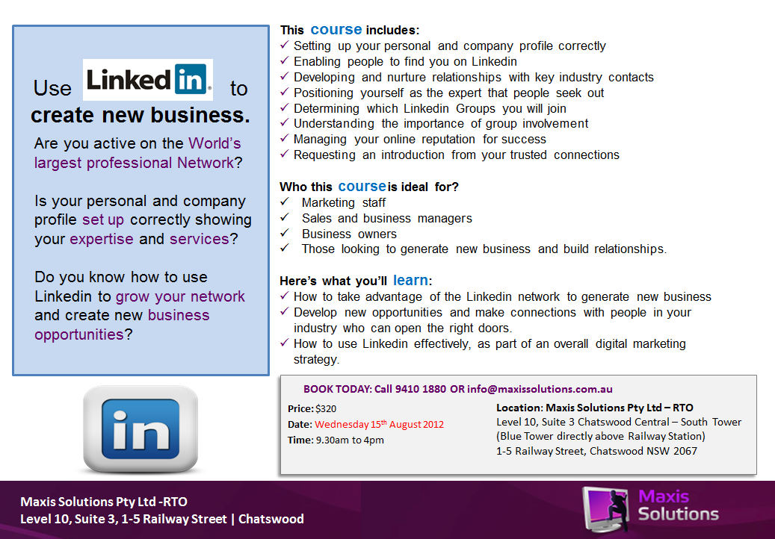
Ask yourself – What is the very best I can do to move my business forward?
$295

