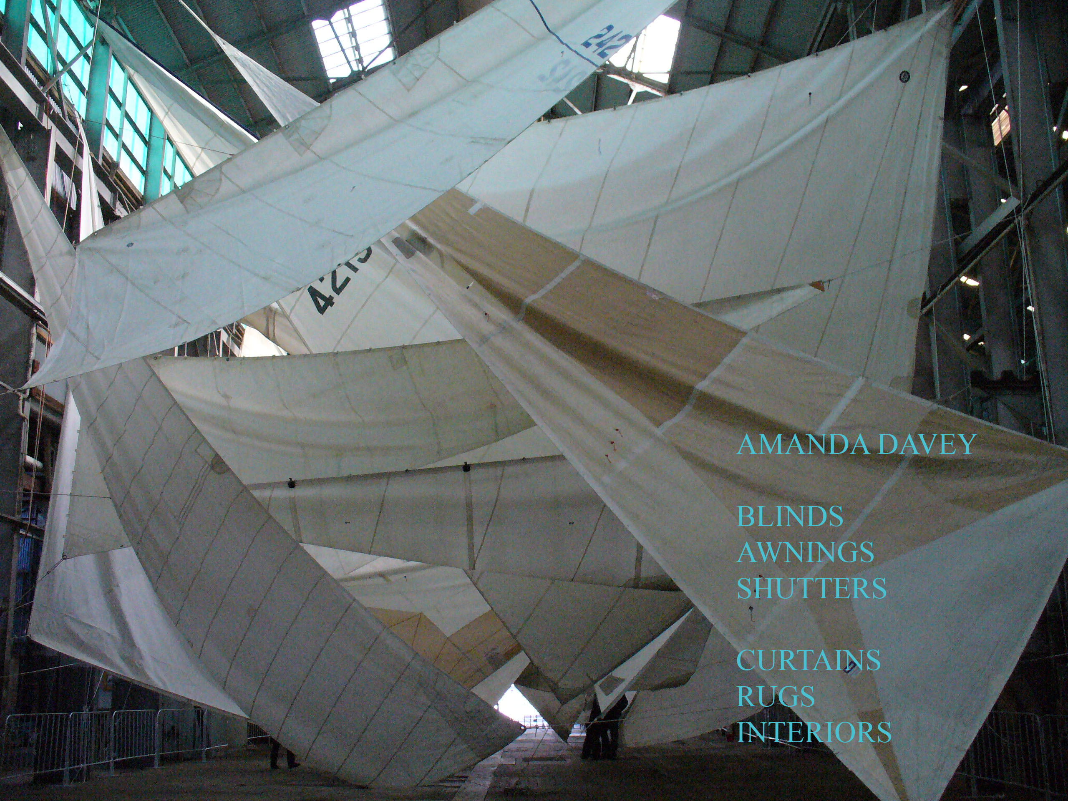
AMANDA DAVEY

BLINDS
AWNINGS
SHUTTERS

CURTAINS
STYLISED PAINTWORK
MODERN AND
PERSIAN RUGS

13 DUDLEY STREET
BONDI NSW 2026
0418645830
amanda1313@optusnet.com.au
abn 17148068425

Dear customer,
I am introducing myself as an agent for manual and automatic blinds,interior and
exterior awnings and extended varioscreens for hot summer shade.
The new exterior mechanized varioscreens are now available up to 6.5meters wide x 6.5 meters extensions and 24 meters linked by Aluxor and Helioscreen Automated exterior arm awnings from Markalux.

Introducing my new range Svensson Markspelle,it has a pearlised backing on a 15mm thick blockout and beautiful striped sheers in many colours ,Satins for Roman blinds,manual or auto.They have been in Australia for 14 yrs.

ROLLETNA is a well priced automated and manual interior screens and blockouts
Matched in a new woven fabric for the most discerning customer.

SHUTTERS in cedar, visionwood, excellent for wet areas and aluminium range from 16mm to 50mm blades.Automated and manual.by ROLLETNA.

The SURMAX exterior anodized aluminium blades range from 50mm to 80mm and 100mm, automated and manual

PAINTWORK from brushed metallics, 3 dimensional and stripes...
RUGS modern and new Persian and antique vegetable dyes on request
CURTAINS in fabulous fine linens,velvets and organsas,in the latest “S” bend.

I am looking forward to meeting you and discussing possible screen sites in the near future.
Yours Sincerely
Amanda Davey.

