
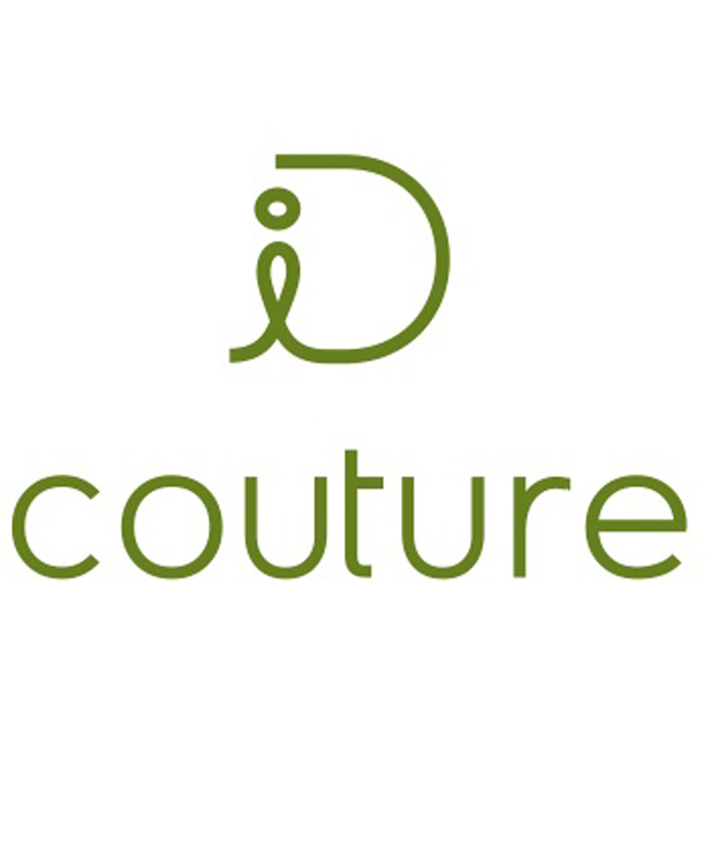

ID is IDENTITY + COUTURE = designer identity

Styleteam

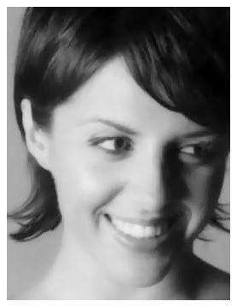
TANJA MRNJAUS is a fun and vibrant commercial and personal stylist. Her fashion expertise are a regular feature in the Australian media and not to mention Aussie wardrobes. As a professional image maker she is also the youngest AICI committee member (Association of Image Consultants International). Tanja’s mission is to seamlessly fuse style with your social and professional identity. She currently reports the hottest looks for FASHIONTREND and Style Magazines. Tanja supports the quote of “you can have whatever you want if you dress for it,” and as your stylist she is here to help you achieve this with a dynamic and creative experience.

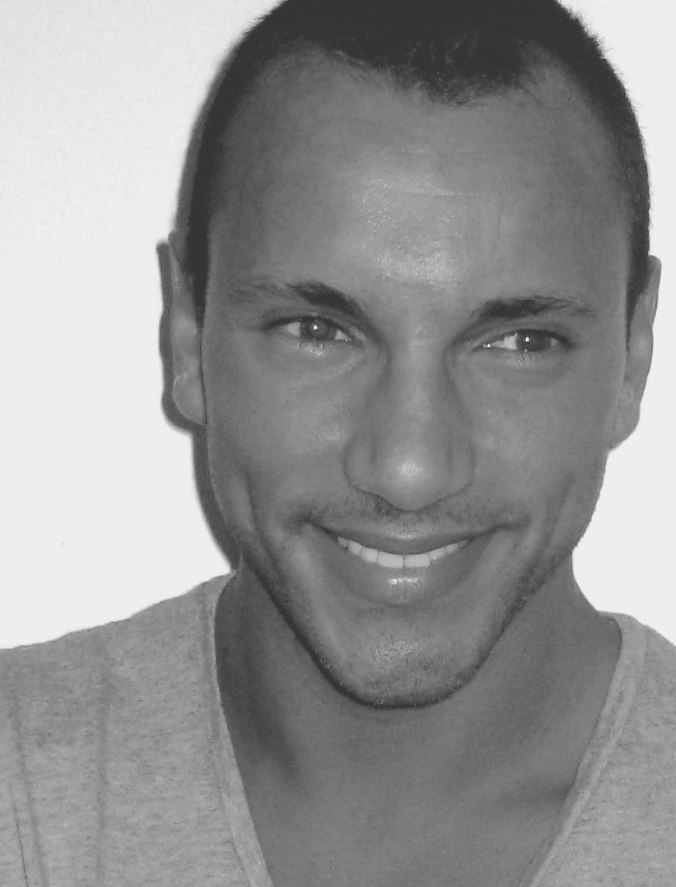
SAM ADAWALLA is a style guru, with over ten years of experience in the fashion industry he has helped dress national and international professionals. On a creative level Sam styled for one of the world’s most prestige agencies Elite Model Management where he working on major advertising campaigns. ID Couture is about helping people experience and innate sense of style and making it work with their personal image. It is about giving people the tools to make them feel both comfortable and confident in their appearance.

For more information please visit www.idcouture.com

Theartoftransformation
A 40-something and dating is looking to feel more stylish. A mid-level executive needs to exude more professional presence. A new mum wants to feel sexy & confident again. Common challenges that require uncommon solutions enter ID Couture a complete service specialising in wardrobe and image improvement. ID Couture brings clients the first-ever range of services for enhancing their personal and professional image.

ID Couture’s founder, Image Stylist Tanja Mrnjaus believes, “From CEOs to school leavers, everyone has a part of their presentation they would like to improve upon. ID Couture brings together an exclusive array of services which allows me to create a custom program tailored to individual needs and distinct lifestyles." Main services include; personal shopping, wardrobe makeovers and professional style training seminars .

ID Couture has come about in a time where Australians passion for makeovers is evidenced in the wealth of new reality TV shows devoted to the subject. At ID Couture, the focus is in enhancing the attributes each client has within himself or herself ... this creates lasting changes as opposed to quick fixes. ID Couture offers a much more measured approach than providers of any one service can offer - and our client's testimonials are testament to such success."

Case in point: ID Couture demonstrates an uncanny knack for discovering each client's individual image or “prescription". "we start by assessing a client's lifestyle, profession, social calendar, perceived needs and desired outcome. We also look at how they carry themselves, their personal appearance and
their comfort level in their own skin. Very often, there is difference between
the person before me and the person they want to be. From here, we start to
enhance’, Tanja & Sam explain.

To watch Tanja work, is to watch artists in action. Tanja mixes and matches the many offerings in her bag of tricks on a client-by-client basis, combining her innate know-how with a modern perspective. "I make it a point to be in the know of what fashion styles are coming before they hit the shop floors ... and pride myself of knowing the intricacies of the cosmetic industry, including the latest products and treatments... this allows me to work preemptively - and to maximise my client's time."

"Our clients are both male and female and range from media personalities to retail and corporate businesses and even students. ID Couture offers them a one-stop shopping spree for their image - a very worthy investment." Tanja & Sam conclude, "People are finding that in their fast-paced worlds, core social and presentation skills have been somehow been neglected. ID Couture is here to help people get them back on track. Image Styling is our passion, We love the journey undertaking with each client to help them fulfill their desired outcome”.

ID Couture operates from Melbourne, Sydney & Brisbane.
ID Couture is by appointment only.
Tailored packages and gift options are also available.

For more information please visit www.idcouture.com
For pricing menu and bookings please email styled@idcouture.com
………………………………………………………………………………………

ClientTestimonials
It has been an absolute pleasure to work with Tanja Mrnjaus... her creative eye, strong sense of style and trend forecasting skills have been invaluable
in shaping FASHIONTREND Australia's 'Fashion Essentials'
editorial pages.

Nikita Papas
Editorial Director
FASHIONTREND Australia Magazine
……………………………………………………………………………………………………Tanja's honest, transperant approach has made her a pleasure to work with. She understands the artforms of professional and personal presentation andhas an infectious enthusiam for both learning and teaching, alike. Tanja makes the effort to discover the needs of the client, tailoring her approach to their wavelength. I look forward to working with her in the near future."

Luke Cahill
Retail Business Manager
Cambridge Clothing
…………………………………………………………………………………………………..

Thank you ID Couture for coordinating a professional 'look' for the Nine Sales Team here in Brisbane. The entire team thoroughly enjoyed the personal wardrobe experience and now have a significantly improved perspective on how to present themselves in the market place.'

Les Hart
Managing Director, Sales & Operations QTQ – 9
…………………………………………………………………………………………………..

We have enjoyed working with Tanja from id Couture. She is passionate, enthusiastic, and very talented! She brings us quality interviews and articles, and we always look forward to her features.

Anna Carpenter

Editor beautyandlace.com.au & pinkdotbeauty.com.au
…………………………………………………………………………………………………....As the CEO of a fashion company, I am constantly traveling overseas to meet with buyers in Europe and the US, who are always impressed with what I am wearing. Sam has got his finger on the pulse of what is happening in the fashion industry. He has great taste, which he instinctively fits in to my own personal image. As an executive of a company, I am always pushed for time, and Sam’s energy and dynamicnature makes shopping and styling a true experience.

Michel Abeyseker, CEO of LM Group
I have worked and continue to work with Tanja from ID Couture on various fashion and lifestyle shoots, her styling skills make my job easy and commercial clients very happy. She has attention to detail, a great imagination and an outgoing manner, which equals a successful shoot.

David Finnigan
MD Sense 6 Photography
……………………………………………………………………………………………………
When it comes to style ID Couture are experts, they ensures that every time
I am in the spotlight I look the part, whether it’ll be an audition or
getting ready for filming, I always check with the style team first, because I know they will give me the right wardrobe and overall image advice.

Dean Kirkright
Actor Neighbours, Blue Heelers
………………………………………………………………………………………………
It’s rare to find a stylist who is both richly talented and exceptionally easy to work with. Tanja Mrnjaus is one such find. Whether styling a last minute shoot for Fashion Journal, or working an advertising job, Tanja’s work has been consistently professional and inspiring.
Michelle Legge
‘Fashion Journal’, David Jones ‘Precinct’, General Pants ‘Our People’
………………………………………………………………………………………
I admire Tanja’s dedication to her continued learning and styling skills and her obvious passion for the young artists and designers of Melbourne. She is truly an asset to Melbourne’s style and culture.

Clare Maxfield
Author – Getting Gorgeous, Getting Handsome, Getting Corporate
President AICI (Australian Image Consultants International) 2007
MD Corporate Confidence
………………………………………………………………………………………………..
Tanja is one of the most efficient and stylish businesswomen I know and at the same time she has this selflessness about her, she's caring, loving and has a passion for all things she does. She is able to provide instant fashion advice and amazing styling tips to make you look and feel special. She knows her stuff!
Paul O'Brien
Actor Home and Away
………………………………………………………………………………………………
I wanted to tell you that I wore my new boots last Saturday night, I've been wearing my scarves and my hats.... everything really. Thanks so much! You have helped me a lot.
Thanks again,
Zyrene Caparas,
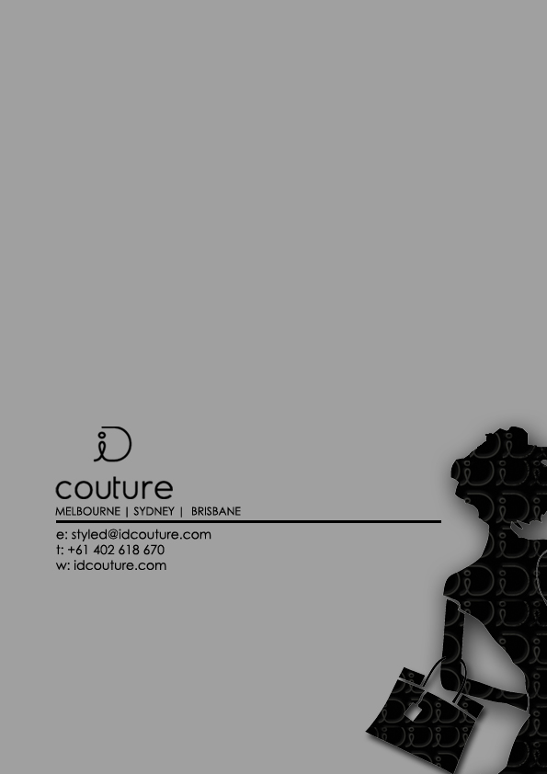
Culinary Scientist
…………………………………………………………………………………………………....

Thank you so much for a great day,,, couldn't have done it without you,,,and I mean that,, you're an amazing person with the most beautiful energy. Can't thank you enough for every thing.
Talk to you soon
Luv Nellie

Nellie Donovan
Singer/Songwriter
………………………………………………………………………………………………

STYLE MENU

ID COUTURE is a personal styling service designed to assist you in all matters of image and presentation. Whether you are looking for a style refresher or a total makeover ID COUTURE will revamp your wardrobe, provide you with endless hair & beauty options and shhh… tricks of the trade to help you redefine your new style and find out just how much fun you can have with fashion!

HER STYLE

COFFEE & STYLE CONSULTATION
COMPLIMENTARY
Your personal stylist at ID COUTURE will meet with you over a coffee to answer your image enquires and put together a styling plan that is individual to you. Feel free to ask any questions and bring any support materials to help you communicate exactly what you would like to achieve from booking ID COUTURE.

MY COLOUR PROFILE $249
Wearing the perfect colours is step one in achieving your ideal look. The right colours can make you look more vibrant, confident and youthful. Your individual colours should compliment your skin tone, eye colour, personality and lifestyle. Discover how to identify and select the right hues and contrast in your wardrobe, accessories, hair & skin. This consultation includes your own personal colour swatch.

MAKEUP EXPRESS

$95
Ideal for special occasions or for your everyday make-up regime, stop buying cosmetics you never wear and learn how to select and apply make-up that is perfect for you face, skin tone and style. Receive exclusive discounted products exclusive to ID COUTURE.

STYLE EXCLUSIVE

$249
Understand and learn how to dress with complete confidence to suit every occasion. ID COUTURE will work with you one on one to show you what to wear and how to create your ideal look. Your personal stylist will provide you with advice and endless options to update your current wardrobe or create a new one. This consultation includes a wardrobe audit and your personal stylebook.

WARDROBE REVIEW

$199

Need a personal stylist to go through your wardrobe and fine-tune the content? Put a stop to buying clothes, shoes & accessories that you never wear and cleanse your wardrobe from dated and unflattering items. Learn how to create new combinations together and accessorise. Finalise your wardrobe review with a shopping list of what is missing for your immediate purchases and later investments. Get instant tips on how to best organise and manage your wardrobe

PERSONAL STYLING & SHOPPING

1hr $129 Half day 4hrs $500 Full day 7hrs $850

Have your own personal stylist take you shopping and provide you with professional advice on what looks suit you best and work within your budget. Learn how to pick out clothes & accessories in a flash and have fun along the way! Half day booking includes a glass of champagne. Full day bookings include a light lunch.

STYLISH PACKAGES

backstage $399
Step out with the backstage essentials including my colour profile, style exclusive and wardrobe review.
This package includes your personal colour swatch & style booklet.

strike a pose $450*
Capture your new look with having your personal stylist choose your wardrobe, hair & make up artist and a photographer in a celebrity style photo shoot. You will receive a CD of your best images.
* fee may vary depending on complexity of looks, time, location and wardrobe requirements

red carpet $699*
Get treated like a star with a total style makeover. A day of stylish treats includes my colour profile, makeup xpress, wardrobe review, 2 hours personal shopping and a glass of champagne.
*Limousine pickups and drop-offs are also on offer for an additional fee

HIS STYLE

IMAGE & STYLE one on one COMPLIMENTARY
Your personal stylist at ID COUTURE will meet with you over a coffee to answer all your image enquires and put together a styling plan that is individual to you. Feel free to ask any questions and bring any support materials to help you communicate exactly what you would like to achieve from ID Couture.

MR FUSSY $95
ID COUTURE will help you with your image by helping you understand your colours, cuts and styles to suit your body and your personality. Your stylist will align you to a professional service that is perfect for you hair & body. Receive special offers on male products only exclusive to ID COUTURE.

WARDROBE SPRUCE UP $199
Your personal stylist will come in and organise your wardrobe, show you how to combine looks, choose accessories (ties, belts, shoes etc) and clean up your dated items. During this session your stylist will teach you what to look for when selecting future purchases by writing a shopping list for your new image and wardrobe revamp.

SHOP-XPERT

per hour $119 Half day 4hrs =$465 Full day 6hrs = $699
Get your quick shopping fix, by having your personal stylist and shopper to help you choose the right looks, colour and cuts to suit your every occasion. ID COUTURE is an expert in making men look good by taking out the stress of shopping and turning it to a fun and efficient experience. Fill your wardrobe with items you will actually wear.
Full day bookings include lunch.

MR IN THE KNOW SEASON UPDATES $99 Once you have your style down packed and would like to continue your new look and experiment with seasonal trends, spend time with your personal stylist to review your wardrobe and get the latest info on style and fashion trends to compliment your lifestyle via email.

HIS STYLE PACKAGES

hello handsome $259
Get your style essentials with your colour profile, style exclusive and wardrobe review. This package also includes your personal colour swatch and style manual.

style quickie $369
Enjoy instant style with a wardrobe review & two hour shopping

poser $400*
Capture your new look in a professional photo shoot. Have your personal stylist choose your wardrobe, hair & grooming and a photographer in a portrait or a conceptual studio shoot. You will receive a CD of your best images for your pursual.

GIFT PASSES

All of the listed services are available as gift options. Please contact ID COUTURE to customise a gift package that is perfect for that someone special.

GROUP BOOKINGS

Please contact ID COUTURE about group, training & staff packages & workshops.

ID STYLE ACCOUNT

10hrs personal shopping + 4 season updates + exclusive offers $1000
You totally love the personal styling treatment and trust your stylist to shop for you without you coming along, after all they already have all the information for your perfect shopping choices and hair & grooming products. All you need is to call or email your requirements and ID COUTURE will take over. You can use your account to redeem 10 hours shopping a year and four seasonal updates and exclusive male & female product offers. Your account is valid for 12 months and can pay off your account in monthly instalments.

CORPORATE

IMAGE & PRESENTATION TRAINING starting at $350
ID COUTURE is available to work with you to raise the profile of your professional presentation to your industry and clients. Have an image stylist train you and your staff on how to create and endorse your expected company image with a tailored wardrobe every time. This service ideal for small to large businesses with frequent customer and client contact, such as:
- creative, advertising & marketing
- hr, recruitment & training, education & government
- corporate, business & finance
- sales & management…
Book in an image stylist for talks, workshops and training sessions.

STAFF INCENTIVE POA
Reward your staff with the ID Couture incentive. Create your own package or simply state the amount you wish your staff to claim and they can choose their own service to the equal value.

UNIFORM DESIGN POA
We offer creative and tailored uniform design and manufacture to any industry, whether you are from hospitality, school, construction & building, health & beauty or corporate. Our design team can create or update your current uniform to suit your contemporary and future image. Price is all subject to, style, fabric and quantity.

RETAIL & FASHION BOUTIQUES

starting at $350

high styling sessions
Why not include an exclusive styling session to your most valued shoppers by booking in a stylist to update your clients on latest colours, styles and designer range and how to wear it!

staff training workshops
Offer a personalised service to your shoppers by booking a stylist to train your staff on how to understand colours and styles to suit all body types. This knowledge will empower your customer and generate ongoing sales.

Please contact ID COUTURE to discuss tailored programs & fees to suit your particular needs. Sessions can be arranged to your preferred time schedule.

COMMERCIAL STYLING POA

For commercial styling assignments in wardrobe, stills, production, editorials, runway, film & TV, live performances, artist image etc. please contact Tanja Mrnjaus as fees vary depending on scope of project.

FASHION EVENTS POA

Allow the team ID COUTURE to style and produce your next Fashion Event, we specialise in Fashion Shows & Runway; wardrobe, talent sourcing, hair & makeup, entertainment, photography and choreography. Our stylists are also available for Guest Speaking. This service is ideal for unique boutique style (small – medium) events.

SPECIAL CONSIDERATION FEES FOR:

Unemployed (looking for work)

Single parents

Students

Emerging talent

Small business owners

ID COUTURE is dedicated to help everybody’s image regardless of the budget. Sometimes all you need is a little outside help to get you where you want to go in your career or a special occasion. Contact ID COUTURE
for special consideration fees for those looking for work, students, emerging talent & new small business owners. This special offer applies for personal and commercial styling services. If you have a special consideration not listed please do not hesitate to contact ID COUTURE for more information.

INTERSTATE & INTERNATIONAL CLIENTS
ID COUTURE operates from BRISBANE & MELBOURNE and surrounding areas. Interstate and international queries will be considered based on scope of services.

PAYMENT TERMS
Direct EFT, Papal, cash, cheque or money orders are preferred payment methods.
All pricing is GST inclusive
Payment to be received within seven days following the consultation.

MORE INFO?
If you have any questions about any of the above services, or if you need a personalised service that is not listed above, please contact ID COUTURE via phone 0402 618 670 or email styled@idcouture.com, alternatively drop into our studio, Lower Level 33 LaTrobe Tce, Paddington, Brisbane.

