History Of Newhaven
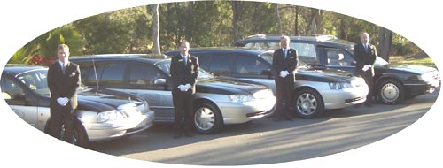
In 1977 the Connolly family experienced the death of a two year old child.
Thirty year old Phil Connolly watched in dismay as a former family friend and Funeral Director carried out the ritual of arranging and conducting the funeral. "There must be a better way," he thought. The final straw came when the Director refused to explain the contents of the abundant account and attempted to belittle him for inquiring.
Phil researched the funeral world examining processes and traditions in an attempt to simplify the funeral so ordinary people could understand the costs and why they were doing what they were doing.
In 1979 he connected with like-minded future partners Keith Russell and Vanessa Hume. This was to change the face of the funeral industry in Australia forever. After two years of operation their funeral company was conducting 3000 funerals per year. The established industry refused to take this beating and embarked on a campaign to discredit this new funeral company. Crematoria bans, union disruption, and rejection from coffin suppliers became common. Misleading national media comment was seen by the public as a sham and support spiraled.
The company became Australia's first national funeral company and enjoyed unprecedented success. Unfortunately growth has a price and a decision was carried to make the company the first of its kind to be listed on the stock exchange. A wise decision for a time but eventually the original shareholders became minority shareholders and control and ownership lapsed.
In 1989 with the vast experience of the former venture behind them the Connolly’s started afresh. Slower, more sustainable growth the target. They were determined Newhaven Funerals would give the very best service to their families and never again be subjected to unfair restriction.
To date all goals are on schedule. The company has a fast and barely sustainable growth rate, operates a crematorium, manufactures coffins, runs grief recovery / training programs and maintains beautiful memorial gardens.
All employees are hand picked for their ability to help people come out the other side of one of the hardest times in their life with minimal long term effects and maximum recovery knowledge. "If we had the choice right now, of all the funeral people in the world, I wouldn't change one staff member" said director Phil Connolly.
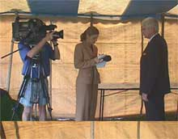 | 