Bookkeeping solutions especially tailored to suit your business.

FREE TIPS & TRICKS
- Retain all your business receipts. Especially petty cash as these can amount to several thousands of dollars a year & are tax deductible.
- Mark your business credit card ‘B’ & your personal credit card ‘P’. This a great bookkeeping time saver !
- Backup your data. Boring, Yes. But critical in the event of a hard disk crash or the loss of the company laptop !

WIN $30 AS A THANK YOU
Join us as a new client & receive 1 Hour FREE bookkeeping valued at $55.00 + GST
Alternatively, for a successful business referral we will gladly reward you with your choice of one of the following:
- 2 x Wallis cinema tickets
- 1 x $30 Officeworks voucher
- 1 x $30.00 donation to a charity of your choice.

Actif Bookkeeping
tim@actifbookkeeping.com.au
Phone 1800 227 949
Fax (08) 8125 6626
SPECIALIST
BOOKKEEPERS
A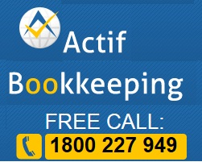


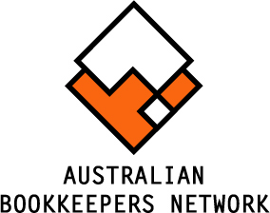

WHY USE US OVER THE COMPETITION?
- We are cost effective. Why pay for a full-time bookkeeper ? Choose the level of bookkeeping service to suit your business.
- We are registered. Since March 1, 2010 the Tax Practitioners Board has regulated that bookkeepers who provide bookkeeping for a fee must be a registered BAS Agent
- We care. We strive to deliver the highest quality of account keeping. In fact, we aim to meet the standard of account keeping your accountant would deliver.

About US
Actif Bookkeeping originally serviced a single client back in 2004. The business today supports numerous clients and is comprised of husband & wife team of Tim & Lilly Freeman and a number contracted bookkeepers selected for their advanced skills & bookkeeping knowledge.

CHOOSE A SOLUTION
There are many different accounting solutions for small business, Actif Bookkeeping supports Xero, MYOB, QuickBooks & Cashflow Manager. Depending which system you have chosen we can work with you to maximise the benefits you get from your software.
“Good record keeping can increase the likelihood of you succeeding in business”.

“ACTIF” ACCOUNTS MANAGEMENT
We believe in actively managing your business records. Hence our name “Actif” ; French for active.
By regularly updating your business records we empower you to control the critical liabilities within your business such as accounts payable (creditors), GST & PAYG .
Similarly, by regular monitoring of your accounts receivable (debtors) and management of your funds on deposit we assist you to control your cash flow, which is the life blood of your business.

Other BENEFITS
Behind with ATO, Workcover, Super ? We can liaise with these agencies on your behalf and negotiate payment plans to ease the burden of meeting your obligations.
Is Superannuation processing a headache ? We can sign you up (if < 20 employees) to Medicare’s Small Business Superannuation Clearing House and make super compliance a simple matter rather than a chore.

End of Year Reporting. Tax year end need not be stressful. With a fully reconciled set of books to supply to your accountant you should hopefully see your end of year tax preparation fees minimised.

HOW TO GET STARTED ?
We work with you to provide a solution suited to your business.
1. We offer a complimentary initial meeting
- We identify the key bookkeeping services that matter to you.
- We design & document a service that meets your requirements. This documented service can be tailored as time passes to meet the growing needs of your business.

READY TO JOIN US ?
We can definitely save you the time, hassle & stress of managing your own accounts. So why not join us today?

Free Call 1800 227 949

