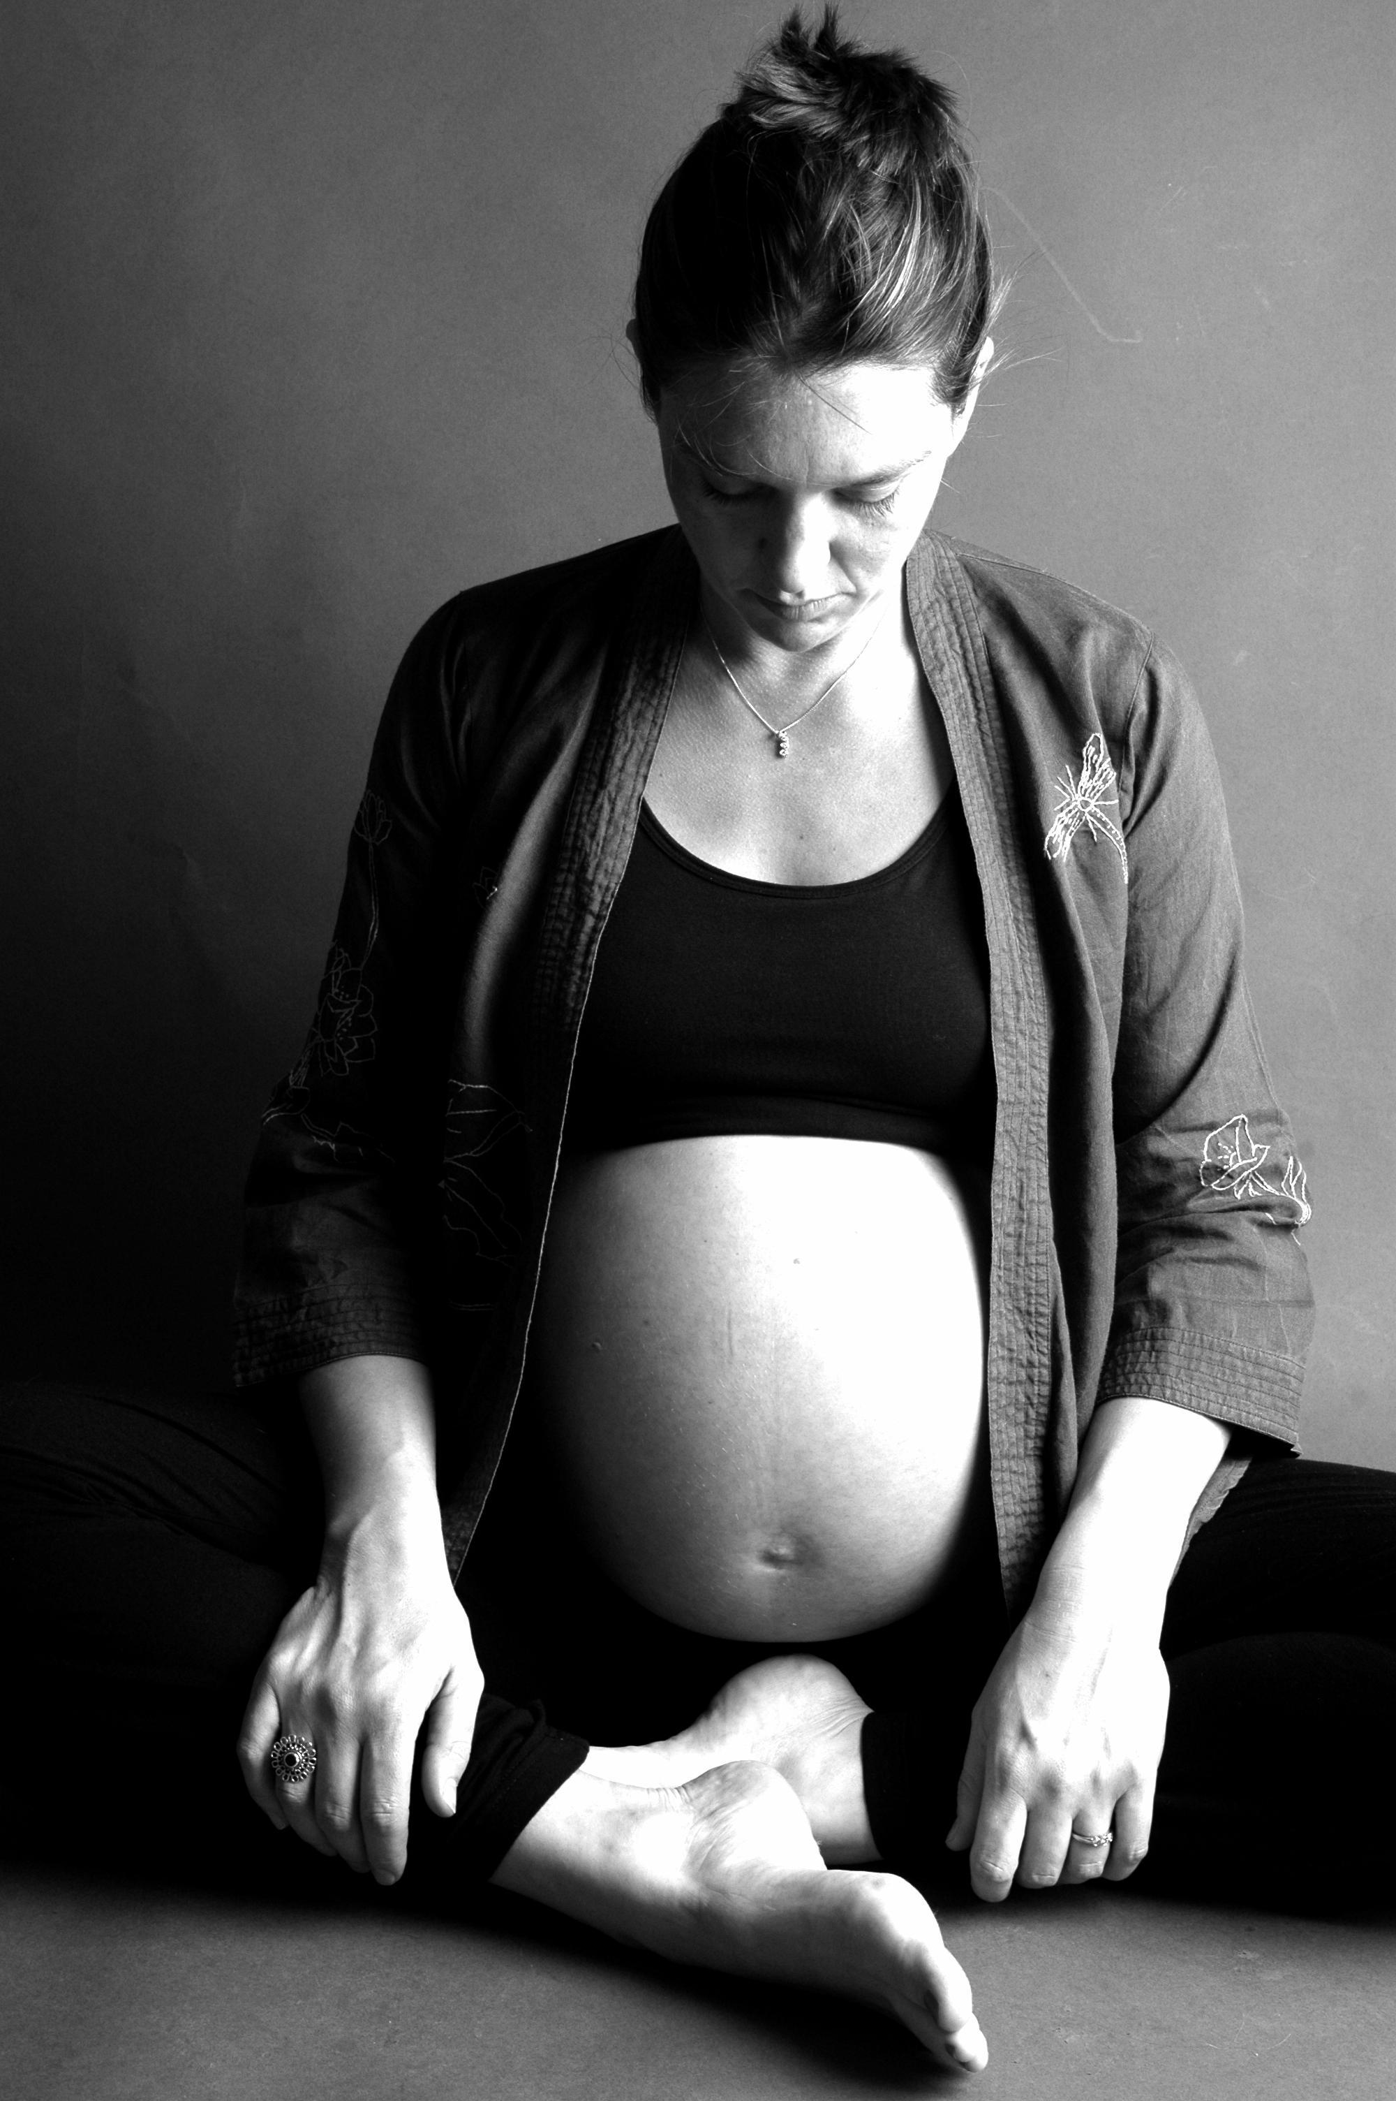

The workshop is led by Helen Macnair (BA hons, ITEC.), mother of three children, an experienced yoga teacher and senior member of the Yoga Teachers Association of Australia (YTAA). Since 1997 she has been involved in the Active Birth movement in the UK and trained as a Doula with Michel Odent, the French obstetrician who pioneered water births. She has also trained with Francoise Freedman at Birthlight.

‘I encourage women to be open to whatever happens during the birth, to keep the health and safety of themselves and the baby as their priority and to use their intuition, knowledge and yoga to enable them to have a positive birth experience.’

Aafke Woldring is an ante natal educator and early childhood nurse with Dutch midwifery qualifications. With over 20 years of experience working with women in pregnancy, labour and post natal, Aafke brings a huge resource of knowledge, practical experience and wisdom to the birth rehearsals.

Birth Rehearsal Workshop
A Yoga Birth Rehearsal is designed for women and their birth partners. A chance to focus on one of the most important events of your life.

The cost of the workshop is $80 per couple.
For more information and workshop dates
please contact Helen Macnair
4344 3936
04 3173 2143
www.bellaroseyoga.com
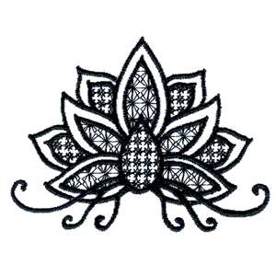
This workshop gives a practical understanding of the physiological process of birth. To help you prepare for and understand birth we outline a typical birth experience and go through a birth ‘rehearsal’ using simple breathing, movement, posture and visualizations for each stage of the birthing process to promote calm, gentle birth. You will have time to discuss ideas and concerns in a very relaxed atmosphere.
The birthing partner gets involved in a practical way and gains an empathetic understanding of what labour is like. The workshop places emphasis on gaining knowledge and understanding through practice and experience. It is important that each couple gets the chance to experience and rehearse before labour. This ensures a familiarity with, as well as a smooth and effective application of the techniques.
We finishes with a deep relaxation practice for both the mother- to- be and her birth partner that assists in the assimilation of the techniques taught.
At the end of the workshop there is an opportunity for discussion, with questions and answers and examples of coping strategies from mums who have recently birthed their babies. Refreshments are provided.

What the workshop covers:-
- How we can influence and change the birth experience.
- The physical and emotional environment.
- The signs and stages of labour.
- The female pelvis with practical ‘feel it for yourself’
- exercises.
- Contractions and how to embrace them with breath, visualization and movement.
- The advantages of upright positions.
- The role of the supportive birthing partner.
- Massage and positions for birth.
- Celebration of birth!


