About Us
Shop address: Shop 1/130 Nathan Street, Brighton 4017 QLD
ABN: 255 363 07568
Website: www.mybeads.com.au (secure online shopping).
Phone: (07) 3869 0880
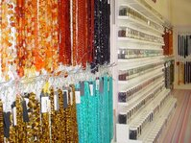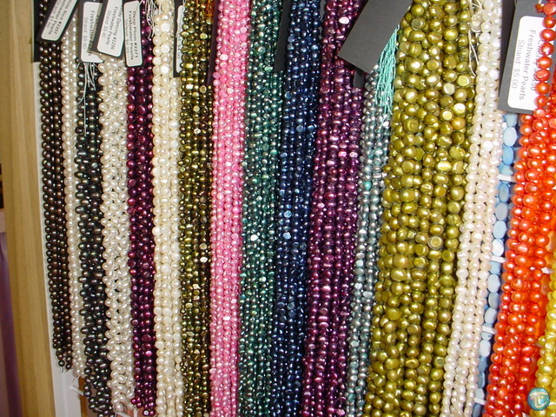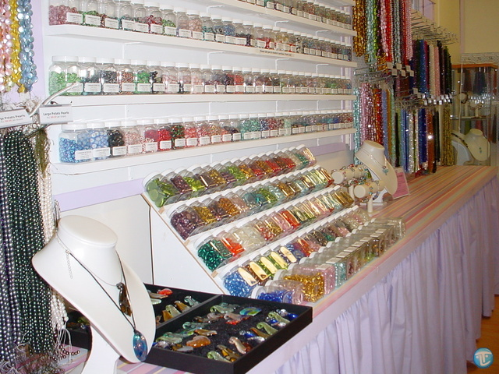

Opening Hours: Monday to Sat: 9am to 4pm. Sunday Closed.
My Beads is based in Brisbane, Australia. In 2008 we opened a retail shop on the northside of Brisbane, in Brighton. My Beads was formed in mid 2003 as an online only business, and has been growing ever since. It started small, stocking mostly hard to find gemstone beads and freshwater pearls (and to this day gemstone beads remain our specialty).
These days we stock:
- An extensive range of gemstone beads including:
  - Amethyst, Aventurine, Carnelian, Citrine, Chrysocolla, Garnet, Black Onyx, Lava, Sodalite, Jasper (Poppy, picture, fancy + more), Peridot, Aquamarine, Tigereye, Goldstone & Blue goldstone, Turquoise, Cherry Quartz, Rose Quartz, Agate (green, red, fire agate + more), Labradorite, Fluorite, Amazonite, Smokey Quartz, Howlite, Moonstone, + many more.
- crystal beads:
  - We stock our own range of genuine leaded crystal beads. Many shapes and styles, sold on the strand. Similar quality to Swarovski Crystal at a much more affordable price!
- freshwater pearls:
  - Huge range of freshwater pearls, south sea shell pearls and glass pearls. Sold by the strand for the best possible price.
- pandora style beads:
  - Sold in bulk (10pcs same bead) for resellers and market stall holders at a wholesale price. Also sold per bead if you were just wanting some for yourself or for a gift.
- lampwork beads:
  - Handmade glass beads in all sorts of elaborate and intricate designs. Beautifully handcrafted at fantastic prices. One of our specialties, huge range.
- coral beads:
  - Red coral beads sold by the strand starting at just $4.00 per strand.
- resin beads
  - Popular for the lightweight and soft feel, these look like frosted glass without the weight.
- recycled beach glass beads
  - Handmade beach glass beads recycled from old bottles. Eco-friendly and very unusual, these beads will set your jewellery apart!
- pewter charms & findings:
  - Huge range of charms and beads, buy in packs of 50pcs to get the best price.
- tools and heaps more.
Our major market is jewellery designers, resellers and market stall holders. Our prices are extremely competitive and are equivalent or lower to many other bead shop's 'wholesale' prices.
We are recommended in the book "Instant Expert Beading" by Lucinda Ganderton! | As the business continues to grow, new items are stocked frequently. By joining our newsletter you will be among the first to know when new stock arrives.  As well as having a huge range of beads, we are hoping My Beads will grow to form a valuable information source for beaders and jewellery makers. We have a growing list of great tutorials, hints and tips and a gallery. We really appreciate all contributions.  Here at My Beads, we LOVE beads. They are our life and it brings us great happiness to be able to make them part of your life too. Thank-you for reading about My Beads, we appreciate it!  NEWSLETTER! Join our mailing list to receive occasional emails containing information about new products, restocked items, promotions and specials! Click: http://www.mybeads.com.au/newsletter.html
You will also find us regularly featuring projects and products in these Australian magazines:

