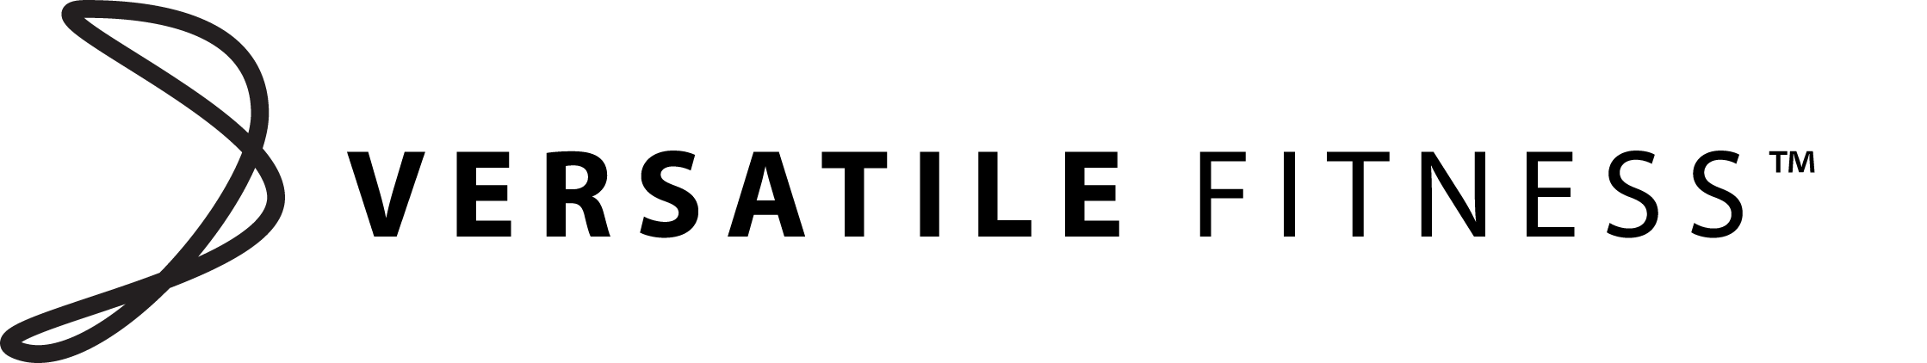

PRICE LIST

- PERSONAL TRAINING

- Quick fix package
1x 60minute session $60
1x 45minute session $45
1x 30minute session $30

- Results Package
5x 60minute session $275
5x 45minute session $200
5X 30minute session $137.50

- Maximum Results Package
10x 60minute session $500
10x 45minute session $375
10x 30minute session $250

Train with a friend for $20 Extra per session

Health Assessment/Fitness Testing $25

- GROUP SESSIONS
30 minute session $7
45–60 minute sessions $10

Kids Martial Arts 60 minute session $5
Adult Martial Arts 90 minute session $20 Casual
Adult Martial Arts 90 minute session $10 Members

$90 Annual membership applies to Martial Art classes only
No join up Fees or Contracts apply for any other classes

