
Your Cheapest Online Supplier of HSP/HISPEED/HIMOTO Radio Control Parts

Love the smell of Nitro ???

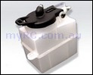  $ 5.40 |  | 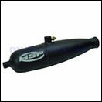  $ 7.00
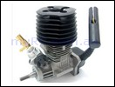  $ 99.00 |  | 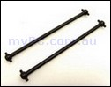  $ 5.80
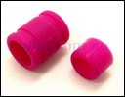  $ 3.50 |  | 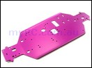  $ 18.00
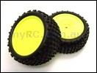  $ 16.80 |  | 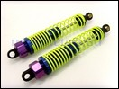  $10.80

