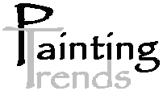
‘e x p r e s s i o n s w i t h c o l o u r’

LETTER OF INTRODUCTION

Amos Moore
Painting Contractor

Particulars:
ABN 70 948 950 148
QBuild Registration: 855390
Safety Induction No. 0296496
Public Liability Ins No. SAW003110BUS ($10M)
Income Protection: 6732558
High Risk Licnence No. 3175518
QBSA. 710358
NSW Lic. 201283c

Business:
Interior and exterior painting to all surfaces
new and old for residential, industrial and commercial sites.

- Prompt written quotations
- Reliable, honest service
- Colour Matching
- Latest vogue colours
- Premium paints
- Non-Toxic range of paints available
- Awarded apprentice of the state
- Non Smoking

Mobile: 0412 250 183
Email: paintingtrends@yahoo.com.au
Website: paintingtrends.com.au

