Civil Wedding Celebrant- Deciding on the Right One For Me

The Australian Marriage Celebrants Program was started in 1973. It allows the selection of duly eligible and entitled people to execute marriages and grants duos with a significant option to Registry Office and religious weddings. After getting registered for the course, an applicant has to convince and assure the Registrar of Marriage Celebrants that he/she is the perfect person to get registered as wedding celebrant.

A Celebrant
- Will put efforts with you to plan or decide a ceremony that gathers your requirements and replicate your needs.
- is dedicated to the maximum values of the service, and
- has enormous understanding and experience to sketch upon.

Civil wedding celebrants assist you to build up a personalise ceremony for the special day of your life by offering you broad range of ceremonies, poem readings, promises to choose from, songs, games. On the other hand, you may write something for your own ceremony. You may engage your near and dear ones in your wedding celebration. A wedding celebrant’s main aim is to make you happy and completely satisfied with your wedding ceremony, the most important day of your life. Wedding celebrant makes sure that your wedding ceremony replicates your individual requirements and ideas, and most importantly, at the same time making sure that you are meeting all legal requirements.

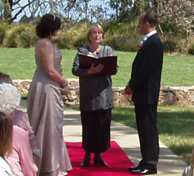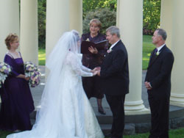
Wedding celebrant conducts your ceremony in garden, private residence, banquet halls or any particular place of your choice. This ceremony usually takes about twenty minutes to finish, as well as the signing of certificates. It is important to book your ceremony, your preferred venue and time with the wedding celebrant once you decide these details. Usually, wedding celebrant prefer to have two gatherings with you. At your first meeting, you need to fill a “'Notice of Intended Marriage”, and then wedding celebrant discusses the details about your ceremony with you. Wedding celebrant provides you a catalogue of finest options for you to read thoroughly at your leisure time.

After submitting the 'Notice of Intended Marriage' to the wedding celebrant, you will be required to submit the proof of birth, if you are a divorcee then proof of your evidence, or the death certificate of your spouse if you are a widow or widower. After completing these formalities, the 'Notice of Intended Marriage' is valid for eighteen months. You are required to complete a Declaration form, announcing that there is no legal barrier to your marriage with the partner.

Getting a wedding celebrant is an essential part of your wedding plans. You can plan meetings with wedding celebrants, better if you book your appointment before visiting the celebrant. Usually, wedding celebrants don’t cost for the discussion about your needs and requirements or you can arrange compulsory free consultation. And the wedding celebrant will give you a clear picture of the ceremony and then you can easily move to legal paperwork. Wedding celebrant will assist you in everything you require to do between now and your wedding day.

And at last, the "special day" with a ceremony that everyone will remember!

Planning your wedding ceremony with a wedding celebrant is a great choice. Wedding celebrants make your wedding day even more special by creativity. Lynne Westland is one of the best Civil Marriage Celebrants in Victoria, Australia.

Keywords: Civil Marriage Celebrants, Wedding Celebrant, Wedding Celebrants

