SYDNEY CAN NOW SMILE AGAIN

Thanks to sydney smiles dental

DR LEE AND TEAM perfectly balance your cosmetic wishes
to your clinical needs.

Sydney Smiles Dental are your local Dentists!
We offer a simple approach to solve any of your concerns by using conservative modern treatments.
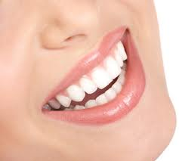
Call today for up to 50% savings on Crowns, Veneers, Bridgework Anti-Snoring and Anti-Grinding Devices

.
Visit our website below to benefit from
the best deals on all things Dental and proven products:
www.sydneysmilesdental.com.au
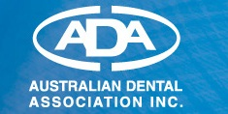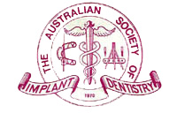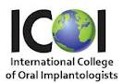
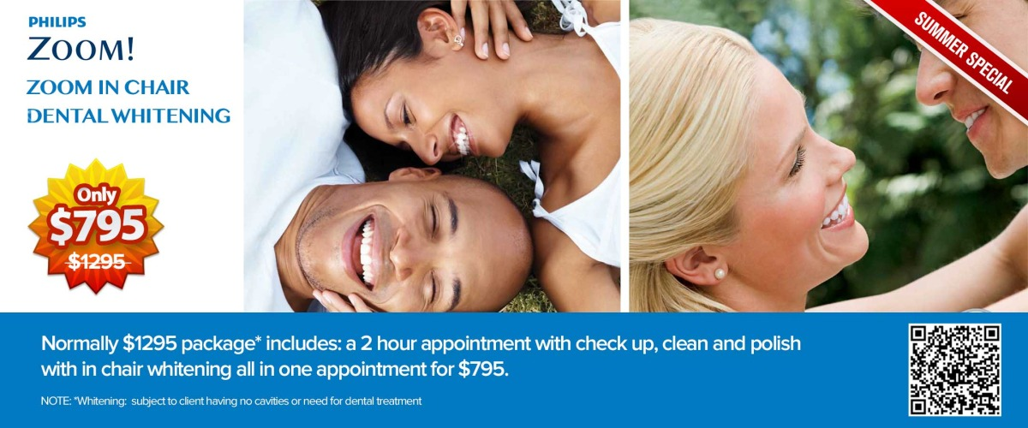

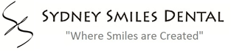

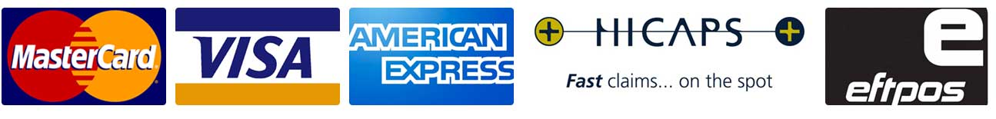



TAKE HOME WHITENING
ONLY $395!

Bring a friend & you’ll only pay $350 each.


cosmetic consultation
We can help you with your Dental needs.
Simply call today: 9410 2001

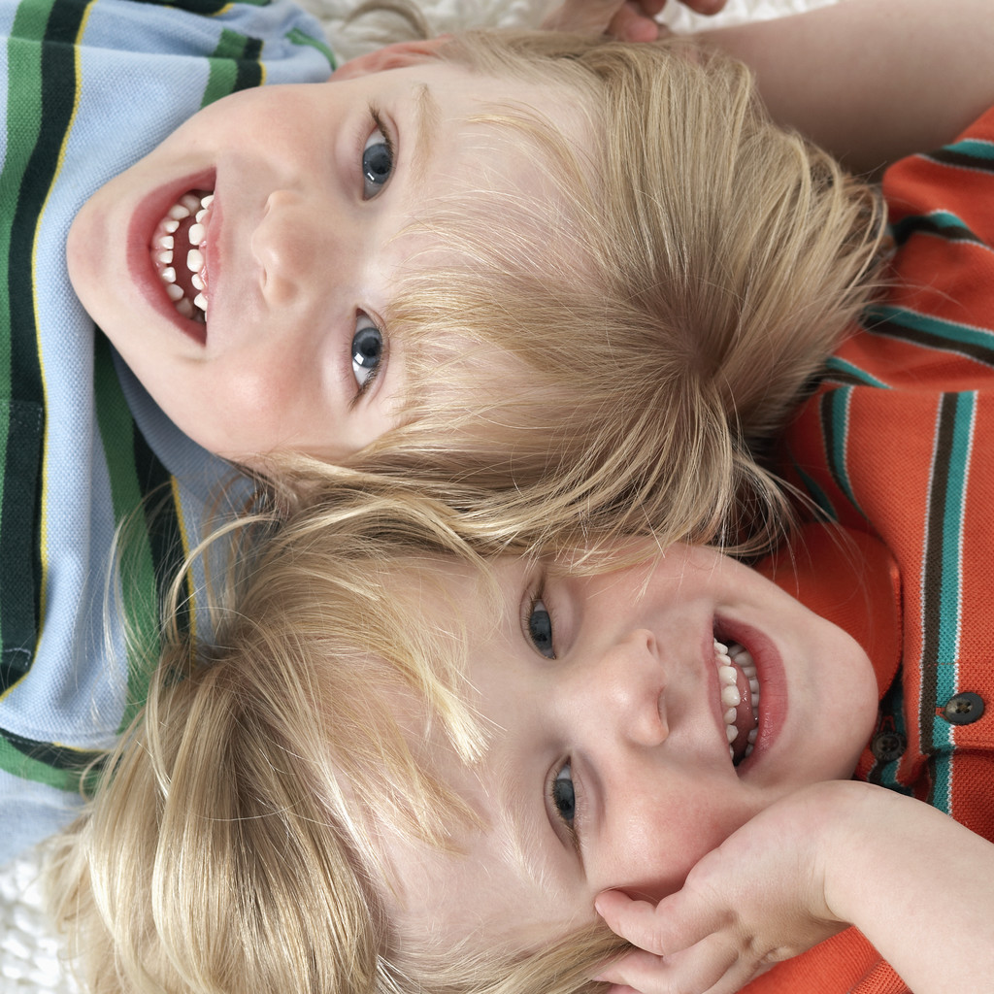
FAMILY DISCOUNT PACKAGES
Pay for an adult check up and clean and you get 50% off your child’s first appointment.

Credit cards and HICAPS Facilities
At Sydney Smiles Dental we have EFTPOS and HICAPS facilities for faster claims through your private health funds. *AMEX will attract a 2% surcharge

At Sydney Smiles Dental we understand that dentistry can be expensive. Dr Marcel Lee and team have made their services and expertise available so you can save. Members of the Smile.com.au and the interest free GEM VISA groups save on dental fees.
All you have to do to start saving money is to go to www.smile.com.au and www.gemvisa.com.au and see for yourself or phone us on: 94102001.
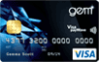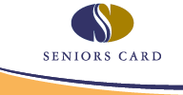

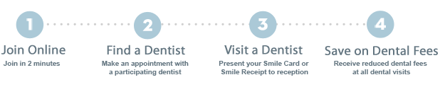


High Quality Dental treatments made affordable for everyone!

- Oral Hygiene fresh breath packages
- Crown and Bridge Work
- Anti-Snoring Devices
- Invisalign- Invisible braces
- General and Cosmetic treatments
- Dental Implants
- Teeth Whitening
- Wisdom tooth removal
- Sleep Dentistry
- Gum (periodontal) disease treatment
- Root canal Therapy
- White fillings
- Amalgam (metal) filling replacement
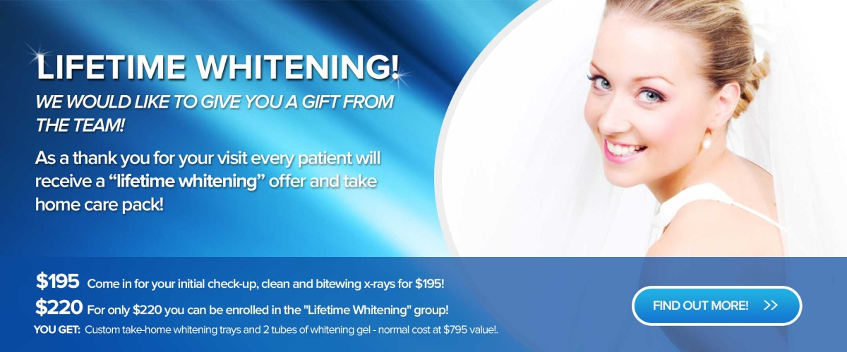
- Emergency same day appointments

T&Cs * Occasionally there may be further work required before the chosen treatment package can begin, your Dental professional will let you know your options. See website for full T&Cs

Opening Hours:
Mon: 8:00am - 7:00pm
Tue: 8:00am - 7:00pm
Wed: 8:00am - 5:00pm
Thu: 8:00am - 7:00pm
Fri: 8:00am - 5:00pm
EMERGENCY SERVICES AVAILABLE P: 9410 2001

Weekend & Public Holidays:
*Please phone before 9pm to leave a message with our emergency dentist, he will get back to you. If it is an emergency that cannot wait for a reply, phone your local emergency medical centre or hospital (Please phone for emergency call out fee information).

Easy to get to location:
CHATSWOOD:
Ground floor, Suite 4,
7 Help Street, Chatswood NSW 2067
PH: (02) 9410 2001
EMAIL: reception@ssd.com.au
WEBSITE: www.sydneysmilesdental.com
© 2012 Sydney Smiles Dental. All rights reserved.
At Sydney Smiles Dental, we proudly support our local laboratories.

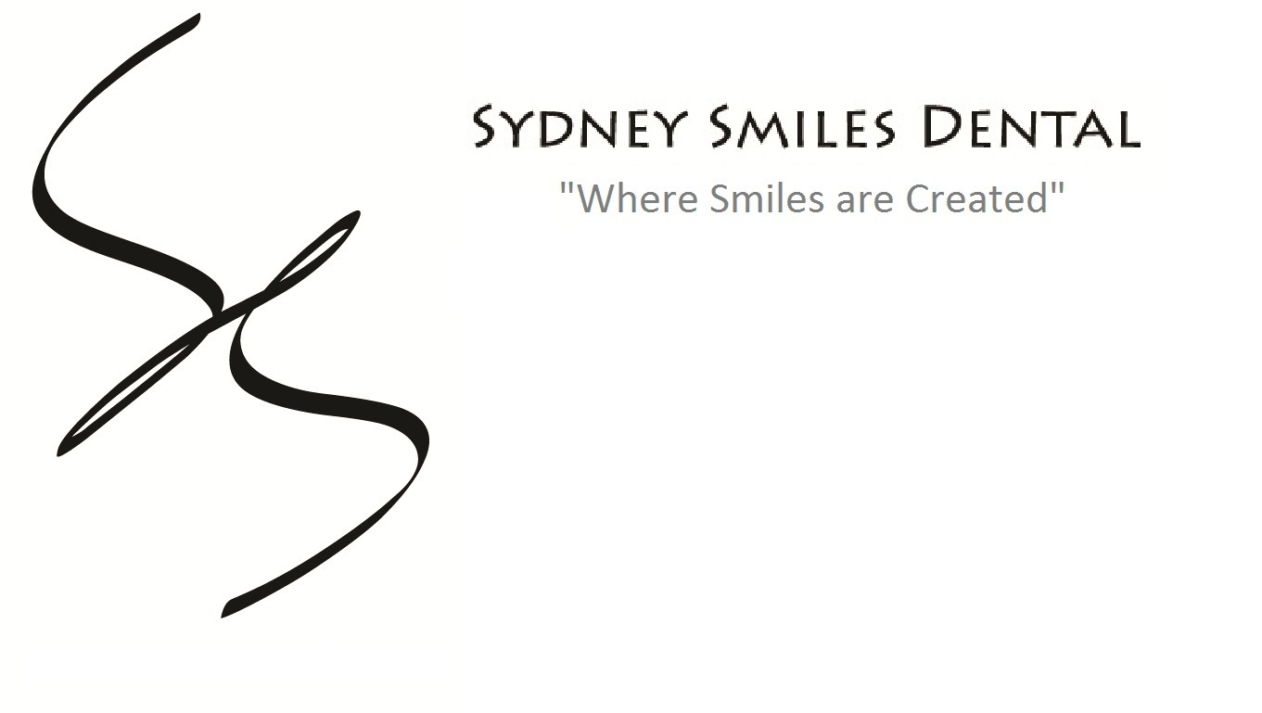

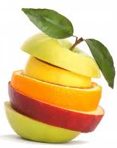
WHERE THE LOCALS GO FOR GREAT DEALS ON EVERYTHING DENTAL!
Start Saving
PHONE TODAY:
02 9410 2001
We offer Preferred Provider* prices to
ALL Health Fund members

