Gregory Neal A-Class Electrician
Registered Electrical Contractor 11515
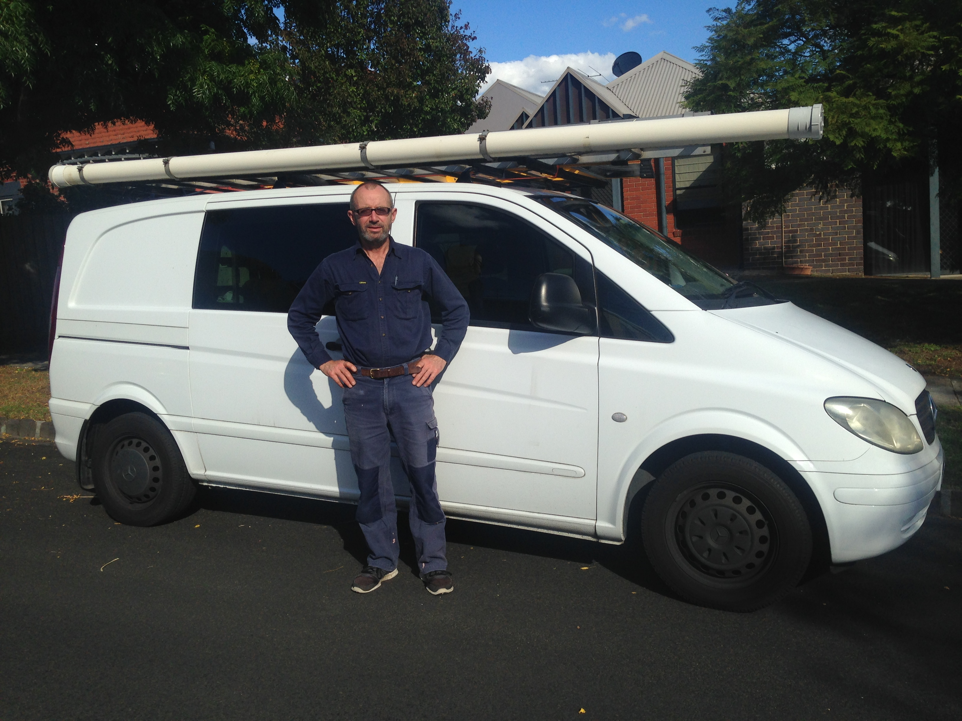
Ph 0428622304 createlx@tpg.com.au
Wahroongaa Road Murrumbeena

- All types of electrical work, repairs, fault finding, maintenance, alterations and additions
- Over 25 years’ experience, Energysafe registered
- Communications and data cabling (TITAB registered)
- TV antennas and audio visual cabling
- Appliance repairs- hot water, stove and ovens
- Emergency Lighting and Testing & Tagging appliances
- No job too small
- Well stocked vehicle to save your time & money
- Detailed itemized invoice provided for all jobs
- Normal Charge out rate $70.00 per hour + GST
- Free Detailed Job Estimates for Jobs over $500
Give me a call or email to discuss your electrical needs

