A Home Brimming with Love, Laughter, Happiness
& the Padding of Tiny Feet!!!!

What a joyous occasion when Pietro and Vicki formally committed their love to each other, with family and friends as their witnesses, in the lovely setting of their beautiful house and garden….

In this Sanctuary they have established together and made their home, what more fitting than to seal their love and pledge to be there for each other as they journey through life as husband and wife.

Adding to the magic of this day, an even greater celebration!!!

Their little darlings, their precious prince, Alexander and sweet princess Isabella were welcomed into the wider family unit, their Circle of Friends and the World. In ceremony, the children were each given their chosen names, which they have made their own, infused with their uniqueness, personality and zest for life….


We mustn’t overlook the fact that in Pietro and Vicki’s garden a mystical and gorgeous Crepe Myrtle tree stands sentinel to their home.

It has long been recognized that the “Myrtle flower is associated with simple, uncomplicated love and marital fidelity.”

It is also believed the “Myrtle blossoms symbolise good luck in relationships, prosperity and a long happy life”.

The blossoming of the Myrtle on this auspicious day does auger well for our couple and their family, as
Mother Nature in all her glory, through the beautiful Myrtle has blessed Pietro and Vicki’s happy union, as well as the gift of their love, their precious children…..
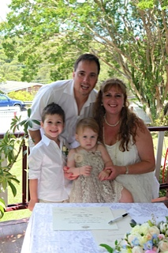
Congratulations Vicki, Pietro, Alexander and Isabella!!!!

© Jenny Butler-Grech CMC.,JP

