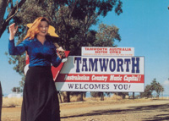
Welcome to Tamworth Country Music Capital

Confidently marching through its third decade demonstrates musically, the importance placed by Australians on celebrating, learning and participating in the unique and envied essence of being Australian.

Nationally acknowledged as a hallmark event the official ten day period draws over 50,000 visitors who are entertained by a wide range of musical genres all housed comfortably under the very exceptional umbrella that is called Country Music.
The Tamworth Country Music home for 33 years to the Australian Country Music Family has long left behind its “hicky” and sometimes laughed at image. It is mainstream, it is acknowledged and admired world wide. Its Professional Performers are comfortable and are welcomed touring outside of Australia. Nashville significantly respects Aussie Singers and Songwriters welcoming their inter-change of ideas and skills.
The country music family is held in high esteem by the nation with members recognised at high profile levels. Australia’s revered icon and major pioneer of the Australian CM Industry the late Slim Dusty was one of the inaugural National Treasures along with the loved by all Jimmy Little. More recently Ted Egan was appointed to the important office of the Chief Administrator of The Northern Territory.

Places of Interest

Tamworth Town Hall

Tamworth’s famous War Memorial Town Hall has seen just about every Australian country music act grace its stage over the years, from household names like Slim Dusty and John Williamson to many young stars who are featured every year in a number of concerts during the Tamworth Country Music Festivals.

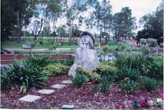
Bicentennial Park

The beautiful parkland setting is the ideal setting for the annual open air concerts, if you are going to attend these concerts you are urged to bring along folding chairs or blankets.

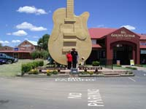
Golden Guitar Souvenir Gift Shop

You can’t miss seeing Tamworth’s famous “Big Golden Guitar” on the Sydney road and right behind it you’ll find the aptly named Golden Guitar Souvenir Gift Shop, where you’ll be able to buy just about anything to do with country music, from T-shirts to key rings, from CD’s to posters. In fact, about the only thing you won’t be able to buy here is a real Golden Guitar statuette—but there’s a couple on display in the famous Gallery of Stars Wax Museum. There are over 20 magnificent life size wax figurines in the Gallery and there’s plenty of history to go along with the stunning figures.

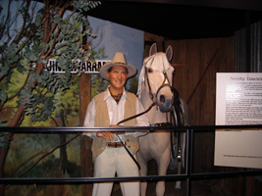
Walk A Country Mile

Australian Country Music is full of great stories, events and stars and the Walk A Country Mile Interpretive Museum in the Tamworth Regional information Centre gives you the chance to see, and hear , a lifetime of great music, memories and “hands on” facts via the touch screen computers. The museum is open every day from 10am to 4.30pm.

Hands of Fame/Coca Cola Park

At around 9.15am on the last Saturday the ACMF will induct another group of country music personalities into the Hands of Fame Gallery.

West Tamworth League Club

The biggest club in Tamworth is the West Tamworth League Club and has by far the biggest program during the Tamworth Country Music Festival. Beside its indoor venues, Blazes and Legends—the club has a number of outdoor venues and all up you’ll find just about every kind of country music you can think of.

Tamworth RSL Club.

The Tamworth RSL Club has long been known as “The Home Of Country Music” and will feature a number of great shows in the upstairs auditorium as well as a full line up of free shows downstairs in the Lounge Bar.

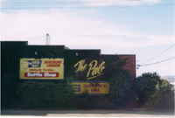
The Pub

You’ll find the Pub on the Gunnedah Road, where you’ll find the best in free entertainment in the acoustically designed music area. The Pub has an awesome reputation for presenting some of the finest Australian songwriters and singers. Another feature of the Pub’s entertainment roster are the special shows that are by now a traditional part of the program. Like Stuey French’s VB Pickers Night, these gigs attract some of the best pickers and singers along for a song or two, so be sure to get in early, because it is usually “standing room only”.

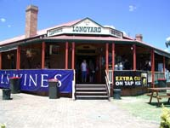
The Longyard

The Longyard Hotel is almost an institution on the Tamworth Country Music Festival Calendar and you will find plenty of great acts there.

Locomotive Hotel

The Locomotive Hotel—affectionately known as “The Loco” can be found tucked away in William Street and its three performance spaces have plenty of great shows to keep everyone entertained. The footpath stage is the home of the famous Drunk But Not Intoxicated Talent Quest every day.

Southgate Inn

The Southgate Inn has two performance venues - The Gate Bar and the Scully Room—and there’s plenty of action to be found in both. The Scully Room is one of the best venues in Tamworth and attracts some of the best acts around.

History of the Awards.

The Australasian Country Music Awards were first staged in 1973. Planned and organized by local radio station 2TM, the awards were scheduled for the January Australia Day long weekend. January, considered to be the hottest time of the year, appealed to 2TM because of a number of reasons. Firstly there was already a small country talent quest being run at that time of the year and secondly the radio station felt it could handle the added pressure in January because it was considered to be a quiet time. They also felt the long weekend was a good time for travellers and finally they believed that the media would be able to concentrate on the festival giving it more publicity because of the lack of hard news during the holiday period. 2TM ran a radio program called Hoedown” and it was through this that they were able to promote and build on the awards. Word spread and Tamworth became a name that was widely recognized throughout Country Music circles. The awards became so successful that in 1978 they were moved from the small Town Hall to a huge Marquee which had the capacity to seat 5,000 people. Other activities were added and complimented the overall festival atmosphere. The festival grew from a two day event to a ten day event due to the increasing interest. Currently the population of Tamworth swells with approximately 50,000 visitors staying for an average of two weeks. Visitors travel from all over the world to enjoy the atmosphere and great country music. Some of these visitors are long time fans increasingly, many of them are brand new to the experience. Whether you are one of the faithful or someone wishing to discover this magic event, Tamworth will extend you a warm welcome. 2TM was considered to be at the centre of the festival. Their professionalism and insight is what has made the awards. When the Tamworth City Council became involved they also worked alongside 2TM. Sponsorship sought by 2TM immensely helped promote the festival. In 1992 2TM ran their last awards before handing the event over to the newly formed Country Music Association. The awards major sponsor is Toyota Australia. In 1994 Tamworth City Council took on an increased responsibility for the event by employing a management team to handle all publicity. Over the years many new involvements have helped the awards continually grow. It is an excellent example of what can be achieved by the private sector. The awards were given no assistance by the Government and despite this benefits for the community of Tamworth have been created. So you see it’s no coincidence that the Country Music industry calls Tamworth home. Every January the best performers in the country and their fans come to Tamworth for 10 days of non-stop entertainment.

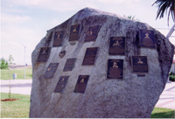
Roll of Renown

The roll of renown was established two decades ago to pay tribute to those country artists who have made a major contribution to Australia’s musical and cultural heritage. It’s first two plaques honoured Tex Morton and Buddy Williams and it has since paid tribute to artists like Slim Dusty, Jimmy Little, Reg Lindsay, Smokey Dawson, Stan Coster and many more.

Golden Guitar Awards.

The Golden Guitar is the Country Music equivalent of the Oscar or the Logie: the industry’s highest accolade for its most successful artists and the symbol of achievement in the fastest growing sector of the Australian music industry.

Golden Guitar Award Tickets.

Cross Country Express has placed aside a number of Tickets for this gala awards night. So don’t forget for the best seats in the house at the Golden Guitar awards

