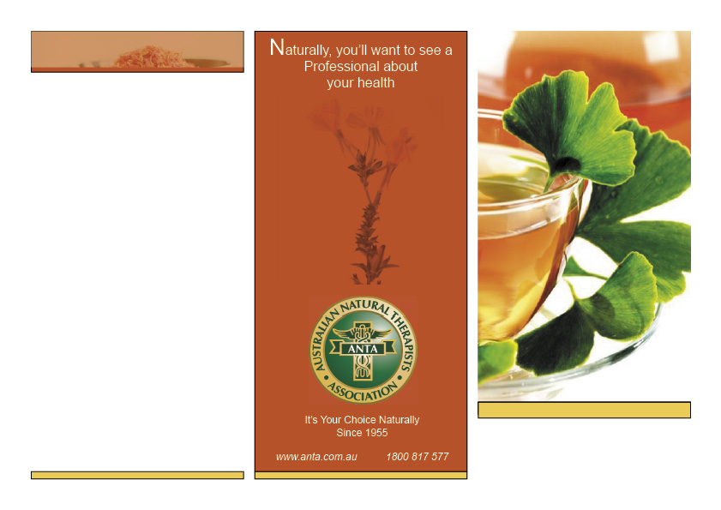
Why the Naturopath is Successful When Treating?

The Naturopath treats the cause and not just the symptom, therefore treating all conditions in this manner. Orthodox practitioners and Naturopathic Physicians work hand in hand when a mechanical injury or emergency arises.

Naturopathy does not interfere with orthodox prescriptions and procedures; rather, it is vital for a person to seek Naturopathic Medicine to enhance the immune system, detoxifying any unwanted poisons whilst the whole person is re-constituting.

6 PRINCIPLES OF NATUROPATHIC MEDICINE
FIRST, DO NO HARM: Use the most natural, least invasive and least toxic therapies first.

IDENTIFY AND TREAT THE CAUSE: Look beyond the symptoms to effectively address the underlying cause(s) of illness.

THE HEALING POWER OF NATURE: Trust in the body’s inherent wisdom to heal itself.

TREAT THE WHOLE PERSON: View the
body as an integrated whole in all its physical
and spiritual dimensions.

DOCTOR AS TEACHER: Educate patients in the steps to achieve and maintain optimal health.

PREVENTION: Focus on promoting health and wellness, and preventing disease.

Four Seasons Natural Health Clinic

314 Heaths Road,
Hoppers Crossing Vic 3029

Tel: 03 9749 8125
Email:naturesbalm@gmail.com
Hours:
Monday – Tuesday 9am-8pm
Wednesday Closed
Thursday – Friday 9am-8pm
Saturday – 9am-5pm
Sunday - Closed

Healing Power of Nature
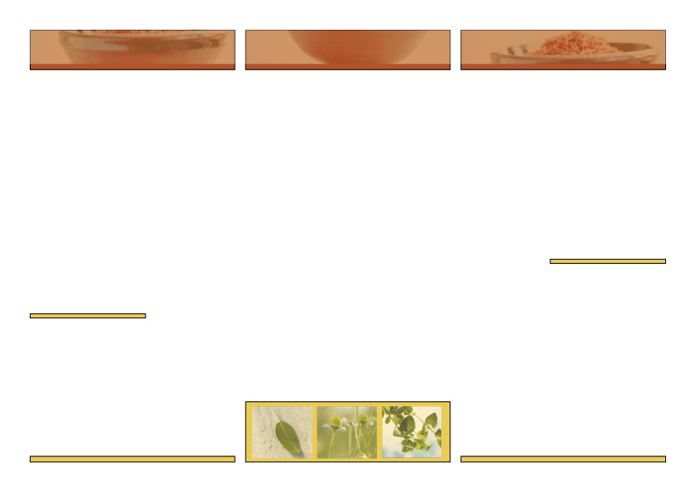
as external influences.

Naturopathy comprises a range of modalities such as Nutrition, Herbal Medicine and Homoeopathy. As part of a treatment plan the Naturopath may also suggest nutritional supplements, herbal medicines or homeopathic preparations when designing a patient’s individual treatment program.

Naturopathy is gaining recognition as a part of the Australian health care system. The wholistic approach used by Naturopaths to the prevention and treatment of all disease states, is now being recognised by many medical practitioners.

Four Seasons Natural Health Clinic is a newly established naturopathic clinic that focuses on natural healthcare for men, women and children, from birth into old age.
The clinic modalities include Naturopathy, Herbal Medicine, Nutrition, Homeopathy, Iridology, Mineral Therapy, Flower Essences and Scientific Health analysis.

Women’s health issues treated include:

What is an ANTA Accredited Naturopath?

Your ANTA accredited Naturopath is a health care professional trained to a high competency in the art and science of ‘nature cure’. There are currently no government requirements for Naturopaths to meet any minimum standard of training, therefore when selecting a Naturopath you should ensure they belong to a bona fide association such as the Australian Natural Therapists Association (ANTA), which maintains high standards and has been accrediting Naturopaths and other natural therapy practitioners since 1955.

Gynaecological or hormonal problems, menstrual problems, fertility issues, pregnancy, lactation problems, approaching menopause, and emotional or mental issues.

Men’s health issues treated include:

Prostate problems, fertility issues, erectile dysfunction, cardiovascular problems i.e. high cholesterol and high blood pressure,

General health issues treated include:

Chronic health conditions, elevated cholesterol, high & low blood pressure, anaemia, digestive problems, sleeping
problems, arthritis, joint and bone problems, gout, muscular problems, recovery from surgery or injury, depression, emotional and mood problems, skin disorders such as eczema, acne and shingles, colds and flu, headaches, bladder infections and toxin exposure and many other health conditions.

Children and infants health issues treated include:

Teething & dentition problems, behavioural problems, learning difficulties, colds & flu, skin problems, nappy rash, chicken pox and other common illnesses.

What is Naturopathy?

Naturopaths use a range of non-invasive diagnostic techniques to assess the causative factors of a patient’s health problems. It is not necessary for the Naturopath to name a disease as the wholistic approach looks at the physical, mental and emotional aspects, the function of the various systems of the body as well

