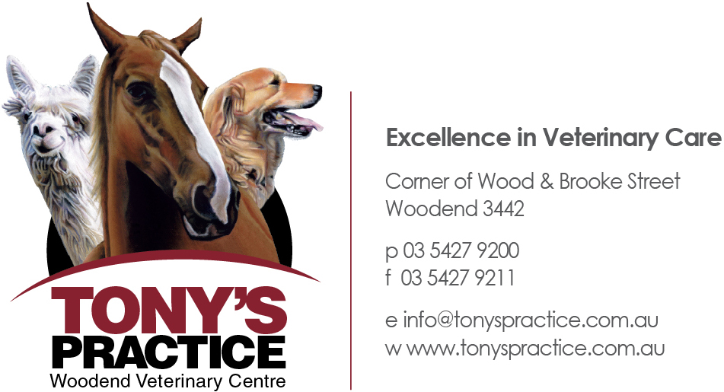

Tony's Practice is a mixed animal Veterinary Centre situated in the heart of the Macedon Ranges in the township of Woodend. We care for all small animals, horses, alpacas and farm livestock.

At Tony's Practice, we are committed to quality of care. We are particularly sensitive to this concept as we are only to aware of how important your animals are to you. For this reason, we make twice the effort. We understand that the service we offer is an intrinsic part of your animal's health.

Our mission at Tony's Practice is to deliver EXCELLENCE IN VETERINARY CARE in a friendly, personalised and caring environment. We aim to provide the highest quality care to our patients, where the genuine concern, care and comfort of our clients and their animals are our priority.

Why choose Tony's Practice to care for your animals?
- We have 5 vets with over 55 years of experience between them
- We are able to care for all animals including horses, small animals, alpacas and farm livestock
- We offer 24 hour emergency care, 7 days a week, 365 days of the year so that your animal can be cared for at any time of the day or night.
- We invest in the latest diagnostic equipment including, digital x-ray, digital ultrasound and blood machine so that we can offer the best possible care to your pet with immediate results
- State of the art premises including a small animal centre and an equine facility

Features |  | Benefits
Reception area with designated cat and dog areas | which means that | Separate areas for dogs and cats to feel comfortable
A children's play area | which means that | Children have activities to do whilst their pet is visiting our centre
Two consultation rooms | which means that | Waiting times will be reduced between consultations
An outdoor area adjoining the reception area | which means that | Animals that are uncomfortable or nervous in reception have an outdoor area to feel more comfortable
A grieving room | which means that | Clients have a designated room in which to spend time with their pet prior to euthanasia and afterwards
A cat boarding area | which means that | When clients go on holidays, they can rest assured that their cat is well looked after by our team of vets and nurses
Separate dog and cat recovery areas | which means that | There is less stress to animals post procedure/surgery
Two surgeries | which means that | Routine surgeries can be performed as well as visiting specialist surgeons
Treatment room | which means that | The room is separate to surgery where procedures, eg dentals can be performed and emergency cases can be seen
Alpaca run | which means that | There is a separate area for holding alpaca's pre and post treatment
Grooming room | which means that | Pets can be kept clean and cool in summer, preventing grass seeds, as well as keeping their coat in top condition. Pets that require sedation for grooming are cared for by our veterinary team
Anaesthetic machines | which means that | Patients can be quickly and safely anaesthetised for procedures
Cardiac and respiratory monitors | which means that | Patients can be carefully monitored under anaesthesia and problems can be detected quickly
Digital x-ray | which means that | Instant and clear pictures for immediate diagnosis. Images can be emailed or burnt to CD
Ultrasound | which means that | Instant and clear pictures for immediate diagnosis. Images can be emailed or burnt to CD
In house blood machine | which means that | Diagnostic results can be achieved more quickly, particularly in an emergency situation
Dental equipment | which means that | Dental procedures can be done effectively to prevent dental disease and pain
On-site parking areas | which means that | Easy access to and from reception, including disabled and emergency parking

The Features and Benefits of our Equine Centre

Features |  | Benefits
Stables x 8 | which means that | Horses can be hospitalised for continued treatment and monitoring. This is also more cost effective for the client, saving on travel costs for horses that need to be monitored daily, etc
Crush | which means that | Clients who do not have a crush can bring their horse to us for breeding and other procedures. The priority is safety for our staff, your horse and you
Mare and foal stable | which means that | A sick mare and foal can be comfortably accommodated in the hospital for treatment
Knock down box | which means that | Surgical procedures can be performed in a clean and safe environment
Lunging area | which means that | Lameness examinations can be safely and thoroughly carried out on-site
25m Trot up area | which means that | Lameness examinations can be safely and thoroughly carried out on-site
On site parking for car and float | which means that | Direct access to and from the Equine facility for horse and owner. Horses can be safely taken off floats and moved directly to the appropriate area

