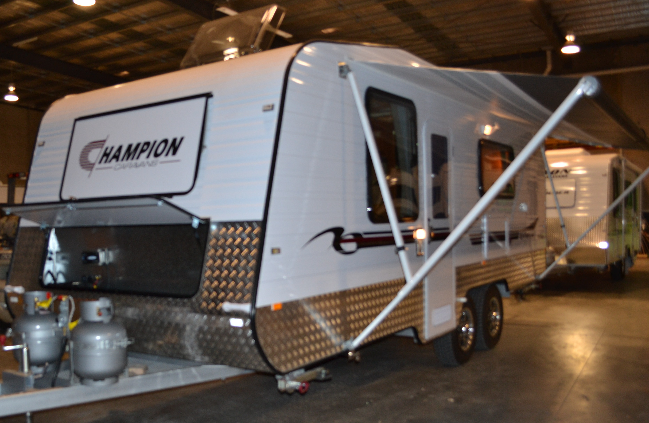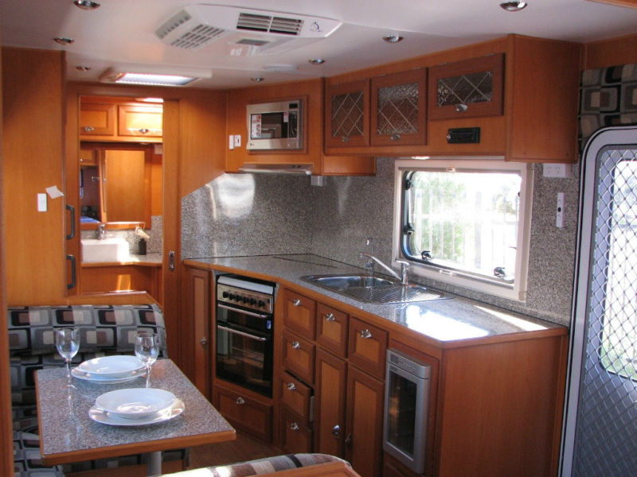
Champion Caravans
Floor Plan Layouts
Here at Champion Caravans we deal direct with the public to ensure you get the absolute best value when purchasing your new caravan. We specialize in custom designs at an affordable price. We will produce an engineered CAD (Computer-Aided Design) drawing layout of your caravan to ensure that you receive exactly what you require. We offer a 12 month Australia wide warranty on all our vans as well as a full maintenance inspection at 6 six months from date of purchase.
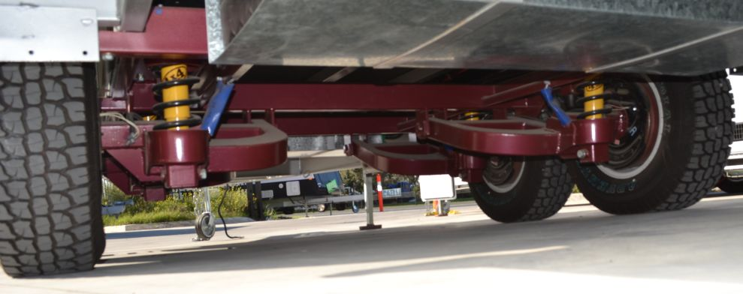
Included In All Our Caravans
Free 1x120 Watts solar panel with digital regulator

DAZZLING 22’ I

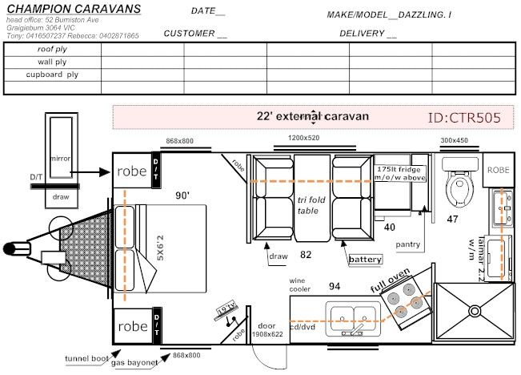
Chassis Exterior
- 6” A-frame - Tunnel boot
- 4” Main Chassis - Roll out awning
- Tandem Axle - Pull Out Step
- 10” brakes - Ibis, reverse cycle Air Conditioner
- 4 x drop down stabilizing legs - 12V fans in shower
- Heavy duty 2-arm bumper - 1 X Mini Sky Light Hatch
- 1 x 4 Season Hatch in bedroom
Plumbing - Picnic Table
- 2 x 95L Water tanks - 2 x Speakers
- 23L Suburban Gas/240V Hot water Service - European Windows (Double Glazed)
- Ensuite Toilet and Shower Interior
- Flick mix taps throughout - Caffee dinette
- Tap on A-frame - Stove. Grill & Full Oven
- Mains pressure in - Recessed lid over stove
- Lockable water filler - 12V rangehood
- 2 x 9kg gas bottles - Lead Light Glass in Overhead Cupboards
- Gas bayonet - Waeco Six Bottle Wine Cooler
- 2.2kg Top Loader Washing Machine - Deep bowl stainless sink
- Queen size bed on gas assisted lift up frame
Electrical - Inner spring mattress
- Break away controller - Full pantry
- 2 x 100amp battery & Charger - Stainless front microwave
- Battery Protector - Dometic 184L, 2-door, AES, 3-way fridge
- External 240V, 12V, TV point
- Wineguard Antenna
- External LED clearance and tail lights
- CD/DVD/Radio player
- 19” LCD Wide screen
- 4 x internal speakers
- Internal LED down lights PRICE $57,850
- Solar Wiring with digital regulator
DAZZLING 22’ II

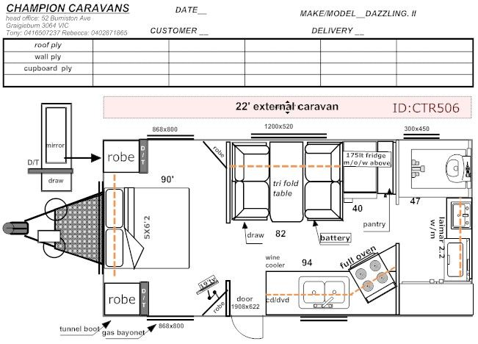

Chassis Exterior
- 6” A-frame - Tunnel boot
- 4” Main Chassis - Roll out awning
- Tandem Axle - Pull Out Step
- 10” brakes - Ibis, reverse cycle Air Conditioner
- 4 x drop down stabilizing legs - 12V fans in shower
- Heavy duty 2-arm bumper - 2 X Mini Sky Light Hatches
- 1 x 4 Season Hatch in bedroom
Plumbing - Picnic Table
- 2 x 95L Water tanks - 2 x Speakers
- 23L Suburban Gas/240V Hot water Service - European Windows (Double Glazed)
- Toilet and Shower Combination Interior
- Flick mix taps throughout - Caffee dinette
- Tap on A-frame - Stove. Grill & Full Oven
- Mains pressure in - Recessed lid over stove
- Lockable water filler - 12V rangehood
- 2 x 9kg gas bottles - Lead Light Glass in Overhead Cupboards
- Gas bayonet - Waeco Six Bottle Wine Cooler
- 2.2kg Top Loader Washing Machine - Deep bowl stainless sink
- Queen size bed on gas assisted lift up frame
Electrical - Inner spring mattress
- Break away controller - Full Pantry
- 2 x 100amp battery & Charger - Stainless front microwave
- Battery Protector - Dometic 184L, 2-door, AES, 3-way fridge
- External 240V, 12V, TV point
- Wineguard Antenna
- External LED clearance and tail lights
- CD/DVD/Radio player
- 19” LCD Wide screen
- 4 x internal speakers
- Internal LED down lights
- Solar Wiring with digital regulator PRICE $57,850

SUMMER 21’6 FT
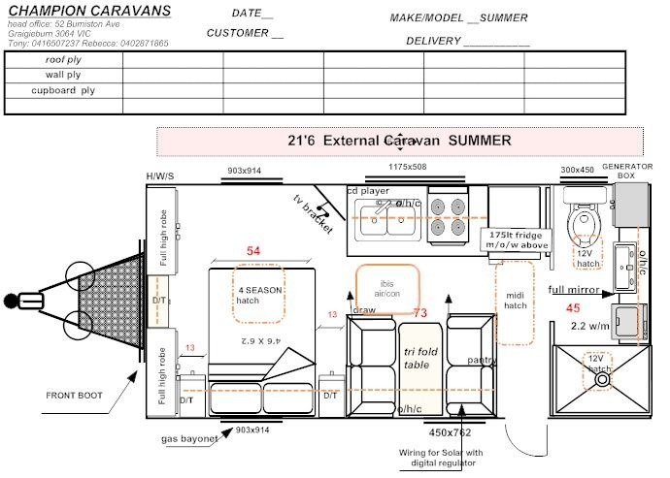
Chassis Exterior
- 6” A-frame - Front boot
- 4” Main Chassis - Roll out awning
- Tandem Axle - European Windows
- 10” brakes - Ibis, reverse cycle Air Conditioner
- 4 x drop down stabilizing legs - 2 x 12V fans in ensuite
- Heavy duty 2-arm bumper - 1 X Mini Hatch
- 1 x 4 Season Hatch in bedroom
- 2 x Speakers
- Picnic Table
Plumbing Interior
- 2 x 95L Water tanks - Caffee dinette
- 23L Suburban Gas/240V Hot water Service - Full Oven
- Ensuite toilet and Shower - Recessed lid over stove
- Flick mix taps throughout - 12V rangehood
- Tap on A-frame - Dometic 175L, 3-way fridge
- Mains pressure in - Deep bowl stainless sink
- Lockable water filler - Double size bed on gas assisted lift up frame
- 2 x 9kg gas bottles - Inner spring mattress
- Gas bayonet - Slide out pantry under bench
- 2.2kg Top Loader Washing Machine - Stainless front microwave

- Electrical
- Break away controller
- 2 x 100amp battery & Charger
- External 240V, 12V, TV point
- External LED clearance and tail lights
- CD/DVD/Radio player
- 19” LCD Wide screen
- Wineguard antenna
- 4 x internal speakers
- Internal LED lights PRICE $56,500
- Solar Wiring with digital regulator
MAIYA 19’6 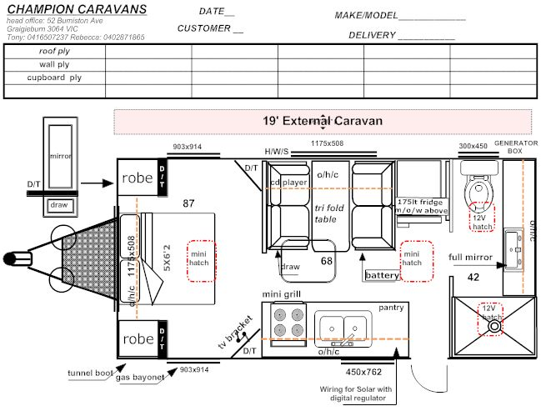
Chassis
- 6” A Frame Exterior
- 4” Main Chassis - Tunnel Boot
- Tandem Axle - Checker plate front and sides
- 10” brakes - Roll out awning
- 4 x drop down stabilizing legs - European Windows
- Heavy duty 2-arm bumper - Ibis, reverse cycle Air Conditioner
- 2 x 12V fans in ensuite
Plumbing - 2 Mini Hatches
- 2 x 95L Water tanks
- 23L Suburban Gas/240V Hot water Service Interior
- Ensuite toilet and Shower - Caffee dinette
- Flick mix taps throughout - Mini Grill
- Tap on A-frame - Recessed lid over stove
- Mains pressure in - 12V rangehood
- Lockable water filler - Dometic 175L, 3-way fridge
- 2 x 9kg gas bottles - Deep bowl stainless sink
- Gas bayonet - Queen size bed on gas assisted lift
- up frame
Electrical - Inner spring mattress
- Break away controller - Slide out pantry under bench
- 1 x 100amp battery & charger - Stainless front microwave
- External 240V,
- External LED clearance and tail lights
- CD/DVD & Radio player
- 19’ LCD Wide Screen
- TV Brackect
- Wineguard antenna
- 2 x internal speakers PRICE $47,000
- Internal LED lights
- Solar Wiring with digital regulator

YIANNIS 18’
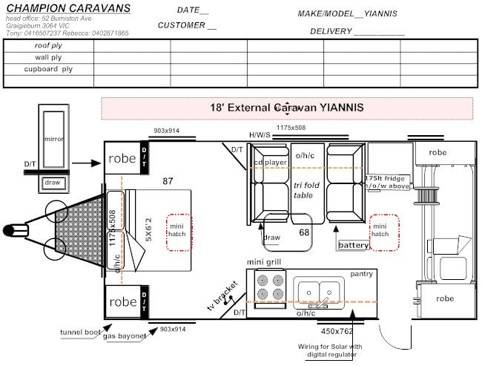

Chassis Exterior
- 4” A-frame - Tunnel Boot
- 4” Main Chassis - Checker plate front and sides
- Single Axle - Roll out awning
- 4 x drop down stabilizing legs - Wind out windows
- Heavy duty 2-arm bumper - Ibis, reverse cycle Air Conditioner
- 2 X Mini Hatches

Plumbing Interior
- 1 x 95L Water tanks - Caffee dinette
- Flick mix taps throughout - Mini Grill
- Tap on A-frame - Recessed lid over stove
- Mains pressure in - 12V rangehood
- Lockable water filler - Dometic 175L, 3-way fridge
- 2 x 9kg gas bottles - Deep bowl stainless sink
- Gas Bayonet - Queen size bed on gas assisted lift up frame
- 2 Fixed Bunk Beds
Electrical - Inner spring mattress
- Break away controller - Slide out pantry under bench
- 1 x 100amp battery & charger - Stainless front microwave
- External 240V,
- External LED clearance and tail lights
- CD/DVD & Radio player
- 19” LCD Wide Screen
- Wineguard antenna PRICE $39,850
- 2 x internal speakers
- Internal LED lights
- Solar Wiring with digital control regulator

VICTORIA 17’
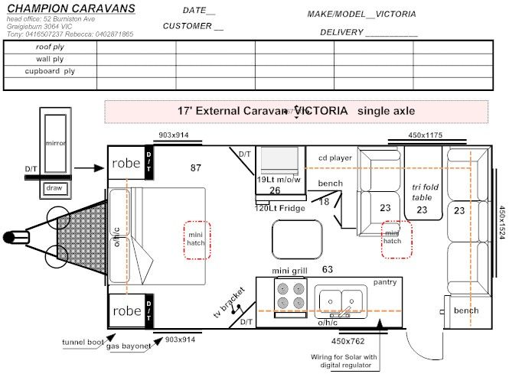

Chassis Exterior
- 4” A-frame - Tunnel Boot
- 4” Main Chassis - Checker plate front and sides
- Single Axle - Roll out awning
- 4 x drop down stabilizing legs - Wind out windows
- Heavy duty 2-arm bumper - Ibis, reverse cycle Air Conditioner
- 2 X Mini Hatches

Plumbing Interior
- 1 x 95L Water tanks
- Flick mix taps throughout - Mini Grill
- Tap on A-frame - Recessed lid over stove
- Mains pressure in - 12V rangehood
- Lockable water filler - Dometic 120L, 3-way fridge
- 2 x 9kg gas bottles - Deep bowl stainless sink
- Gas Bayonet - Queen size bed on gas assisted lift up frame
Electrical - Inner spring mattress
- Break away controller - Slide out pantry under bench
- 1 x 100amp battery & charger - Stainless front microwave
- External 240V,
- External LED clearance and tail lights
- CD/ DVD & Radio player
- 19” LCD Wide Screen
- Wineguard antenna
- 2 x internal speakers
- Internal LED lights PRICE $37,500
- Solar Wiring with digital control regulator

