Learn How to Grow your Own Vegetables

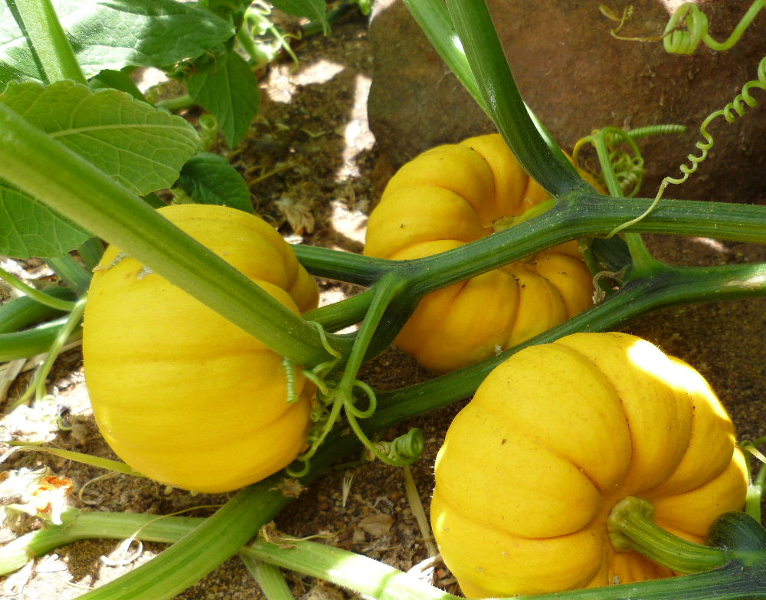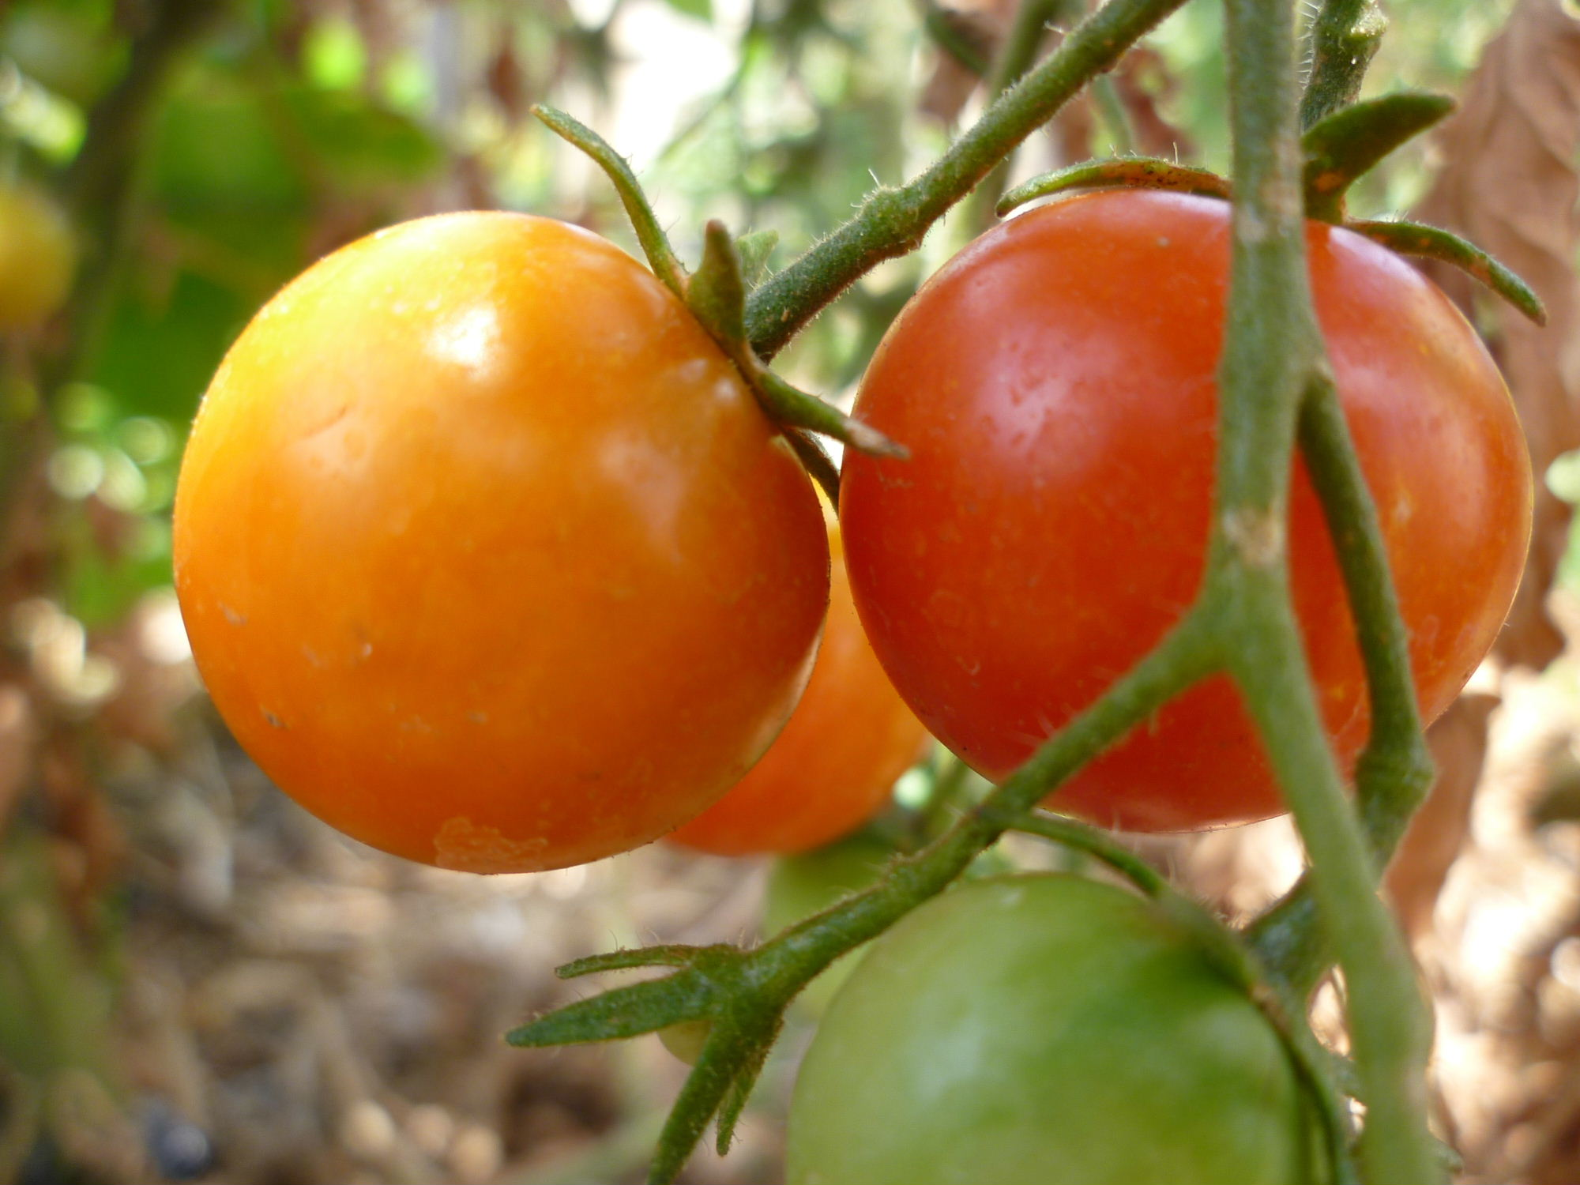

Educational 2 ½ hours WORKSHOP held in a productive organic garden
Covering how to grow edible crops from start to finish
Also includes many tips and ideas on how to grow your vegetables successfully no matter what the weather
Easy to follow principles to get you started and make a success of your own vegetable garden.

Includes: information file on growing vegetables a cup of freshly picked herb tea (or tea/coffee) and a home cooked muffins/cake

Times and dates to suit groups or individuals

Contact Sandy at

‘U Grow Vegies’

Ph: 9574 4721

Email: arose4u@bigpond.com

I can visit your back yard to help with decisions on your vegetable garden and any problems that need to be addressed

For Community groups I can visit your meeting place and offer an introduction
seminar about growing vegetables.
