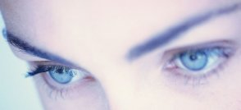
Essence of Health & Beauty

Suite 1, 191 Ramsgate Road Ramsgate Beach NSW 2217
(Above Franklins – up Spiral Staircase)
Ph:-9529 0366 Fax:- 9529 0377
eoh@bigpond.com

IRIDOLOGY CONSULTATIONS
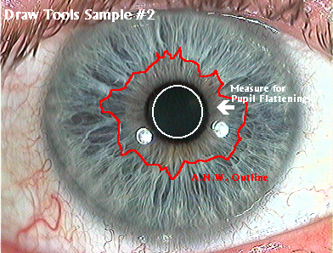
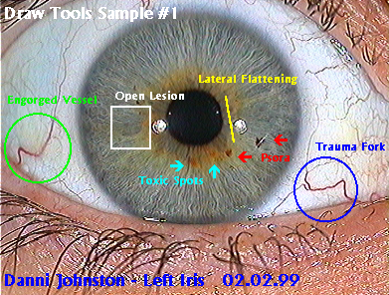

$45.00

Includes:- 30 Mins Consultation*

Other Services available:-

* Naturopathy consultations * Beauty Therapy
* Intensive Skin Treatments * Oxygen Facials
* Natural Skin Peels * Live Blood Analysis
* Weight Management * Natural Skin Care
* Nutrition & Vitamins * Homoeopathy
* Herbal Medicine * Massage
* Natural Fertility * Sports Medicine
* Corporate Massage * Bach, Bush Flowers
* Shell Essences * Ayurvedic Medicine
* Oxygen Inhalation * Dr. Hauschka Products
* Weleda Skin Care * Dr. Hauschka Cosmetics
* Gifts, Crystals, Jewellery * Candles, Incense, Soaps

*Full Consultation also available at extra cost. $65.00 Hr
IRIDOLOGY

Iridology provides a simple, painless, economical means of looking into the body.

Iridology does not name diseases; instead, it can reveal the level of tissue activity in the body.

Iridology reveals:-
- Genetic Inheritance – constitutional strength. Are we built strongly or weakly ? How well does the body endure stress ?
- Nutritional imbalances and requirements. What elements are lacking and where ?
- Psychological factors, the condition of the nervous system, digestive function and circulation.
- Reveals the health level. What is the health potential ?
- Reveals areas of over or under activity and areas of toxic waste accumulation.
- Reveals the whole body as a unified structure. What is the “overall” health level ?

Iridology helps us to obtain our maximum health level. It brings an awareness of how to help prevent diseases. It helps us to understand our weaknesses, so we can try to strengthen them for future generations. It tells us what foods we need to strengthen our bodies.

We examine the eye under magnification by taking a photo onto a computer screen and overlay a chart, showing the correlations of segments of the iris to parts of the body.

We examine colour variations, markings, pupil configurations and many other signs in the eyes. For example, when body tissue is overactive, inflamed and sometimes painful, the iris records this condition by being very white in the corresponding reflex area.

Good health allows us to become the individual we want to be and to obtain the highest goals in life. Of all the early treasures, vibrant health is the most precious.

