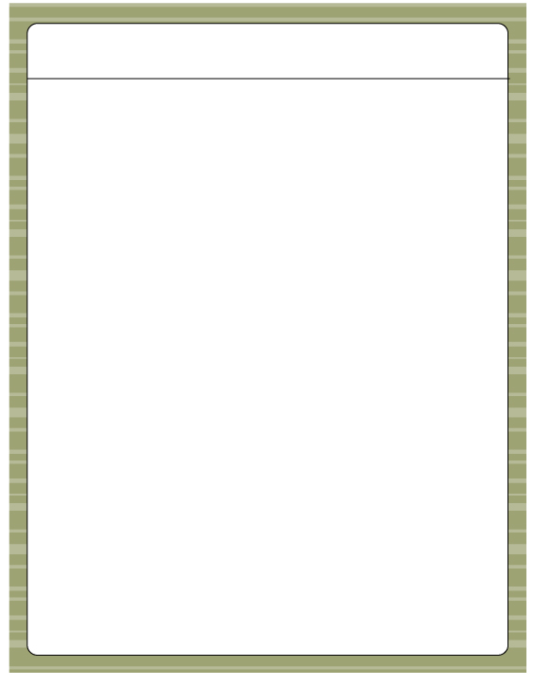

Want to Sell Scentsy?
Scentsy Business Q & A - Australia

Q. How much does it cost to get started?
A. It’s $139 plus tax and shipping to order your Starter Kit.
Q. What does the Starter Kit include?
A. Everything you need to plan your first Scentsy event! Scentsy Family Consultant Guide,Scentsy Catalogues (25),Showcase Brochures (25),Product List (1 50-sheet pad),Print-Your-Own Labels (10 sheets),Invitations (100),Order Forms (100),Host Envelopes (5),Host/Join Brochures (25),Discover Scentsy DVD, Party Testers (1 Full Set),Category Cards, Full-Size Scentsy Warmer, Scentsy Bars (2),Scentsy Buddy, Scent Pak, Layers Products (2) (contents subject to change)

Q. How much do I have to sell to stay active?
A. Scentsy has made it incredibly easy and stress-free to become a consultant and earn extra cash on your own terms! All you have to do is enter an order of at least150 PRV points ($195 AUS) in one month, over a 3 month period to stay active.

Q. How much money can I make?
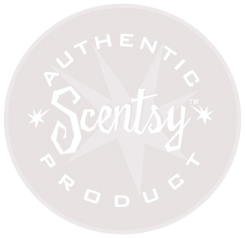
A. You can earn 20-39% on your own sales and leadership bonuses of up to 9% of the entire down line volume of the people you recruit and train to sell Scentsy products.

Q. How long has Scentsy been around? What is the growth potential?
A. Scentsy was started in 2003 in the US. It has been in Canada since 2009, and will be launching in Australia and Mexico starting September 1st, 2013. This is an amazing opportunity to get started at the very beginning and be one of the first Scentsy Consultants in Australia!
The quality products practically sell themselves. They provide a safe alternative to burning candles so they appeal to a wide customer base. Because the products are consumable, they also prompt reorders. The company has experienced incredible growth as this concept has taken off. Signing up today is advantageous for you because the company is still new and growing rapidly.
Q. Do I have to buy a lot of inventory and keep it stocked to do parties?
A. No. You order the products on your consultant workstation when customers order from you.

Q. How can I sell Scentsy?
A. Home Parties, Basket Parties, Expos, Fundraising, Catalogue parties – Basket Parties are catalogue parties with small scent samples your hostess can take to work, friend’s places, sports clubs, family gatherings, or wherever to show and collect orders, website orders and re-orders, Fairs/Expos, etc. Check the handbook for complete information. Selling Scentsy through online auctions (eBay) or through retail establishments is not permitted.

Q. How do I get paid commission and bonuses?
A. You collect the retail price (plus tax* and shipping** if applicable) from customers and pay the retail price when you enter the order. Scentsy sends you commissions and bonuses on the 10th of each month. You will receive your commission payment online (through our Scentsy PayPortal) and you can set it up to automatically deposit into your bank account.
* The tax rate is based on where the order will be shipped. If an order will be shipped to someone’s home directly, charge the tax rate for that destination.
** Shipping is FREE on party orders of $220 AUS or more unless the customer wants the order shipped directly to a specific address instead of to the consultant or hostess. Then there is a 20% shipping charge.
Q. What payment types can I accept from customers? Are there credit card processing fees?
A. You can accept personal or business checks made payable to you, cash or credit cards (American Express, Visa, Discover, Master Card). Consultants do not pay credit card processing fees.

Want to Sell Scentsy?
Scentsy Business Q & A (Continued)

Q. Do I have to pay for all of the rewards a hostess gets for having a party?
A. No. Scentsy pays for all hostess rewards and shipping on the entire party order!

Q. Is there training available?
A. Absolutely. I’ll train you personally. I’ll make sure you’re ready for your first party and answer any questions you have after that. You’ll be notified when there will be team training meetings (usually once a month) or conference calls. Scentsy also sponsors annual regional meetings and an annual convention in July.

Q. What do I do if I have a question?
A. Read the Start Up Guide as soon as you sign up. It’s available in the Resources section of your consultant workstation. It answers most questions but you can always call me if you want something clarified. My phone number is 0402 341269 or 5333 1545
News updates are also posted from the company on your Scentsy consultant workstation.

We also have a wonderfully supportive facebook group for our Scentsy team where you can always find answers to your questions.

Q. How often are the products and catalogues updated?
A. Twice a year in March and September. Consultants can purchase the new catalogues and scent samples in February and August when the new and discontinued products are announced.

Q. Can I have my own Scentsy web site?
A. Yes. Online sales and reorders are a big part of our business. You can subscribe to a Scentsy sponsored website so clients can order and reorder whenever it’s convenient for them. Your website subscription is free for the first three months after you sign up and $13 AUS a month after that. If you choose to create a website that is not sponsored by Scentsy, you have to have it approved by Scentsy.
Newsletter - The $13 AUS monthly web site fee also includes a newsletter for clients (Making Perfect Scents) that Scentsy creates and sends to your list of clients through email. You just set up the email list in the Newsletter Management section of your consultant workstation.

Q. How do I get marketing materials and business supplies?
A. Business supplies (catalogues, order forms, scent samples, generic business cards and invitations) are available to order through your Scentsy consultant workstation.
Marketing Materials (custom business cards, invitations, banners, clothing, pens, buttons, yard signs, etc.) are available through Scentsy Success. There is a link to that through your workstation. There are lots of fun things to check out! Flyers for monthly specials are available to download and print in the Resources section of your consultant workstation and also in Scentsy Success.
Create your own - If you’d like, you can make your own flyers, invitations, etc., just get approval from Scentsy before printing and distributing (adapproval@scentsy.com).

Q. Great! How do I sign up to be a consultant?
A. You sign up through my Scentsy website by clicking on www.missjojo.scentsy.com.au or call me and I can guide you through it!
Click on the flag in the top right corner and switch the country to Australia. Then, click on “Join my team” and once you’ve agreed to the terms and conditions and paid for your starter kit, a consultant number will be assigned to you. Scentsy will then contact you through email and give you a URL for your personal Scentsy website where customers can begin ordering.
I will send you a “Welcome to my team” email right away with more info and tips to get started!

