Diamond Information
Diamonds are like graphite, pure carbon, and have been created millions of years ago in intense temperature and pressure in volcano pipes. Consequently, most diamonds contain tiny marks, known as inclusions, which make each stone unique. The fewer and smaller the inclusions, the more valuable a diamond will be. But inclusions don't necessarily weaken the stone and its beauty will not be affected if the light is reflected from one facet to another and then back out through the top of the diamond. The skill of the cutter will reveal the hidden fire and brilliance.
Diamond is the hardest material on Earth and can only be cut by diamond dust and because of the fact that the hardness varies on the crystal facets. Diamonds are durable and won't deteriorate. A diamond will shine as brilliantly as new each time it is cleaned. In fact it will not be completely dull like glass stones or cubic zirconia, when skin oils, soap, cosmetics and grease have left deposits.
We use conflict-free diamonds Russian cut from an Australian Supplier.
Their fire and brilliance is unquenchable, which its owner can be proud of. For every carat of rough diamonds recovered, more than 250 tonnes of ore have to be blasted, crushed and processed. Only 20% will be gem quality. Its value depends on the quality which is determined by carat, clarity, colour and cut.
Cut = most important, depending on the finish grade (polishing) and the proportions that determine the fire and brilliance (brightness)
ideal Brilliant cut - 57 precisely angled facets offer best reflection and high dispersion of the light causing a colourful sparkling in better quality diamonds.
Single cut (Eight facet cut) – usually medium to lower quality small diamonds.
Other cuts - Triangle, Trilliant, Baguette, Baguillion.
Fancy cuts and coloured Diamonds also have their lovers.
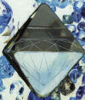
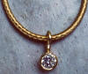
Colour (determined by comparing it to an internationally approved set of master stones) International Grading Scale:
Diamonds with no trace of colour are extremely rare and valuable.
D - exceptional white + = River R+
E - exceptional white = River R
F - rare white + = Top Wesselton TW
G - rare white = Top Wesselton TW
H - white = Wesselton W
I & J - slightly tinted white = Top Crystal TCR
K & L - tinted white = Crystal CR
M & N - tinted colour 1 = Top Cape TCA
O & P - tinted colour 2 = Cape CA
Q& R - tinted colour 3 = light yellow LY
S to Z - tinted colour 4 = up to Yellow Y
A range of white, rare pink, cognac and champagne coloured diamonds are found at the Argyle Mine in Western Australia. Their popularity and prices vary according to fashion.
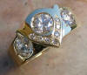
Clarity (International Grading Scale of internal impurities)
Loupe-clean = if = with 10 times magnification no inclusions
VVS 1 = " " " " very very small minor inclusions
VVS 2 = " " " " very very small inclusions
VS 1 = " " " " very small minor inclusions
VS 2 = " " " " very small inclusions
Si 1 = " " " " small minor inclusion
Si 2 = " " " " small inclusions
P1 or 11= pique 1 small inclusions visible without magnification
P2 or 12= pique 2 inclusions visible without magnification
P3 or 13= pique 3 large inclusions visible without magnification.
External characteristics on the surface of the stone only have an influence on the clarity grade if they are sufficiently noticeable and if the stone is not internally flawed. Size to ct comparison:
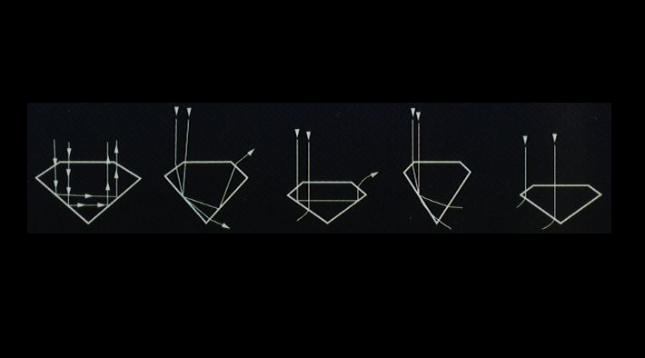
4.1mm 5.15mm 5.9mm 6.5mm Carat means the actual weight of the 0.25ct 0.50ct 0.75ct 1.00ct gemstone. 1 carat is the equivalent of 0.2g and has nothing in common with the 'purity carat' of gold.
Brilliant Facets Light Performance Reflection
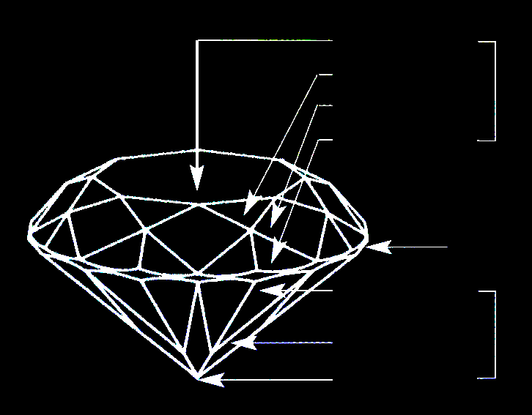
Crown Table
Star facet
Bezel facet
Upper girdle
facet Good Cut Too heavy & too shallow
Girdle =best Brilliance
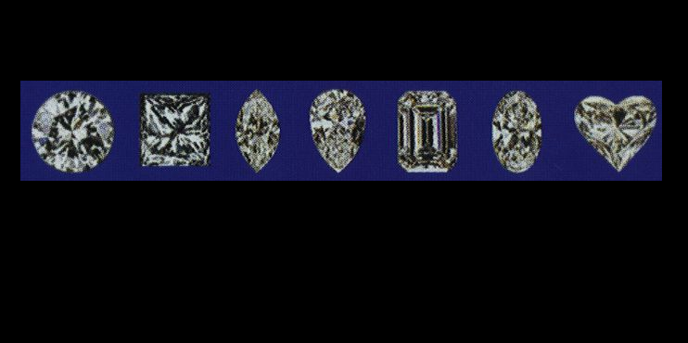
Lower Girdle
Pavilion facet Common Diamond Shapes Cupid is said to
Pavilion have used
Culet diamonds as tips on
his arrows.
Different setting styles Round Princess Marquise
Bezel setting: Pear Emerald Oval Heart
the gemstone is enclosed in a rim of gold, rubbed over all the way around. For extra sparkle a facet can be cut to the inside of the setting with an engraving tool. Channel setting: a straight or curved open channel of metal walls on both sides with incision holding a row of gemstones set close together.
Claw setting: 3, 4 or 6 individual wires in e.g. crown or basket shape are secured to the gemstone by pressing the ends over the stone.
Pavé/Grain setting: grains of gold are lifted with an engraver out of the solid metal to raise a bead-like claw securing the gemstone, offering a way of creating bright sparkles from a lot of diamonds placed close together.
Buying a diamond means entering an enchanted world of romance, intrigue, legend and history which compared diamonds with tears of Gods or splinters of stars that fell to earth like the Ancient Greeks believed. They were worshiped, sought after, fought over and have become the ultimate gift of love.

Diamonds
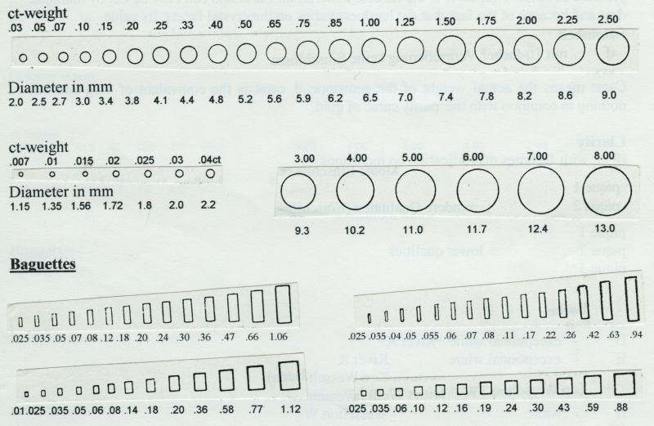

Diamonds are like graphite, pure carbon, and have been created millions of years ago in intense temperature and pressure in volcanic pipes. Consequently, most diamonds contain tiny marks, known as inclusions, which make each stone unique. The fewer and smaller the inclusions, the more valuable a diamond will be.
But inclusions don't necessarily weaken the stone and its beauty will not be affected if the light is reflected from one facet to another and then back out through the top of the diamond. The skill of the cutter will reveal the hidden fire and brilliance.
Diamond is the hardest material on Earth and can only be cut by diamond dust and because of the fact that the hardness varies on the crystal facets. Diamonds are durable and won't deteriorate. A diamond will shine as brilliantly as new each time it is cleaned. In fact it will not be completely dull like glass stones or cubic zirconia, when skin oils, soap, cosmetics and grease have left deposits. You can find information on our website about how to clean jewellery under 'Jewellery Care'.
We use conflict-free diamonds with exceptional Russian cut from reliable Australian Suppliers (certificate available) in the quality you desire. Our suppliers hand-pick the gemstones, which display best brilliance because of very hard to spot inclusions e.g. only at the edge, which will be covered by the setting anyway. Their fire and brilliance is unquenchable, which its owner can be proud of.
For every carat of rough diamonds recovered, more than 250 tonnes of ore have to be blasted, crushed and processed. Only 20% will be gem quality. Its value depends on the quality which is determined by carat, clarity, colour and cut.

Cut
The cut is the most important thing, depending on the finish grade (polishing) and the proportions that determine the fire and brilliance (brightness) as shown in the images and desciptions below.
ideal Brilliant cut - 57 precisely angled facets offer best reflection and high dispersion of the light causing a colourful sparkling in better quality diamonds.
Single cut (Eight facet cut) – usually medium to lower quality small diamonds.
Other cuts - Triangle, Trilliant, Baguette, Baguillion.
Fancy cuts and coloured Diamonds also have their lovers.

Carat
means the actual weight of the gemstone. 1 carat is the equivalent of 0.2g and has nothing in common with the 'purity carat' of gold.

Clarity
(International Grading Scale of internal impurities)
if = Loupe-clean = with 10 times magnification no inclusions
VVS 1 = " " " " very very small minor inclusions
VVS 2 = " " " " very very small inclusions
VS 1 = " " " " very small minor inclusions
VS 2 = " " " " very small inclusions
Si 1 = " " " " small minor inclusions
Si 2 = " " " " small inclusions
P1 or 11 = pique 1 small inclusions visible without magnification
P2 or 12 = pique 2 inclusions visible without magnification
P3 or 13 = pique 3 large inclusions visible without magnification
External characteristics on the surface of the stone only have an influence on the clarity grade if they are sufficiently noticeable and if the stone is not internally flawed.

Colour
(determined by comparing it to an internationally approved set of master stones) International Grading Scale:
Diamonds with no trace of colour are extremely rare and valuable.
- D - exceptional white + = River R+
- E - exceptional white = River R
- F - rare white + = Top Wesselton TW
- G - rare white = Top Wesselton TW
- H - white = Wesselton W
- I & J - slightly tinted white = Top Crystal TCR
- K & L - tinted white = Crystal CR
- M & N - tinted colour 1 = Top Cape TCA
- O & P - tinted colour 2 = Cape CA
- Q& R - tinted colour 3 = light yellow LY
- S to Z - tinted colour 4 = up to Yellow Y
A range of white, rare pink, cognac and champagne coloured diamonds are found at the Argyle Mine in Western Australia. Their popularity and prices vary according to fashion.

Different setting styles
Bezel setting: the gemstone is enclosed in a rim of gold, rubbed over all the way around. For extra sparkle a facet can be cut to the inside of the setting with an engraving tool.
Channel setting: a straight or curved open channel of metal walls on both sides with incision holding a row of gemstones set close together.
Claw setting: 3, 4 or 6 individual wires in e.g. crown or basket shape are secured to the gemstone by pressing the ends over the stone.
Pavé/Grain setting: grains of gold are lifted with an engraver out of the solid metal to raise a bead-like claw securing the gemstone, offering a way of creating bright sparkles from a lot of diamonds placed close together.
Buying a diamond means entering an enchanted world of romance, intrigue, legend and history which compared diamonds with tears of Gods or splinters of stars that fell to earth like the Ancient Greeks believed. They were worshiped, sought after, fought over and have become the ultimate gift of love. Cupid is said to have used diamonds as tips on his arrows.
To avoid blood diamonds we buy large diamonds with certificate, cut in Russia or from the Australian Argyle Mine. Both suppliers don't support black markets nor child labour.
To guarantee conflict free diamonds, they might not be the cheapest, but from legal sources which is providing fair payments for the labourers in the mines.
CONFLICT DIAMONDS (BLOOD DIAMONDS) FAQ http://www.gem.org.au/images/mr0407.pdf
When Princess cut became the latest Fashion, it was sometimes not appreciated, when any good jeweller explained that quality diamonds with brilliant cut have the best fire, because they contain the most facets and are cut to the ideal proportions to best reflect the incoming light, but it is important to mention, because other cuts don't sparkle as nicely and as long, when they become clogged up with dirt. There is another beautiful option to achieve the princess look, we can set a brilliant cut diamond like a princess cut with a square facet cut into the metal around the gemstone and little beads raised in the corners as claws.
To help comparing approximate sizes of for example a 1.5ct diamonds of standard depth and perfect symmetry of the actual stone. (carat is the weight, not a physical dimension of size)
Round Brilliant cut = 7.4mm - 8mm diameter (across)
Princess cut = 6.5mm x 6.5mm
Emerald cut = 8.0mm x 6.0mm
Pear shape = 9.0mm x 6.0mm
Oval shape = 8.5mm x 6.5mm
Heart shape = 7.0mm x 7.0mm
Trillion Cut = 7.0mm x 7.0mm
Marquise Cut = 11.0mm x 5.2mm
Radiant Cut = 8.0mm x 6.0mm
Asscher Cut = 6.5mm x 6.5mm
Cushion Cut = 6.5mm x 6.5mm
Comparing the surface area of 1.5ct diamonds with standard values for both sizes :
round Brilliant cut : approximately 42.98 mm2
Princess cut : approximately 42.25 mm2

