A Road-trip to Top Tourist Attractions In Victoria

Embarking on a road-trip from Melbourne offers a unique way to enjoy the splendor of Victorian landscapes. A state like no other in Australia and even in the world, Victoria is worthy of exploring, and what better way than in a caravan. Seeing Victoria from a caravan will get you up close to the deserted beaches and unforgettable scenery. From the large rural cities to the small country towns, and everything in between. Enjoy the diversity and vastness of this magnificent state in a time-honoured tradition; a caravan road-trip.

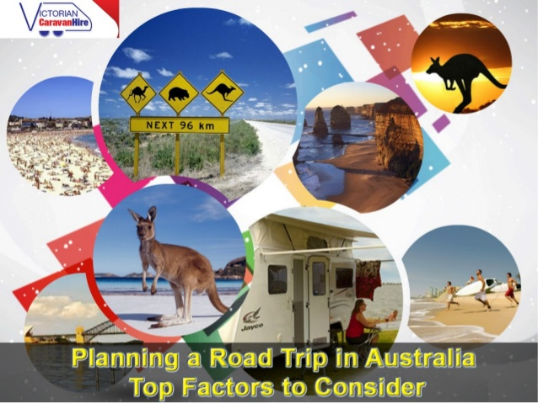

Caravan Hire from Melbourne is a great way to make such a trip possible. Typically a hire caravan is fully equipped with all basic household items and necessary equipment to ensure your trip is comfortable and enjoyable. A great reason for hiring a caravan in Melbourne is the proximity of the best Victoria has to offer. Explore the hidden beauty of nature in the lush forests, gorgeous fishing villages, wonderful pristine beaches and vast horizons of farmland.

Here are five road trips through Victoria to get you started on the trip of a lifetime.

Daylesford: In the foothills of the beautiful Macedon Ranges, Daylesford and its surrounding towns is all about indulgence and good food. It’s an escape destination better known for romantic dates, thanks to the spas and hot springs. Daylesford is a notable tourist destination, approximately 115 kilometers north-west of Melbourne. The Midland highway runs directly through the town linking it with Castlemaine in the north and Ballarat in the south-west.

Echuca: Head up the Hume Highway on your way for the 200km journey to Echuca. Echuca is a popular holiday destination for those wanting to relax and unwind in a warmer climate. Be sure to check out the Great Aussie Beer Shed, the sprawling Gunbower Island State Forest and a trip to Echuca is never complete without taking a tour down the Murray River on a paddle steamer.

Phillip Island: Phillip Island is a dream destination for a family getaway. The island is home to many marine treasures and undulating coastlines. This unique environment offers something for nature lovers and adrenaline junkies, alike. Attractions include A’Maze’n Things, Churchill Island Heritage Park, the Phillip Island Chocolate Factory, GP circuit for some fast-paced go carting and of course, the world famous Penguin Parade where you sit back at dusk and enjoy the show as these amazing little creatures waddle into shore.

Inverloch: For the true beach lover, Inverloch offers both the excitement of a Surf beach and the safety of an Inlet beach. This popular seaside escape is perfect for a variety of water based activities, including fishing, snorkeling and jet skiing; as well as for that well earned relaxing getaway.

Lake Eildon: Bonnie Doon, Mansfield or Eildon townships offer 3 unique holiday destinations surrounding the picturesque Lake Eildon. Lakeside camping available at Bonnie Doon and Eildon as well as other lakeside sites in the National Park allow you to experience water front camping as its best. Mansfield is the base from which to explore the beautiful sights and scenery that only the High Country can offer.

These are just a few of the locations that make Victoria such a desirable place to explore on a caravan road trip. Contact Victorian Caravan Hire and bring that holiday dream to life today!

