Behind Old Switchbaord
Old Rubber cabling behind switchboard. And unsafe fuses.

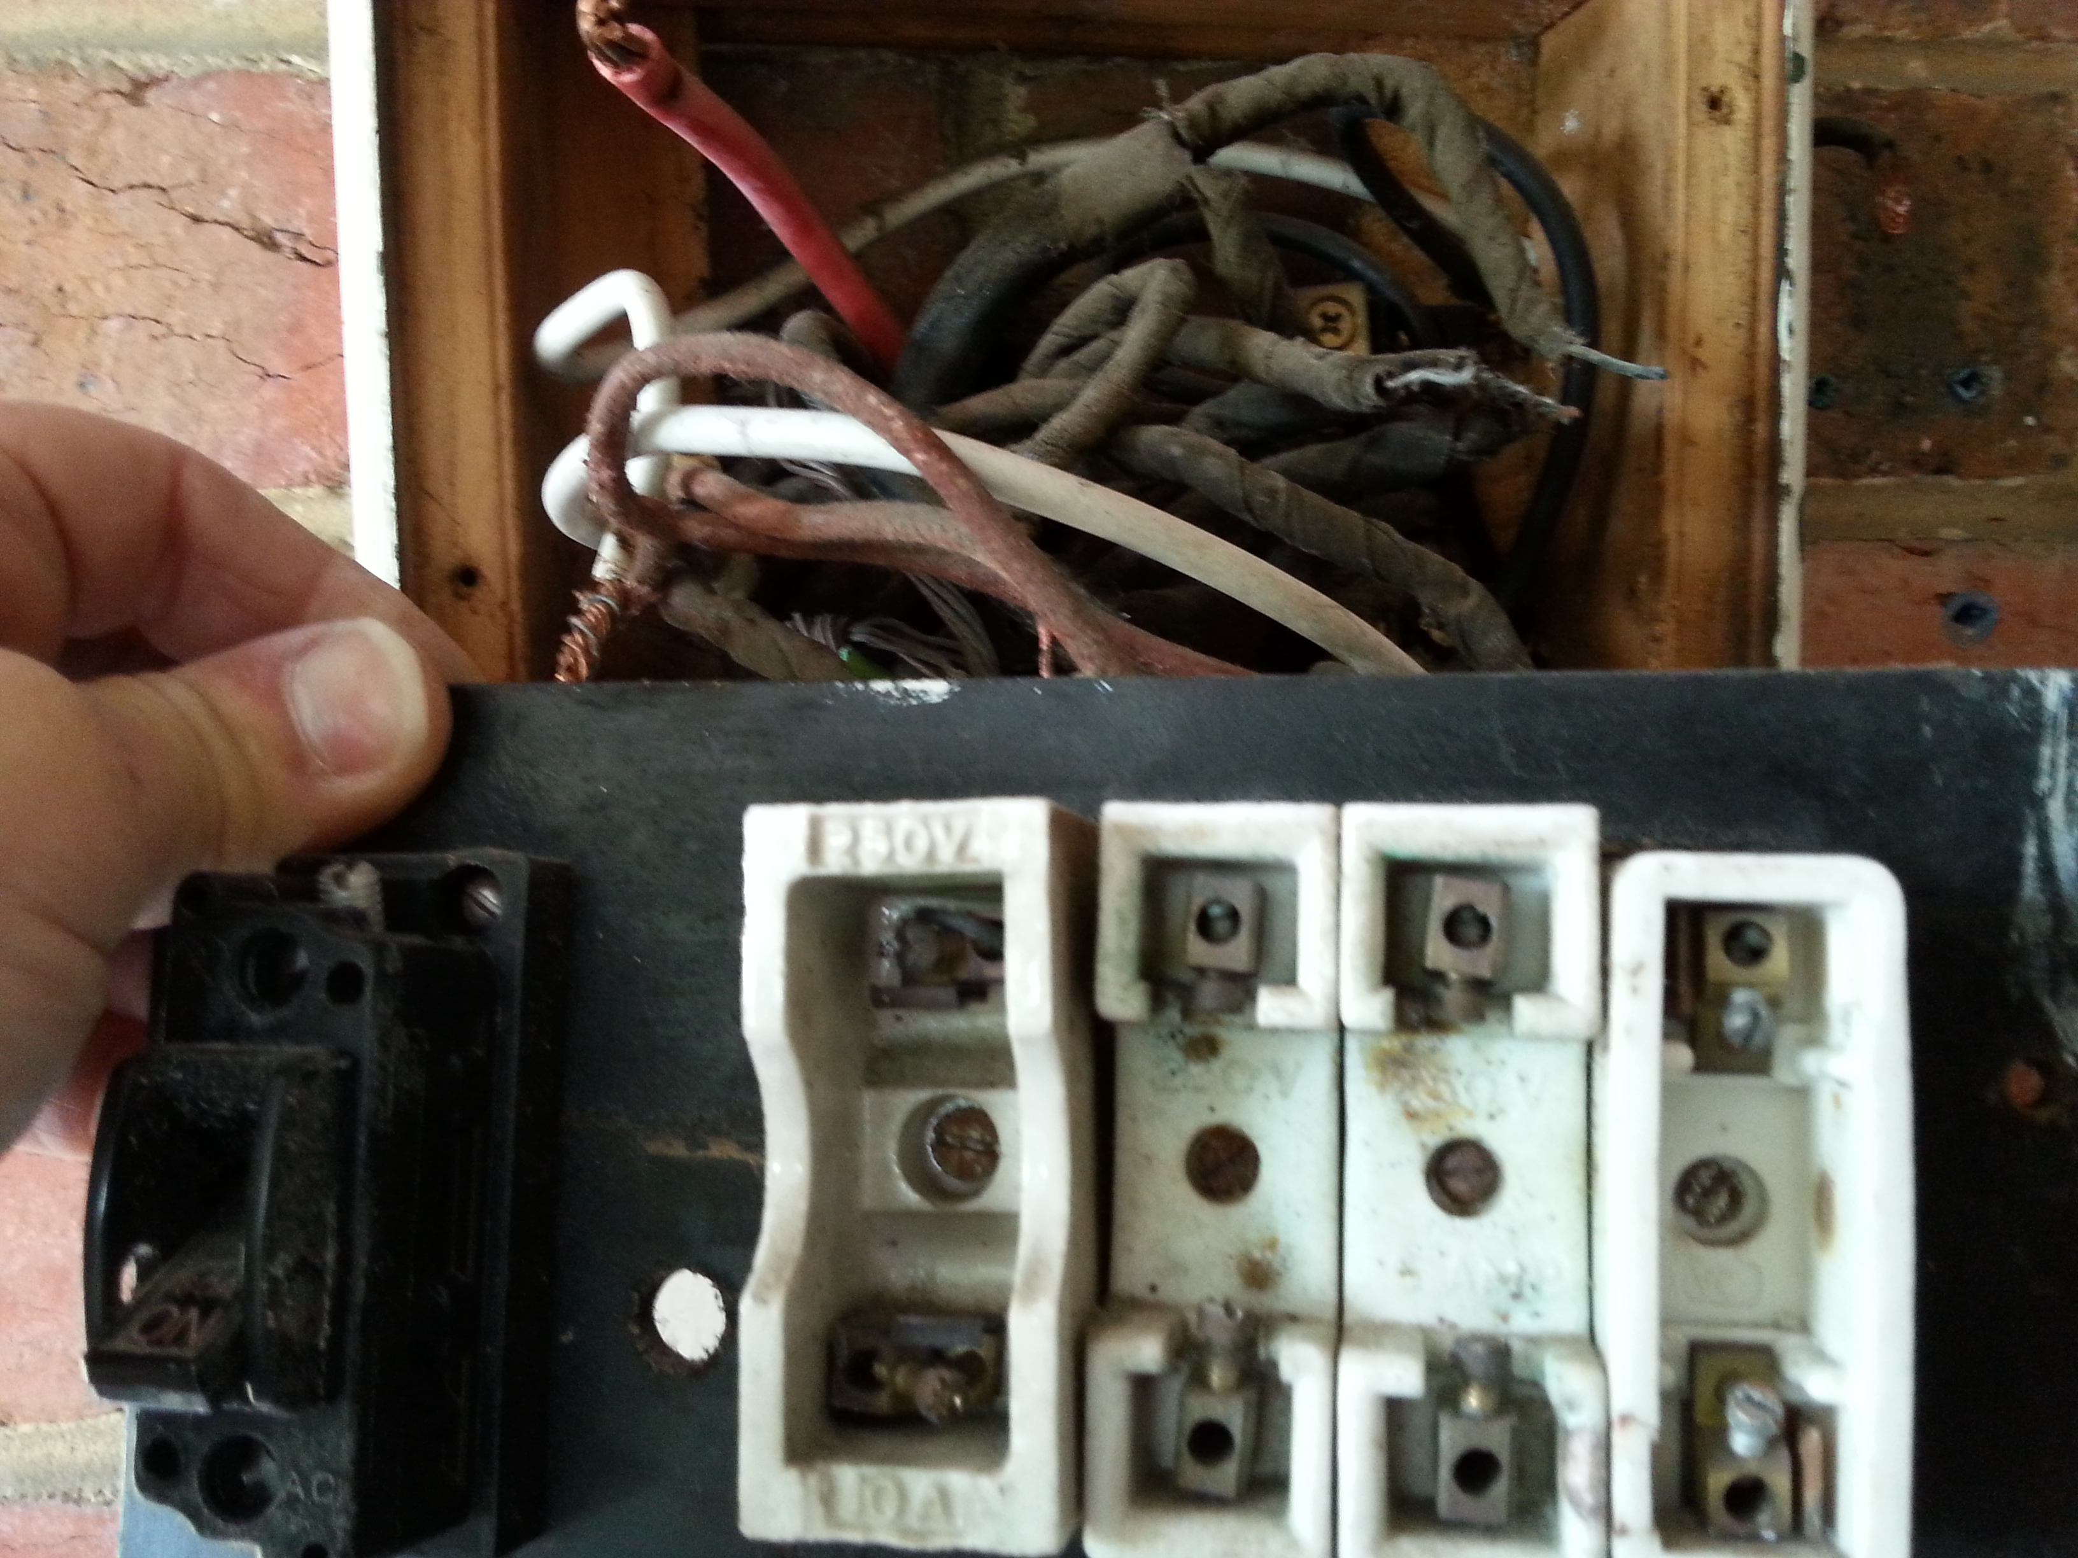
Rubber cabling behind old switchboard

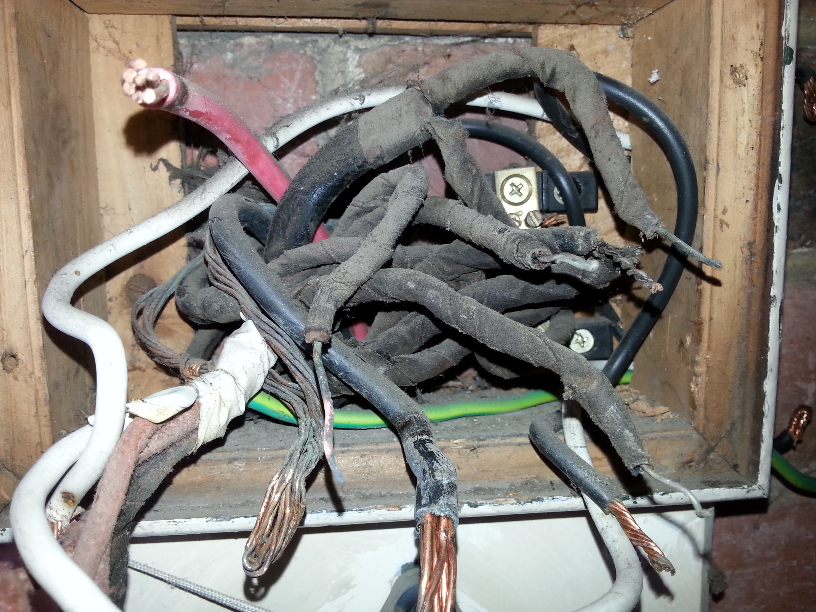
Rubber cabling behind old switchboard 1
Rubber VIR cable installed in the 50, s. this cable falls apart when you handle it and needs to be replaced immediately.

