
Ph: 1300 515 530

Lawn & Garden Maintenance

Budget Package

(No catcher is used, Clippings Mulched back into lawn, No Edging or Cleanup)

Townhouse / Small Allotment / Single Unit Dwelling (Up to 400 sqm) $35.00
Standard House Block (400 to 650 sqm) $45.00
Large House Block (650 to 850 sqm) $55.00
Over 850sqm - Please call for a Free on-site Quote

Standard Package

(Clippings collected, Edging done, Cleanup with Blower)

Townhouse / Small Allotment / Single Unit Dwelling (Up to 400 sqm) $40.00
Standard House Block (400 to 650 sqm) $50.00
Large House Block (650 to 850 sqm) $60.00
Over 850sqm - Please call for a Free on-site Quote

Deluxe Package

(Clippings collected, Edging done, All Hedges Trimmed, Cleanup with Blower)

Townhouse / Small Allotment / Single Unit Dwelling (Up to 400 sqm) $60.00
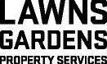
Standard House Block (400 to 650 sqm) $70.00
Large House Block (650 to 850 sqm) $80.00
Over 850sqm - Please call for a Free on-site Quote
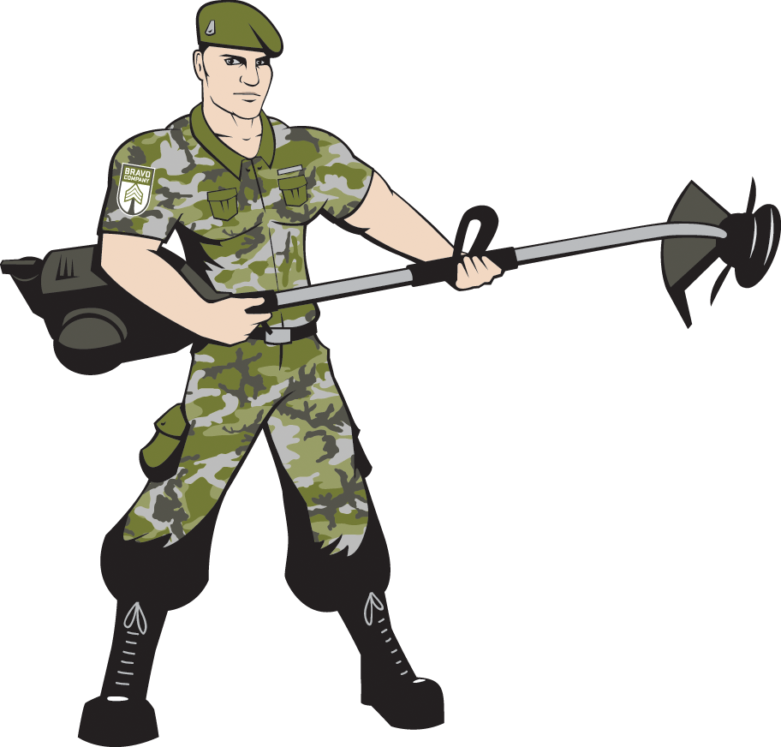



All Pricing is based on a lawn length of 100mm or less and includes GST.
For grass height over 100mm and up to 150mm add 20%
For grass height over 150mm and up to 200mm add 30%
For grass height over 200mm, please contact us for a free on-site Quote.

Opt for a regular service and enjoy an on-going discount of 10% starting with your second service

Bravo Company Australia
ABN: 457 190 25838

