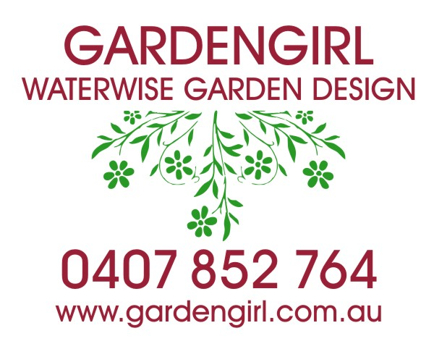

DESIGN MY GARDEN!

* Think carefully about your current garden, and what's there now (if anything).
* Now think about how you'd like to be able to use your garden.
* Try and imagine how your DREAM garden would look.
* Answer the following questions in as much detail as you can.

YOUR NAME
SITE ADDRESS
SUBURB/CITY POSTCODE
BH Phone AH Phone
If you would like email communication, please provide your email address:

What time frame are you looking
to start construction?
Yesterday! □
Within 4 weeks □
Within 2 months □
3 to 4 months □
Around 6 months □
OTHER

What is your approximate budget? (this is vitally important and may require a reality check!)
Less than $5,000 □
$5,000-$10,000 □
$10,000-$15,000 □
$15,000-$20,000 □
More than $20,000 □

THE NITTY-GRITTY: YOUR PLACE!
Approximate dimensions of site:
(eg 20m frontage x 30m depth)
This is a new garden □ We have an existing garden □

What do you LIKE about your existing garden space?

What do you DISLIKE about your existing garden space?

Age/s of any children who will use the garden?
Will any pets need access to the garden?

How much time do you ideally want to spend looking after your new garden?
None, thank you! □
A few hours a month □
Every weekend- I love my garden! □

Describe your outdoor entertaining style
Entertaining? What’s that? □
The Occasional BBQ □
We always seem to have guests! □

Which features do you REALLY want included in your garden? (tick all that apply)
Built-in Barbecue □ Vegie Garden/Fruit Trees □
Water Feature □ Water Tank/s □
Sculpture □ Swimming Pool □
OTHER

LOOKING AT THE FOLLOWING IMAGES, WHICH GARDEN STYLE ARE YOU MOST DRAWN TO? (try to narrow it down to one or two)

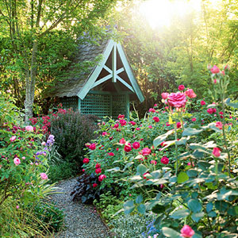
□ COTTAGE GARDEN
DESCRIPTION: Rambling plants spilling over paths, loads of flowers, winding paths.
PROS: If you love flowers, this is the obvious choice. Can survive with minimal maintenance. A very relaxed garden style. Suits period homes and cottages. If one plant dies it won't look obvious! Often attracts butterflies and many birds.
CONS: Deadheading plants (pruning off spent flowers) is recommended, so larger cottage gardens can take a bit of work. This look is NOT for you if you are an obsessive neat freak!

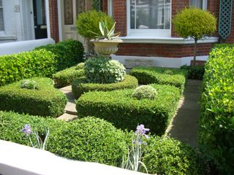
□ FORMAL ENGLISH GARDEN
DESCRIPTION: Manicured and clipped plants, symmetrical paths and plantings, green foliage is the dominant feature. Neat and formal.
PROS: As the garden relies mainly on evergreen foliage, it will look great all year round.
CONS: Don't choose this style if you don't LOVE clipping plants and maintaining your garden (or can’t afford a regular gardener!). Not a garden you can plant and forget. Not recommended if you love flowers- these gardens have few or none.

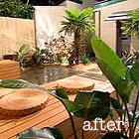
□ MODERN CONTEMPORARY GARDEN
DESCRIPTION: Mix of hardscaping textures and plant life, structured look and feel. Suits modern house styles.
PROS: Tends to be lower maintenance than some other garden styles. Maximises the amount of useable space in your garden.
CONS: Paving and retaining walls as in this image will probably require a professional landscaper, which will add greatly to the costs of construction.

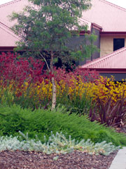
□ MODERN NATIVE GARDEN
DESCRIPTION: Bold use of colours and textures using predominantly native plants, can also include structured elements like retaining walls and benches. Suits modern home styles, and looks fantastic against a home built of sandstone.
PROS: Very drought hardy, a striking look, will likely attract native birds and butterflies. Many natives have very long flowering periods. Requires basic maintenance only.
CONS: No garden is completely maintenance-free, so you will need to trim off spent flowers occasionally (or cut them for a vase).

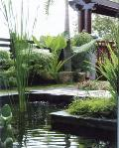
□ TROPICAL STYLE GARDEN
DESCRIPTION: Abundance of broad leafy textures and colours, mix of low-growing plants under a canopy of taller plants.
PROS: A really lush, abundant look. They tend to have a beautiful tranquil, "resort" feel, and create lots of cool shady areas. They are also quite waterwise and very low-maintenance.
CONS: These gardens generally won't include a lot of flowers in our Melbourne climate. If you love flowers this might not be for you.

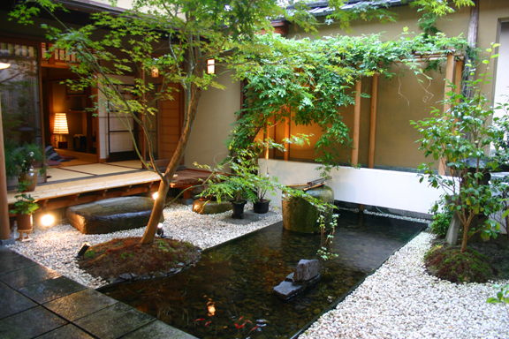
□ JAPANESE ZEN GARDEN
DESCRIPTION: Orderly and minimalist, featuring extensive use of raked gravels, ornamentation, contemplative water features and bamboo.
PROS: Very neat, peaceful and tranquil. Gardens in this style make brilliant meditation gardens for busy executives. Very low maintenace and low water.
CONS: Not many- although you will want to enjoy raking gravel and you will seldom find a flower other than an azalea.

Lastly, imagine you and your family are enjoying your new DREAM garden. Describe how the garden makes you feel, and any words that come to mind.

Thank you for your interest in GardenGirl Design.
We’re only a chat and a site visit away from starting the design brainstorm!
