BUSINESS OVERVIEW

Hardware, Industrial & Tool Supplies… the name says it all!

If we don’t have it, we’ll find it and have it to you in the fastest time possible because the people that run the store own the store.

Our business is aligned with the national buying group HBT (having over 600 members with 100 of us being Industrial Stores), providing access to a wide variety of products at competitive pricing.

We evolved from a small hardware store to providing consumables to the building trades to where we are today, supplying tools and equipment to industry. Therefore, our range and experience is extensive.

Our philosophy is simple. Provide a service to make sure our customer’s requirements are met and quality products at great prices.

This commitment to providing superior supplies means our product range is constantly developing.

We consider this is the reason why our customers return to H.I.T. Supplies as their business provider.
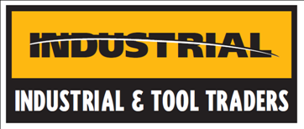
DELIVERY

Next day delivery to Cannington, Canning Vale, Thornlie, Forrestdale & surrounding Commercial Areas at 7:30am (subject to stock availability).

SUPPLIES

Abrasives
Air Tools
Air Tool Servicing
Automotive
Batteries
Cleaning
Consumables
Drilling
Electrical
Engineering
Fasteners
Gases
Grease Guns
Hand Tools
Hardware
Materials Handling
Office Supplies
Spray Paint & Accessories
Power Tools
Protective Clothing
Safety Signs
Sealants
Soldering
Storage
Tool boxes
Welding
Workshop fitouts
…and so much more

BRANDS to name a few
