

ABN 22 659 451 607

PO Box 1203

Waverley Gardens Vic 3170

Phone: 03 9795 7604

Mobile: 0439 944 575

WHOLESALE

PRICELIST MARCH 2008

*ALL PRICES INCLUDE GST
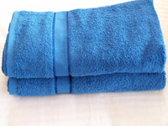

Towelling Products

Ring Spun Standard Cotton Towels

520 Grams - 100% pure cotton
Bath Sheet - 95 x 160 cm $15.95

Bath Towel - 70 x 140 cm $10.95

Bath Mat - 50 x 70 cm $ 7.95

Hand Towel - 43 x 67 cm $ 5.95

Face Towel - 33 x 33 cm $ 1.90

Available in Terracotta, Bottle Green, Royal Blue, Butter Cup, Burgundy, Jade, Pale Green, Bluestone, Chocolate, Charcoal, Berry, Navy, Wheat, Purple, Yellow, Sky Blue, Olive, Baby Pink, White, Cream

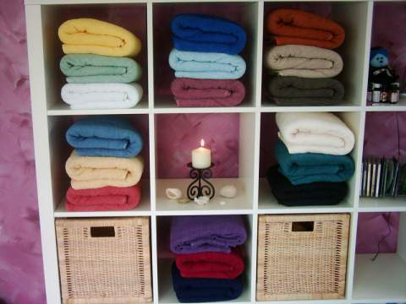
Luxurious Combed Egyptian Cotton Towels

600 gsm 100% pure Egyptian cotton

Bath Sheet - 95 x 160 cm $17.95

Bath Towel - 70 x 140 cm $12.95

Bath Mat - 50 x 70 cm $ 9.95

Hand Towel - 43 x 67 cm $ 7.95

Face Towel - 33 x 33 cm $ 2.90

Available in White, Cream, Chocolate, Navy, Charcoal, Royal Blue, Frost (pale green), Berry, Bluestone, Burgundy, Light Grey and Wheat

Super Egyptian Cotton Towels
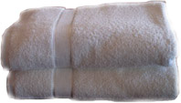
Bath Sheet 95 x 160 cm 100% pure Egyptian cotton $19.50

Bath Towel 70 x 140 cm 100% pure Egyptian cotton $14.50

Bath Mat 50 x 70 cm 100% pure Egyptian cotton $14.95

Hand Towel 43 x 67 cm 100% pure Egyptian cotton $9.50

Face Towel 33 x 33 cm 100% pure Egyptian cotton $ 3.90

Super Egyptian cotton towels are available in White, Cream, Chocolate, Ocean (Navy), Charcoal, Pebble, Moonlight (Mid-Grey), Berry, Sky Blue

Bathrobes

Bathrobes - 480 Grams
Adult - One size fits all $35.95
Available in selected colours

100% Australian Wool Doonas

Single $77.00
Double $84.00
Queen $91.00
King $98.00

For your convenience payment can be made by direct deposit or cheque.

All items will be sent by courier or registered post through Australia Post and the charges will be added to your order according to weight and size of order.

Colour chart for standard towels and bathrobes

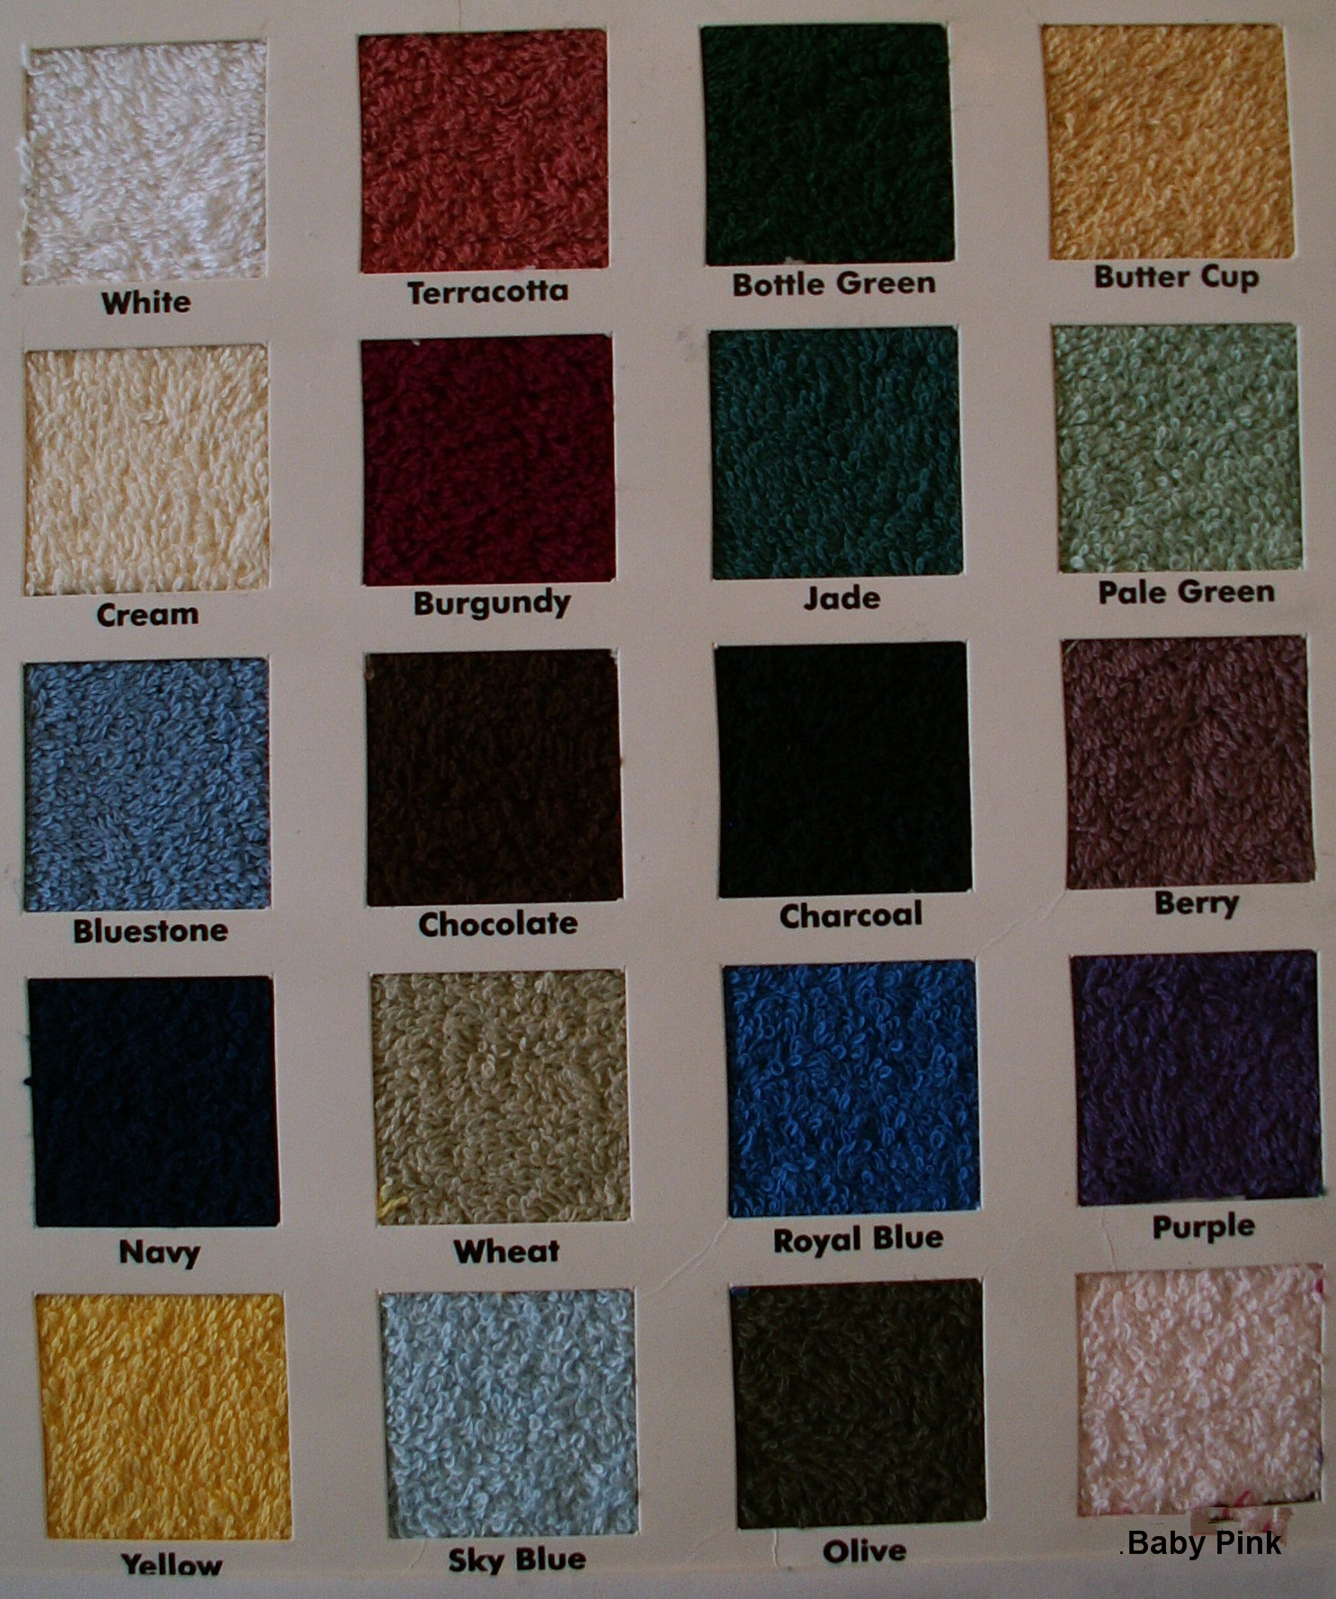

PLEASE NOTE:
Colours may vary on your screen to actual colours so this should only be used as a guide

