 Marilyn Colvin Boon CHt. HBCE

How HypnoBirthing Can Benefit You and Your baby.

A well thought out , tried and tested programme spread by word of mouth recommendation from one coffee table conversation to another over the past 22 years, has now established HypnoBirthing as a leader in the field of Child Birth Education and Preparation. Worldwide . HypnoBirthing is now in 32 countries with full y certified and train professional Practitioners to assist couples in their desire to have a normal, calm and often pain free birth.
Let us look at the unique benefits the programme holds :-

- Introduction to hypnosis through the HypnoBirthing breathing, relaxation and visualisation techniques.
- Reinforced practise with CD recording of Marie Mongan’s Rainbow Relaxation & Birth Imagery.
- Educational notes from the HypnoBirthing The Mongan Method Book
- Walk through the techniques with your qualified HypnoBirthing Practitioners over a five week period you will learn the power of your mind and body.
- Watch HypnoBirthing Birth Stories that show women birthing without fear, fully in control at each stage of Birth , naturally and uncontrived.
- Guidance on how your Birth Companion/Partner/Doula/Midwife can assist you using correct language, birth cues and prompts.
- Mothers are awake and aware, yet calm and confident. Baby is free of drugs and is assisted by mother’s own hormones to birth.
- Mother is fresh, calm and in love with her baby.
- HypnoBirthed Babies are Calm Babies.
- HypnoBirthing Provides ongoing support and friendship to our couples.

Our marvellous birthing device, the Uterus is unique in that its environment is totally outside the premise of the Sympathetic and Parasympathetic system. We call it the Healing Room or the Emergency room. Which do you spend most of your time in? The Uterus’ environment is solely designed to nurture the unborn baby. Its language is Love and emotional calm , The Healing Room. That is what HypnoBirthing teaches. Birth is an emotional experience and the unborn child is aware of its environment, its parents behaviours and attitudes to birth and to them. These are overlooked by a culture of medicalized interference and harsh language used in hospitals and birth centre, predisposed to the ‘Emergency Room’.

HypnoBirthing has its own language , a language that is softer, describing what is happening in a normal, natural and spontaneous birth. A language that has positive overtures without negative implications. A language that addresses the emotional mind to feel safe, loved, free to be and birth as nature intended.

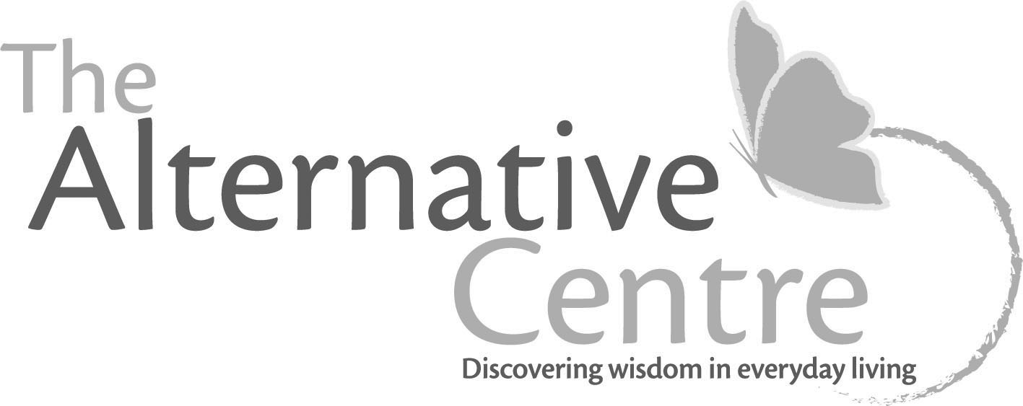................2...............

Our couples realise that birth is a normal and natural as love-making. The ambiance of birth is the same as that of the bedroom. Intimate, close, soft lighting, nurturing, spending time together, cuddles, hugs, kisses , light touch, comfortable positions and we use our own language in love as we now do in birth.

In the five week period, HypnoBirthing couples come to realise that birth is about them. It is about their family. Its about them taking full responsibility for themselves as well as their yet to be born child. It is about making decisions and how to make the right decisions and how to ask the right questions.

During the daily practise of relaxation and visualisation your mind develops a conditioned response that changes the perception of pain. Research shows that a hypnotised brain, a relaxed brain feels no pain. During the programme, we teach our couples several techniques that will certainly change any perception of pain and learn how to direct the course of their thoughts and their body.

Research has also shown that labour is shortened by several hours using HypnoBirthing, time is distorted, the birth dance becomes evident most often in the latter stages of labour. Birth is a journey and not just a diaried event.

The number of c-sections one reads in hospital reports , newspapers, magazines are performed as a result of failure to progress, FTP or in another way, Fear Tension Pain , FTP. Grantly Dick Reed wrote Childbirth without Fear after he saw a woman in the east end of London birthing and rushing to her aid with pain relief, the woman startled and asked him “ Was it supposed to hurt doctor?’ a question that led Grantly Dick Reed to question the validity of pain surrounding birth . His book, is the basis of the HypnoBirthing programme.

To take advantage of this amazing, powerful, foolproof programme, register Now online at
http://www.thealternativecentre.com.au/Sunshine-Coast-events

