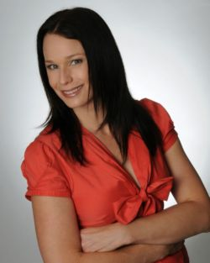
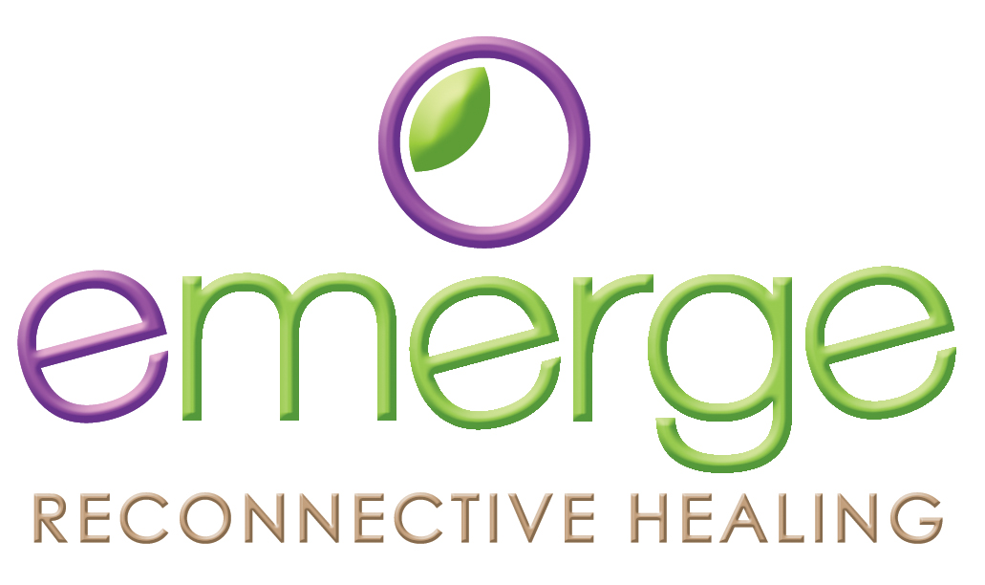

Testimonials

I am a professional athlete that has come from a standpoint that surgery and ‘modern’ medicine (i.e. prescribed drugs) were the only things that really worked quickly. Also with a religious upbringing I was hesitant to try reconnective healing with Paige.

To my surprise there was no weird vibe, burning of incense or chanting chakras but a relaxed easy atmosphere that welcomed the powers of healing to take place. Paige is not promoting herself to be doing the healing but rather allowing your own personal beliefs to be prominent while opening the channels of healing to take place. In my own mind I can’t see any reason why the body can not be encouraged by a professional to do what it does best (re generate) only faster and with better results.

I have now received the benefits of several healings and a reconnection 2 part process.
I am unable to explain how or why but know that my body has responded in unusual ways often giving itself what it needs most. Very recently I saw Paige while I was in a very tense mood and found that I could not hold back the urge to belly laugh while Paige was doing whatever she does, I laughed so much with no encouragement unable to stop that it made me believe that something beyond my understanding occurred that forced me to feel better and heal my issue right there and then.

From my observation Paige is a genuine caring person who has a natural gift that has the beneficial outcome of being able to help people. I would recommend her treatments as something for those who have tried everything as well as those who can believe straight away that there is so much we do not understand about our body that unique people like Paige may be able to tap into and encourage results beyond our imagination. Oh the best thing is it does not hurt and there’s no long term treatment plan often with only one visit required.

Tim Wood
Professional Athlete

I went to visit Paige with a torn calf muscle in my left leg. I was concurrently seeing a physio and a massage therapist to assist in my recovery.

While the physio and massage therapist offered physical and muscular care for my torn calf muscle, the value that Paige bought to my recovery was one of enlightenment. Paige offered me a more holistic approach with her treatment.

The treatment itself is difficult to explain, but the experience is not. Paige’s treatment of my torn calf muscle offered me a sense of all over physical and mental calm, which is so important given that the body is a community. Moreso, the treatment offered me an understanding of why my calf was only minimally responding to the other treatments.

While Paige offered me a treatment that I had not previously experienced, I would have no hesitations to seek Paige’s expertise again.

Joanne Taylor - Project Manager / Triathlete / Running Coach

As a complete skeptic, I came to Paige's healing session with no expectations. I doubted that natural therapy or healing could assist with my purely physical injury, but I was amazed to feel a distinct sensation of energy transfer during the treatment and a noticeable improvement in my condition.

Duncan - Lawyer

Paige has a very warm and welcoming spirit. I felt completely relaxed and most importantly safe during our sessions. I also felt a presence of something other than and greater than either Paige or myself. The positive benefits continue to this day.

Gail - Psychotherapist

I must admit that at first I was a skeptic about reconnective healing! Your scientific background and practical down-to-earth approach however, convinced me that with the right help the body can indeed heal itself and I was prepared to give it a try.

So glad I did! After but one session I felt some relief from a chronic lower back condition. A rather surprising result which, whilst not instant, persisted. Not only that, I came away with a deep sense of inner calm and a feeling of being in alignment (I even slept well that night for the first time in quite a while) – a good thing at a time when I had a lot on and needed to take a step back.

I now believe that if you approach Reconnective Healing with an open mind and a desire to be well again then remarkable benefits can result. Thank you for introducing me to an alternative that does not need drugs or radical interventions to achieve health again. I’ll come back for more next time my body gets out of kilter.

Barb Brooks – Concept Training

I can’t say what led me to reconnective healing … some things just seem to happen by chance, and when I came across “Reconnective Healing’ on a natural therapies web directory (while looking for something entirely different), I felt a stong compulsion to investigate it, and then felt myself drawn to Paige’s website without feeling the need to read any others. Intuition I guess …

On meeting Paige she said “best to not tell me why you’re here … let’s just see what happens …”. (The truth is, I don’t really know why I was there, aside from a general feeling of lethargy since returning from Europe a year before.)

Well, what a trip! The sessions were incredibly relaxing. I experienced some extraordinary visions, sounds and feelings, and more importantly came away energised and just knew that something (undiagnosed) within me had changed. The sessions were quiet and peaceful and Paige didn’t apply any physical or verbal contact with me, nor were any appliances or technologies used. It seemed she ‘simply’ performed a series of techniques of harnessing and broadcasting a variety of energies; and I suspect no 2 people will have the same responses.

For some time before meeting Paige I had noticed some odd changes on parts of my body and wondered why they were there. Shortly after the sessions with her (and again, quite by chance) I came across some information that identified some of the odd things my body had been displaying, and it suggested these were indicators for a heart attack and liver dysfunction. However, when I checked in the mirror the next day I realised those signs had gone, and the odd discomfort in my chest had disappeared. Other very visible signs on the soles of my feet (likely signalling other health issues) had also vanished.

One other thing, I’ve never been religious, and I’m still not, but during those sessions with Paige I became very aware of God, and feel this presence every day now. I don’t know why or how, it just is. No wonder Paige is the epitome of peace and calm.

Di Hotston - Project Manager

