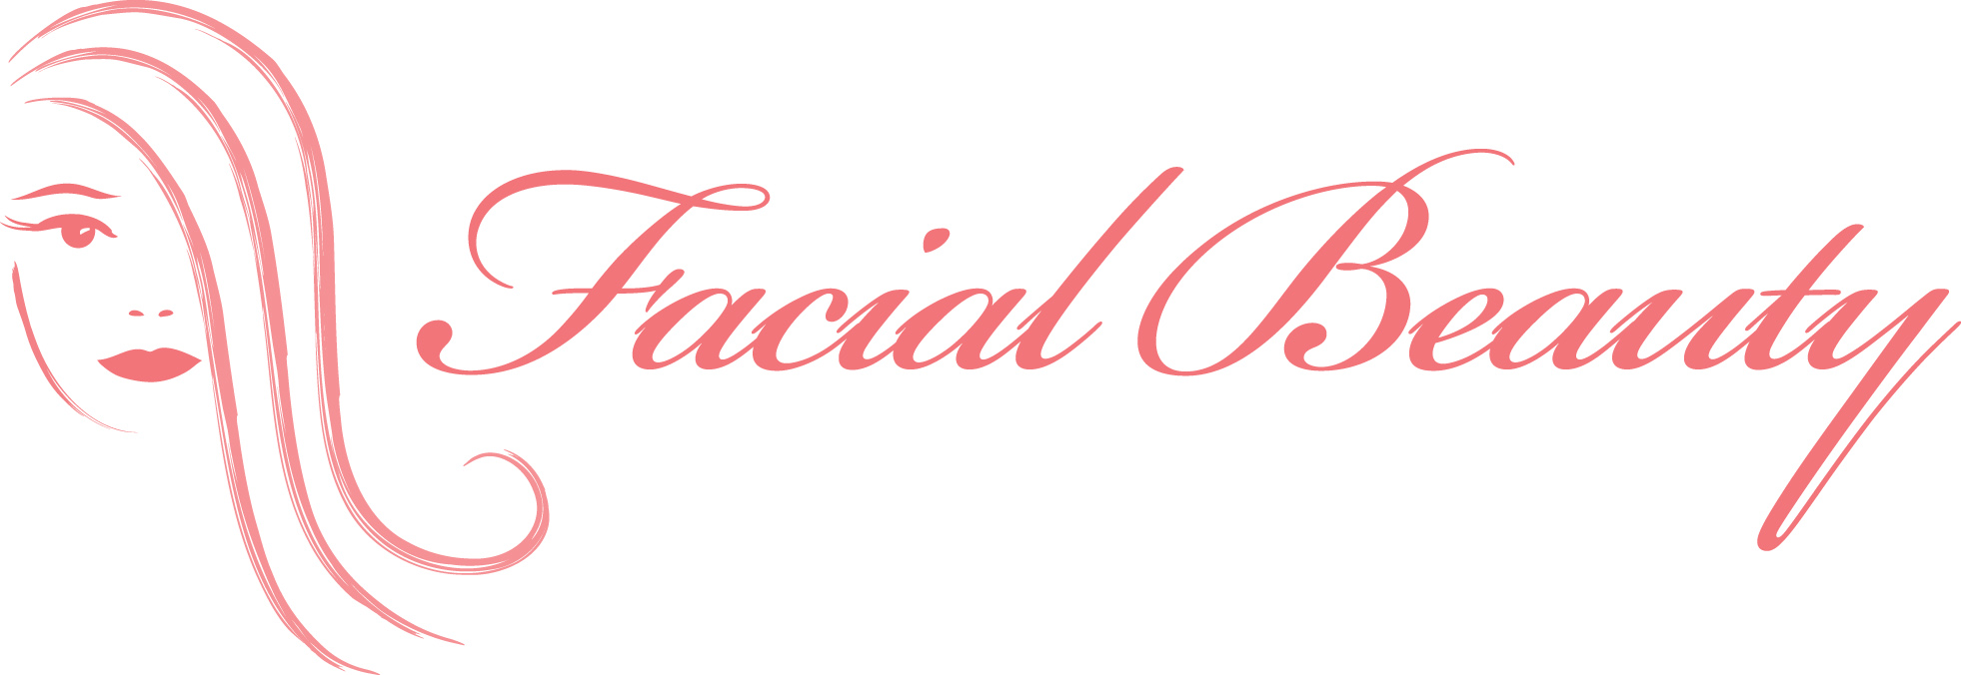

Makeup and Hair
Services

Makeup
Traditional Application (brush or sponge) | $85
Airbrush Application | $105
Tattoo or Body Coverage | From $30
False eyelashes | $15 pp
Flowergirls up to age 6 – blush and lip gloss | Free

Makeup Trial
Salon – Bride only | $70

Hairstyling

Upstyles –
Above shoulder length | From $90-$100
Long hair to shoulder blade | From $95-$105
Past shoulder blade/very thick hair | From $100-$110
Very long hair – past waist line  Flowergirls | From $110-$120  From $35

GHD straightened, hot roller curled or part up/

part down styles
Shoulder length hair or above | From $90-$100
Long hair | From $100

GHD curled
Shoulder length hair or above | From $90
Long hair – depending on thickness | From $100-$120

Style Blow Dry
Very short cropped hair | $50
Bob style or layered above shoulders | $60
Long hair styled blow dry | $70

Hair Trial
Salon – Bride only | $80
Consultations | $25

*Hairstyling prices are starting prices and will be quoted on the day depending on style and difficulty.

*Minimum fee for mobile service is $200. Conditions apply to distance.
*Travel costs may apply for bookings outside Brisbane metropolitan area.

*We only accept cash or a pre-arranged direct deposit as we don’t have credit card facilities.

*Any parking fees incurred must be paid by the client.

*Prices are subject to change without notice.

*In the event that a cancellation is made six weeks or less prior to the occasion our minimum fee of $200 plus travel is payable.

Mobile: 0418 378 920

Email: maria@facialbeauty.com.au

Website: www.facialbeauty.com.au

Facebook: www.facebook.com/facialbeautybrisbane

