The Big Breakfast - $14-50
Bacon (2), Sausages (2), Egg (fried/scrambled or poached) tomato, baked beans, hash browns(2) mushrooms and toast (2)

The Mini Breakfast - $11-50
Bacon, Sausage, Egg (fried/scrambled or poached), tomato, baked beans, mushrooms, hash brown and toast.
The Vegetarian Breakfast – $10-50
Egg (fried, scrambled or poached), tomato, baked beans, mushrooms, hash browns (2) and toast (2).

OMELETTES (3 eggs), Chips and Peas - $10-50
Choice of fillings - $1-00 ea: Cheese, tomato, mushrooms, ham, prawns, bacon.

BAKED POTATOES - $9-00 with butter, sour cream and salad.
Choice of fillings - $1-00ea: cheese, baked beans, coleslaw,
tuna mayo, egg mayo. prawns in cocktail sauce, bacon.

FISH
Beer Battered Whiting - $9-50 (3) $10-50 (4) chips and peas.
Oven Baked Hake - $10-50 with tomatoes, onions, and mushrooms, creamed potatoes and 2 vegetables.

BURGERS
Beefburger (150g) - $10-50 topped with onions, bacon egg, mushrooms and served with chips and peas.

Chicken Schnitzel Burger - $8-00 with Lettuce, Tomato, Cheese and Mayo

PASTA
Pasta Dish of the Day - large $11-00 medium $6-50
Beef Ravioli with tomatoes mushrooms and onions $6-50/11-00

CASSEROLES
Homemade Chicken, Bacon, Mushroom & Vegetable with dumplings $11-00

LAMB SHANK - $14-50 in rosemary and mint sauce and served with creamed potatoes and 2 vegetables.

Ham - $10-00 with pineapple, double egg, chips and peas.
Sausages in onion gravy(2) - $9-00 with mashed potato and 2 vegetables, extra sausage $2-00
Beefburger (150g) - $10-50 cooked in onion gravy, with mash and 2 veg.
Chicken Schnitzel (large) with salad and chips $11-00

HOT ROLLS
Rolls - $3-50 Fillings: Bacon (2) or Sausage (2): $1-75, Egg, Tomato or Mushrooms - $0-75ea

BLT - $6-00

Burger (150g) with onions - $6-00 additional fillings of: bacon(2) $1-20, egg, mushrooms or cheese $0-70ea

SNACKS
Croissants with butter - $4-50 with Ham or Cheese $6-00
Cheese, Beans or Poached Eggs on Toast (2) $5-50
Tomatoes and Mushrooms on Toast (2) $5-50
Pizza $8-00
Large Garlic Bread $3-70
Chips with or without gravy $2-70 plus cheese $3-30

Sandwiches (White or Wholemeal
Egg Mayo, Tuna Mayo, Salmon Mayo, Ham and Tomato, Ham and Egg, Cheese and Tomato, Prawn. $5-50.
With side salad $6-50
Soup of the day $7-00 – with a crusty Roll and Butter
Devonshire Tea $6-80 2 Homemade Scones with Jam and Cream, Tea or Coffee.

CHILDREN’S MENU

Fish fingers or Fish Shapes (5) and small chips $6-50
Chicken nuggets (5) and small chips $6-50
Spaghetti on toast $5-00
Sausages (2) with scrambled egg $5-50

DESSERTS - $6-50

See Board

BEVERAGES

Teas assorted – Cup $2-50 – Mug $3-00

Nescafe instant coffee incl Cappuccino and Latte
-Cup $3-00 – Mug $3-50

Lavazza Espresso - $3-50
Lavazza Cappuccino - $4-00
Lavazza Latte - $4-00

Hot Chocolate $4-00
Milk Shakes (various flavours) $3-70/5-00
Spiders $3-70
Homemade Iced Coffee $4-00
Juices $2-70
Cans various $1-50

Menu and prices subject to change without notice

We appreciate and thank you for your custom and support, if you have enjoyed your visit please tell others by giving us a review at:

www.truelocal.com.au

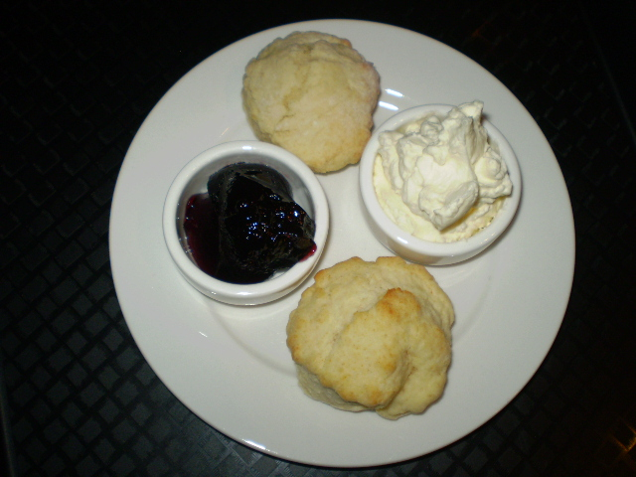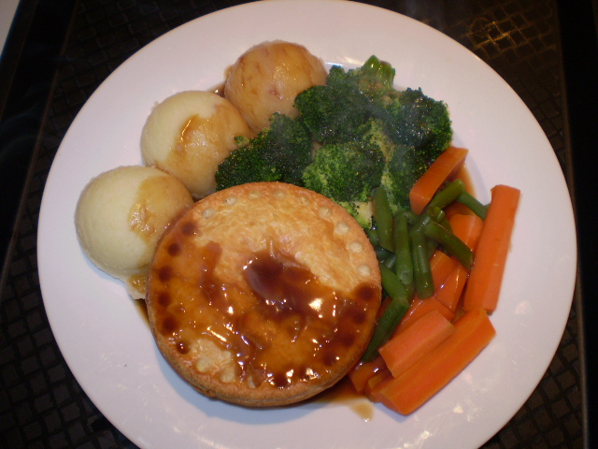

The Marnoo Café &
Bed &Breakfast
28 Newall Street, Marnoo, VIC 3387
Tel: 03 5359 2287

MENU

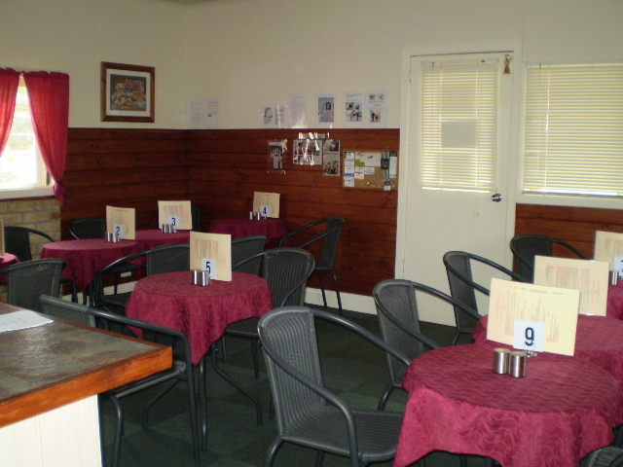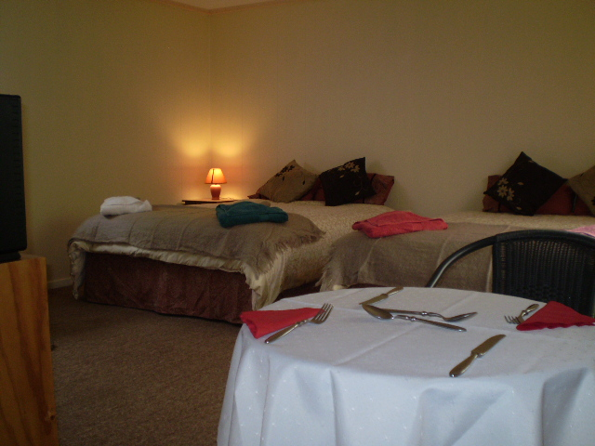

Opening Hours

Monday – Saturday 8am-5pm/6pm-9pm
Sunday 9am-5pm

BYO available evenings only

Groups catered for by appointment

All items freshly cooked to order and subject to availability

Half price tea/coffee or can with food orders
over $8-00pp

Accommodation enquiries welcome
www.marnoocafeandbandb.websyte.com.au

