Scott Coleman – Plastering
QBSA Lic: 1182478

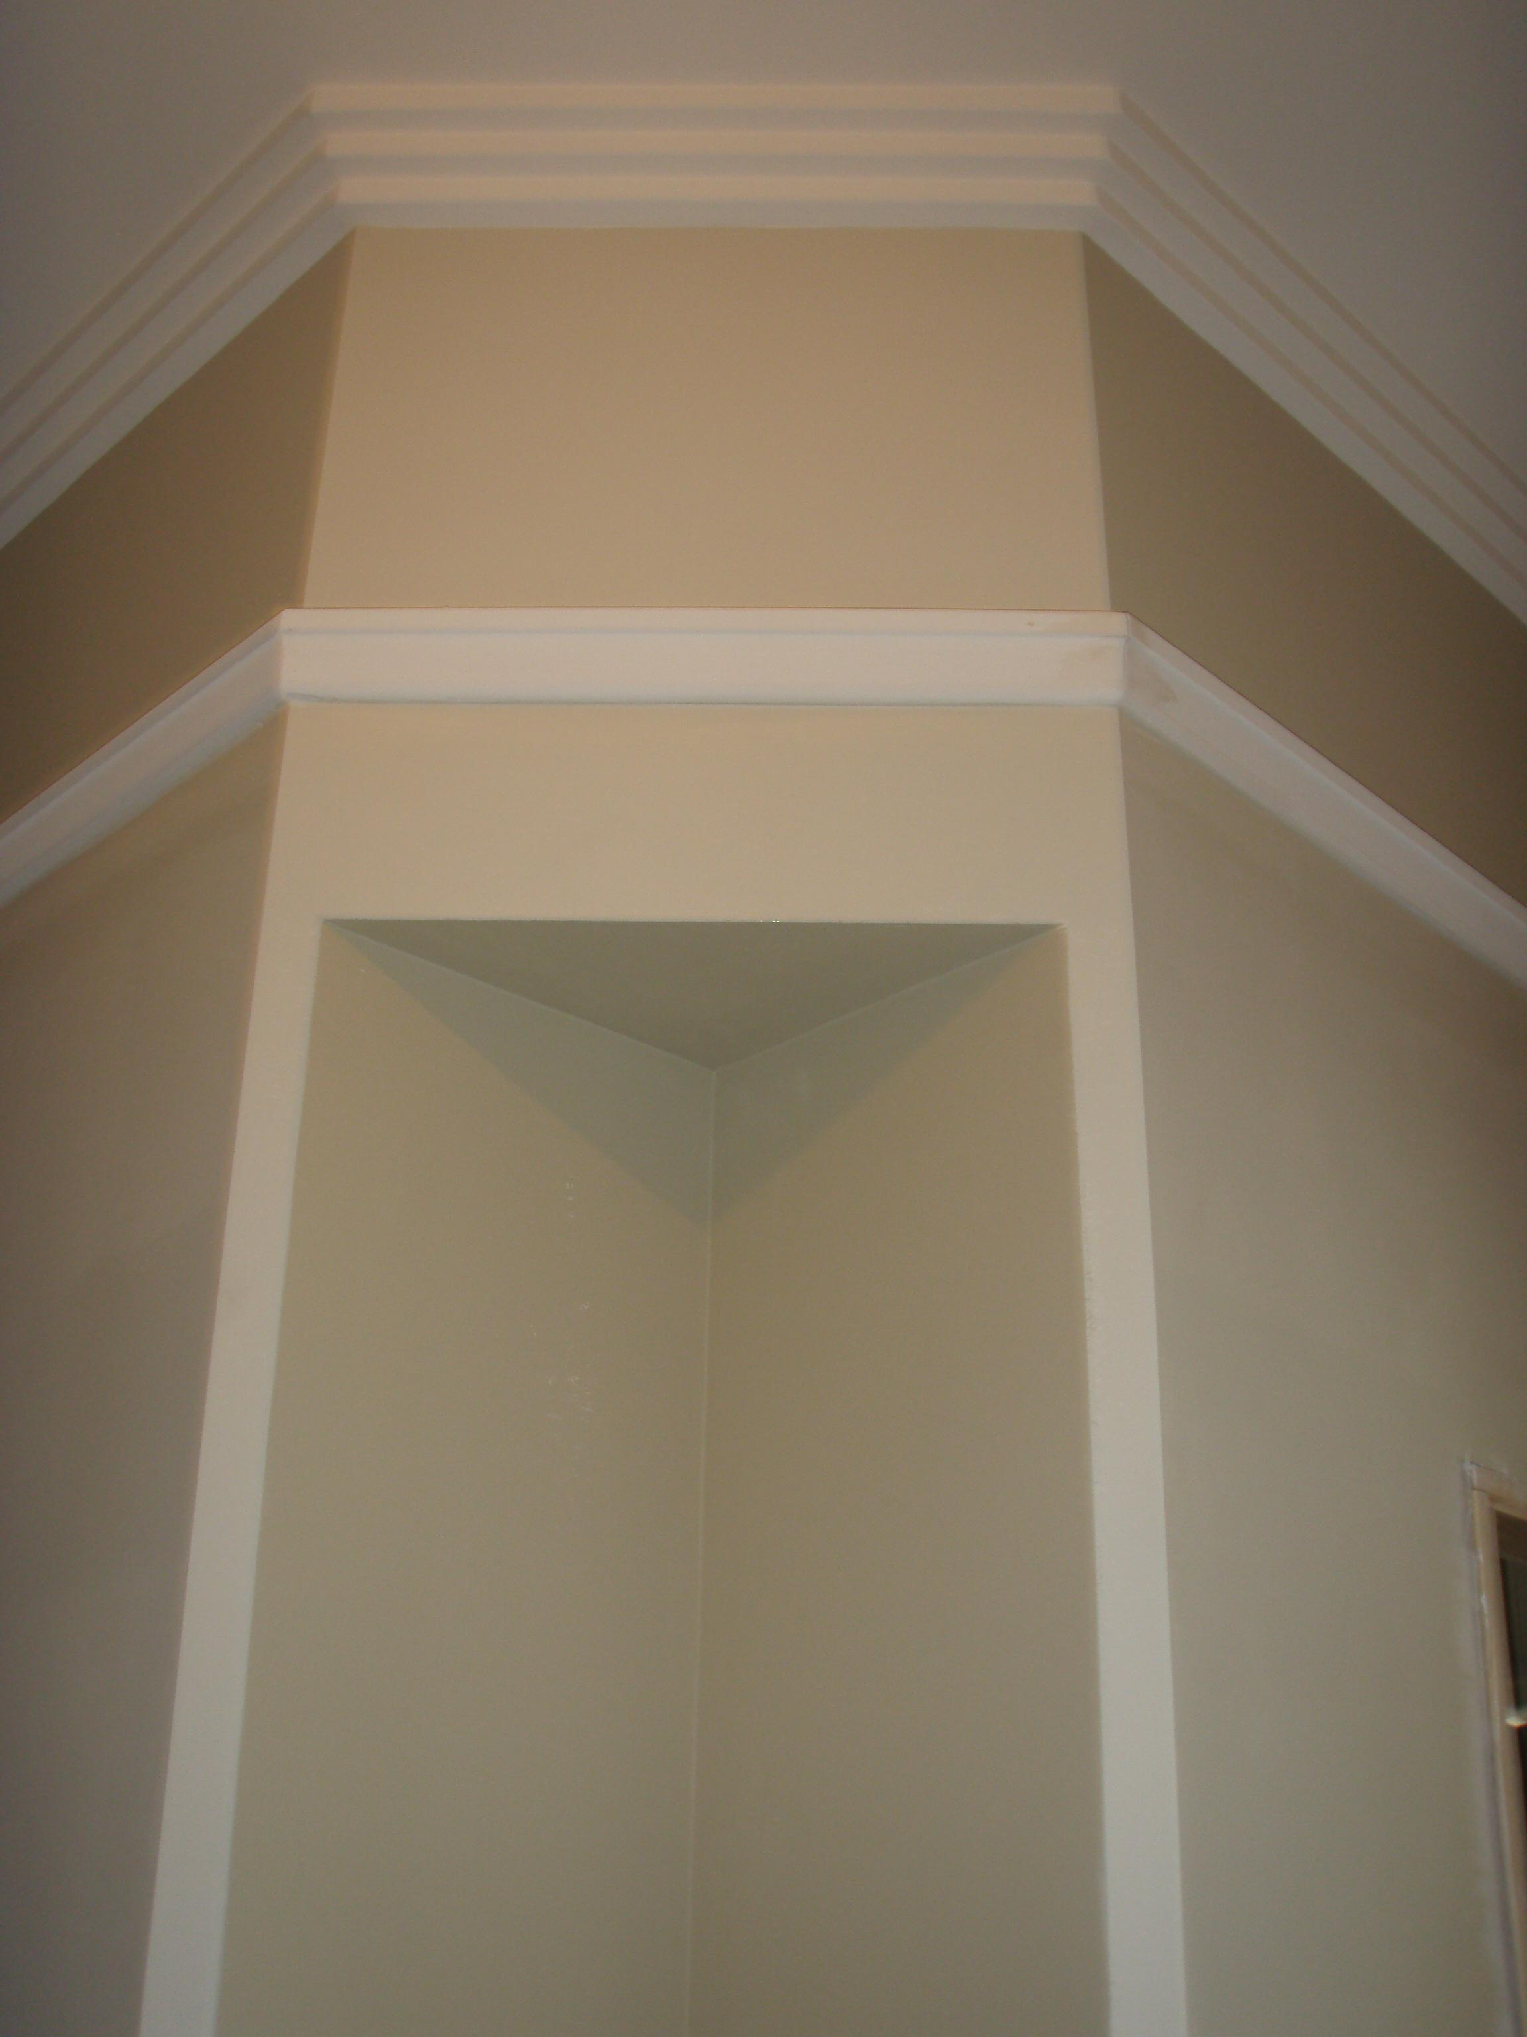
* Residential & Commercial Plasterer

* Repairs, Renovations, General Patching

* Cornice, Bulkheads, Ceilings, Niches

* Modernisation of dated features

Call for a FREE QUOTE today

0410 777 661

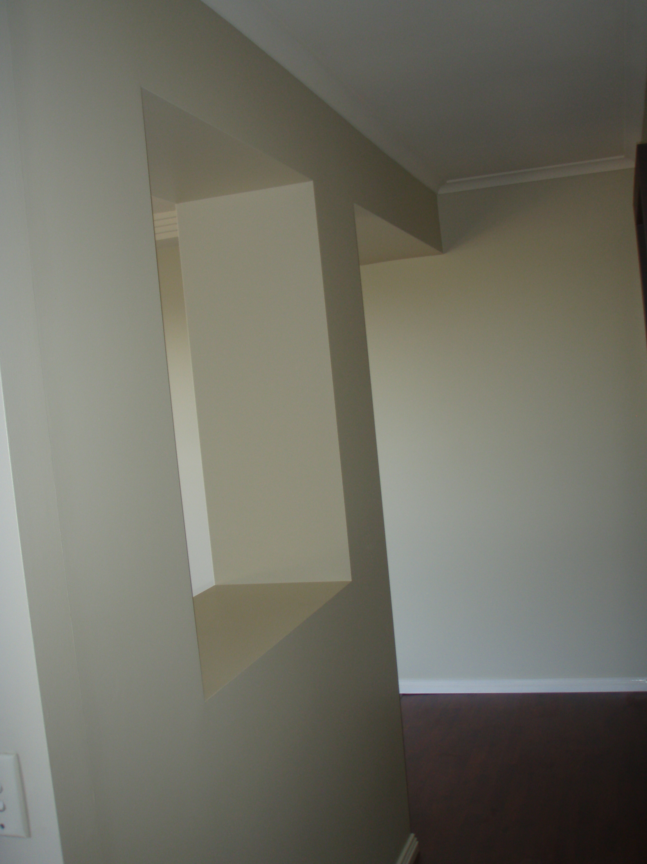
* QBSA Licenced

* Quality workmanship

* Reliable

* Work Guaranteed

