LETTER OF INTRODUCTION
Aussie Painters Direct is a second generation family operated business that has been providing domestic and commercial painting services in Australia since 1965.

Initially established in Adelaide by Dietmar Traub, the family and business moved its operations to Brisbane in the 1986 and in 1997 the company evolved into Traub & Sons Painting Services.
We have recently renamed the company in 2011, however our objective still remains the same, which is continuing to provide both our existing and new clients with a diverse range of quality products and services whilst still remaining cost effective, ensuring customer satisfaction and future recommendations.

Completed Projects
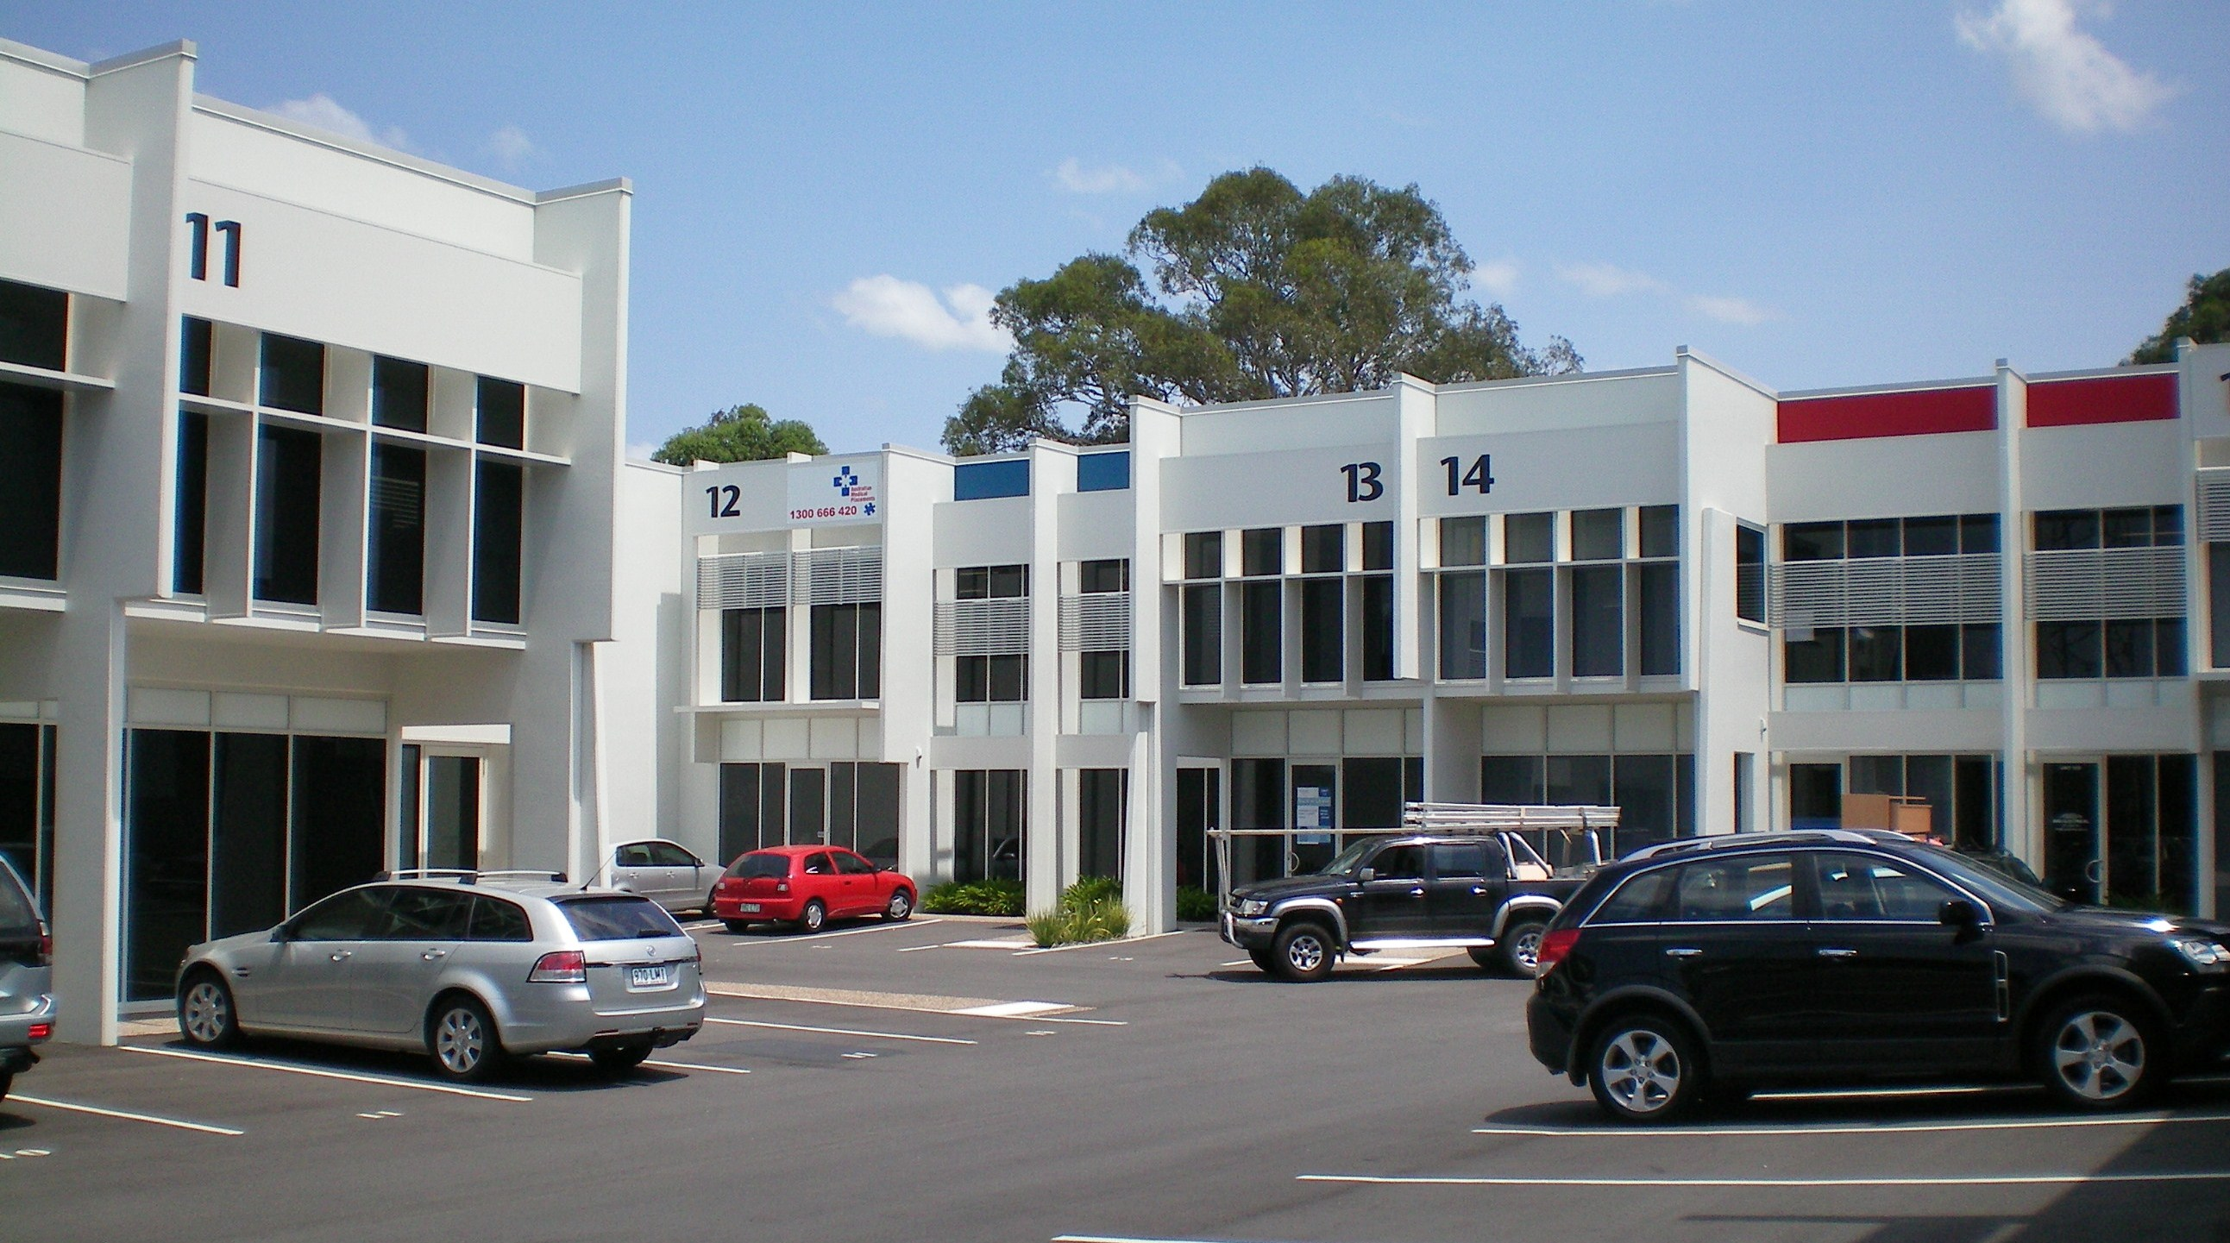
P & O Island Resorts, Heron island, Lizard Island, Dunk Island etc 1995- 2001
Assorted domestic new housing 1995-2002
Gold Coast Bulletin Newspaper Plant 2003
Mayfair on Manly Shopping Centre 2004
Mudgeeraba Shopping Centre 2004
OFM Griffith University, Gold Coast 2004
Multi Level Building, Charlotte Street Police Station, Brisbane 2004
Big W and Woolworths Refurbishment, Strathpine 2005
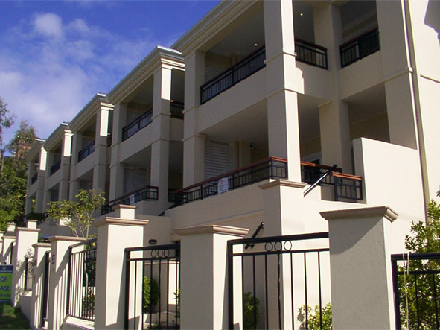
Aldi Food Stores Bald Hills, Kippa Ring, Carindale, Beenleigh etc 2003- 2006
Stradbroke Island Hotel & Apartment Complex 2006
Harvey Norman Refurbishment, Oxley 2006
Gallipoli Army Barracks, Enoggera 2006
36 Unit Apartment Complex, Bribie Island 2007
Gisborne Police Station Watch House, New Zealand 2008
Etro on Gateway Commercial Complex, Murarrie 2008
Commercial Complex Breene Place, Morningside 2008
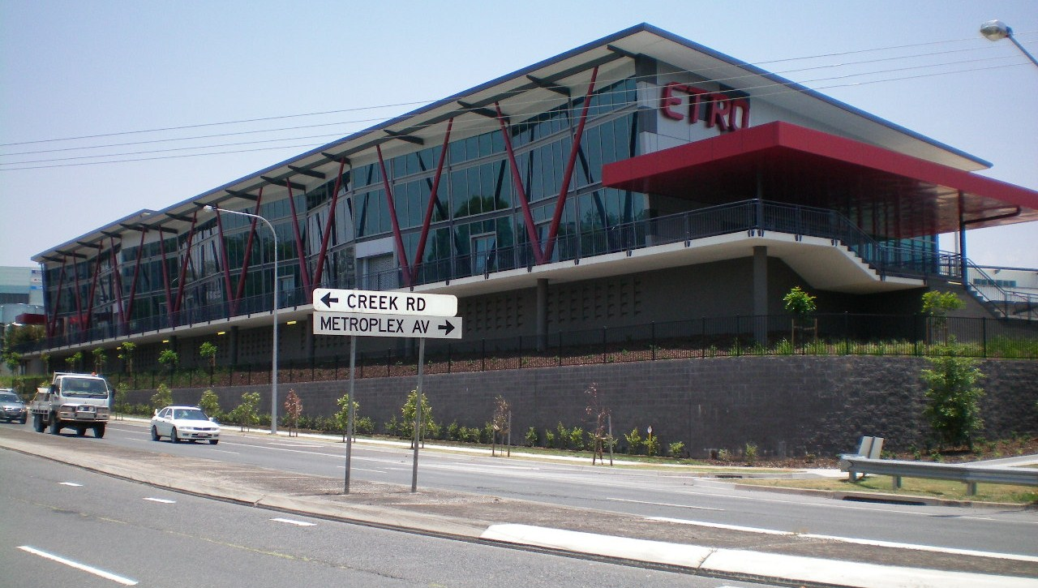
Whitsunday Police Station “Watch House Section” 2009
Ipswich Police Station “Watch House Section” 2009
Portgate Commercial Warehouse, Port of Brisbane 2010
Nut Tree Hill Body Corporate 136 Townhouses, Wynnum 2010-2011
Bellbird Park State School, Brisbane 2010
Audi Car Showroom, Fortitude Valley 2011
Commercial Building Garret Street, Brendale 2011
Storage King, Rocklea 2011
VW & Ford Car Showrooms, Capalaba 2011.

These examples of previously completed projects, along with our objectives have been achieved over the years by providing excellent customer service and consistent results, because at Aussie Painters Direct our clients really are our assets.

Yours

Shane Traub
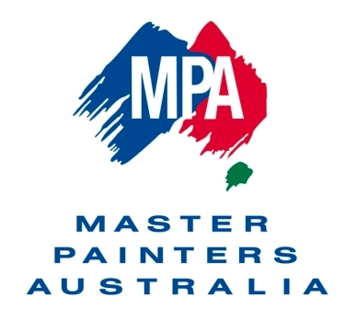
Managing Director

