HAND SWAGER OPERATION INSTRUCTIONS
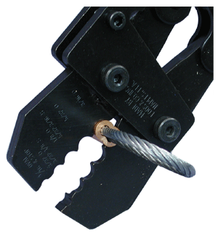
Figure 1
Figure 1. Place sleeve to be compressed in proper size groove
in swaging tool. Single cavity tools should match cable
size to be swaged. Length of cable equal to the cable
diameter should extend beyond length of sleeve to
achieve maximum holding. (See arrow in figure 3)

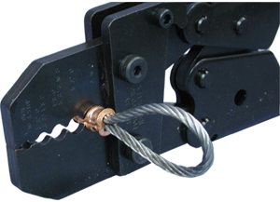
Figure 2

Figure 2. Keep jaws of swaging tool at right angles to the sleeve
to be compressed, making sure the sleeve is aligned in
the jaw grooves. Close tool completely. Tool handles
should snap shut indicating complete closure.

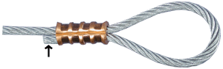
Figure 3

Figure 3. Finished sleeve should look like this. Be sure sleeves have
been compressed the proper number of times. (See NUMBER
OF COMPRESSIONS table below)

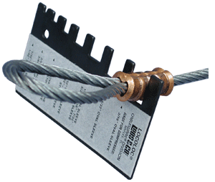
Figure 4

Figure 4. Use Swaging gauge provided with the tool to check proper
after-swage diameter. Compressed sleeve should slide
freely into size slot of gauge.

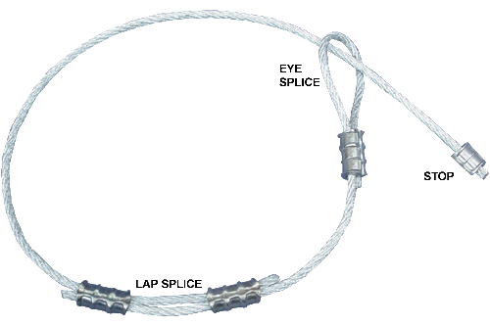

NUMBER OF COMPRESSIONS
CABLE DIAMETER | ALUMINUM & COPPER |  |  | *STAINLESS STEEL
CABLE DIAMETER | OVAL SLEEVES | STOP SLEEVES |  | OVAL  SLEEVES
3/64" | 2 | 1 |  | 1
1/16" | 2 | 1 |  | 1
3/32" | 2 | 2 |  | 1
1/8" | 3 | 2 |  | 2
5/32" | 3 | 2 |  | 3
3/16" | 4 | 2 |  | 4
7/32" | 4 | 2 |  | 4
1/4" | 4 | 3 |  | 5
9/32" | 4 | 3 |  | N/A
5/16" | 5A / 4C | 3 |  | N/A
3/8" | N/A | 3 |  | N/A

