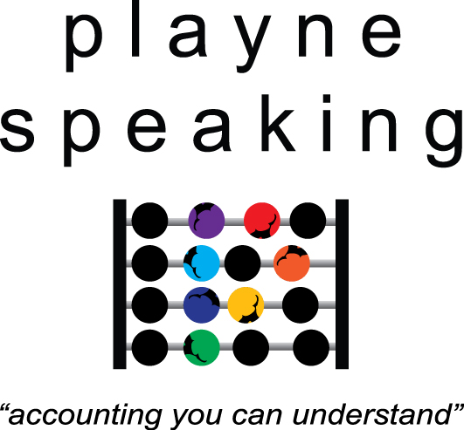

PO Box 897
Newport Beach NSW 2106

Telephone +61 4 0816 8621
natasha@playnespeaking.com

www.playnespeaking.com

13th July 2009

TO WHOM IT MAY CONCERN

Reference: David Hill – handyman services

We own a rental property in Camp Hill. It had been rented out for a number of years and the garden and other areas of the house had fallen into disrepair. So we went looking for a handyman and gardener. Our real estate agent suggested we use David Hill.

We asked David to clean the underneath of our house of all rubbish, lay down some stones, clean out all the garden beds and re-mulch the garden. There were numerous other tasks that he also attended to.

David did a superb job. Without us having to ask, he emailed photos to us immediately after doing the work, which gave us a clear understanding of all the work he had done. He also provided us with an itemised invoice which was much appreciated.

David is a professional and we really appreciated the honest, diligent and thorough approach he has to his work.

If you require this reference to be confirmed verbally, please call Natasha on 0408 168 621.

Yours sincerely,

Natasha Playne & Kieran Hutchison

Owners: 14 Grant St, Camp Hill.

Yours faithfully,
Natasha Playne
Speaker & Trainer

